

**Calligraphy.**

**E-Project Documentation**

**Teacher Name: Sir Ahad Ali**

**APTECH COMPUTER EDUCATION**

**HYDERABAD-1 PAKISTAN**

**Issue Date: 3-July-2025**

TABLE OF CONTENT

|  |  |  |
| --- | --- | --- |
| **S No** | **Contents** | **Page No** |
| 01 | Certificate | 3 |
| 02 | Acknowledgement | 4 |
| 03 | Project Report | 5 |
| 04 | Problem Definition | 6 |
| 05 | Customer Requirements Specification  (CRS) | 7 |
| 06 | Architecture Design of the Project | 8 |
| 07 | System Requirement | 9 |
| 08 | Task Sheet | 10 |
| 09 | Project Plan | 11 |
| 10 | Checklist of work Progress | 12 |
| 11 | Final Check List | 13 |
| 12 | Screen Shots | 18 |
| 13 | Source Code | 20 |

CERTIFICATE

This is to certify that

**Hammad Siddique**

Submitted by:

**Hammad Siddique**

Has successfully designed

Oxford Sofa Website.

Date of Issue: **3-July-2025**

Authorized Signature: Sir Ahad Ali

ACKNOWLEDGEMENT

First and foremost, we would like to express our deep gratitude and most heartfelt thanks to almighty ALLAH for his blessings, for lightening up our heart with the torch of knowledge and for giving us the ability to complete this project.

We would like to thanks Aptech Worldwide and the team of E-Project for their generous support and clarifying the doubts regarding e-project. We would like to acknowledge the way of explanation which the team of e-project gave in e-project to make website and we are equally grateful to our teacher (Sir Ahad Ali) for giving us a moral support and guiding us different matters regarding project in all the time about the research and writing of this project.

We are greatly indebted to Aptech Worldwide, Sir Ahad, Faculty Members and ACE Hyderabad, Pakistan for encouragement and incessant help.

PROJECT REPORT

**BY:**

|  |  |
| --- | --- |
| **Student1631423** | **Hammad Siddique** |
|  |  |
|  |  |

Project Title: Oxford Sofa Website.

Members Name: Sualeha

Batch Code: 2412B

Start Date: 3-Dec -2024

End Date: 8-July -2025

Course: ACCP-PRIME (ADSE)

Teacher: Sir Ahad Ali.

Center Manager: Sir Shoaib Ahmed

Center Academic Head: Sir Shoaib Ahmed

Center Name: ACE Hyderabad-1, Pakistan

Submitted as

E Project Documentation

**PROBLEM STATEMENT**

Oxford Sofas is an organization selling sofas. They make various sofas of different types suiting every requirement and into various sizes, starting from home to office to hotels and etc.

You are supposed to create a website for them with the below mentioned requirement specifications.

The website is to be developed for the Windows Platform using HTML5, JavaScript and Geolocation. The site should work well in all leading browsers including Chrome,IE, Firefox etc.

Requirement Specification:

The Web site is to be created based on the following requirements.

1) The Home Page should be created making use of Sections with a suitable logo, the header section can be added which will show images sofas.

2) The site must contain the links to navigate through any category for the information.

3) The site should display a menu which will contain the options for brief introduction about the various sofas available, location of the shop and any other information if required.

4) The information should be categorized according to the brand names of the

sofas like if a User wants to see only “grand” sofas or any other companies sofas then he/she can click on a Link/button/menu etc and can see only that Brand sofas.

5) When a user selects any particular brand, a list of sofas for that brand will be displayed

6) A brief summary of features of the sofas should be displayed on the Web Page along with the picture but detailed Features should be stored in Individual Word documents which can be downloaded or viewed by the User who wishes to see the same.

7) The user should also be able to compare the various sofas of different as well as similar brands.

8) There should be a “Contact Us” page which will have the Address of the Company which should be displayed using GeoLocation API (eg. GoogleMaps) and the email address which when clicked will invoke the local mail client from where they can send an email.

Architecture & Design of the Project:

Since the website will have client architecture it will have one-tier architecture.

System Requirement:

|  |  |  |
| --- | --- | --- |
| **SR.No** | **Items** | **Description** |
| 01 | Operating System | Window XP, Win7 or win8 |
| 02 | Main Processor | Minimum 2ghz or better |
| 03 | Ram (Memory) | 64Megabytes or better |
| 04 | Web Browser | Google Chrome or Firefox (Latest) |
| 05 | Software | Notepad/HTMLeditor/CoffeeCup  Angular / Angular JS / React /BootStrap Dreamweaver /Figma MS IE / Chrome / FireFox / Netscape /MS Edge |

TASK SHEET

|  |  |  |  |  |  |
| --- | --- | --- | --- | --- | --- |
| **Project Ref. No:** | | **Date of Preparation of Activity Plan:** | | | |
| SR.  No | Task | Actual  Start  Date: | Actual  Day: | Team  Mates  Names: | Status: |
| 01 | Meeting | 14 Jan 2024 | 1 | Sualeha |  |
| 02 | Data  Collection | 15 Jan 2024 | 2 | Sualeha |  |
| 03 | Designing  Home  Page | 18 Jan 2024 | 4 | Waniya |  |
| 04 | Linking | 22 Jan 2024 | 1 | Hammad Khan |  |
| 05 | Check  Links | 23 Jan 2024 | 1 | Hammad Sidddique |  |
| 06 | Designing Menu Page | 25 Jan 2024 | 2 | Hammad  siddique |  |
| 07 | Designing Other Pages | 27 Jan 2024 | 5 | Burhan |  |
| 06 | Finalizing | 1 Feb 2024 | 1 | Hammad  siddique |  |
| 08 | Documentation | 2 Feb 2024 | 1 | Sualeha |  |
| 09 | Uploading | 5 Feb 2024 | 1 | Hammad  Siddique |  |

PROJECT PLAN

* Website is able to execute quickly.
* The color combination of our website is so attractive.
* The collection of data is authentic and taken by the most popular product websites.
* Background of each page is as different as the main page.
* The contact page is well prepared exactly for the same page as user clicks on the link...
* A user can resolve its difficulties easily from this site.

CHECK LIST OF WORK PROGRESS

|  |  |  |
| --- | --- | --- |
| **SR. No** | **Aspect Tested** | **Remarks** |
| 01 | Data Collection |  |
| 02 | Designing Home Page |  |
| 03 | Linking The Pages |  |
| 04 | Designing Other Pages |  |
| 05 | Finalization |  |
| 06 | Documentation |  |

FINAL CHECK LIST

|  |  |  |  |
| --- | --- | --- | --- |
| **SR.No** | **Particulars** | **Yes** | **No** |
| 01 | Do all pages open? | YES |  |
| 02 | Are all hyperlinks working? | YES |  |
| 03 | Are the web page contents devoid for spelling mistakes? | YES |  |
| 04 | Are all the web components working? | YES |  |
| 05 | Is site browser compatible? | YES |  |

SCREEN SHOTS:

HOME PAGE

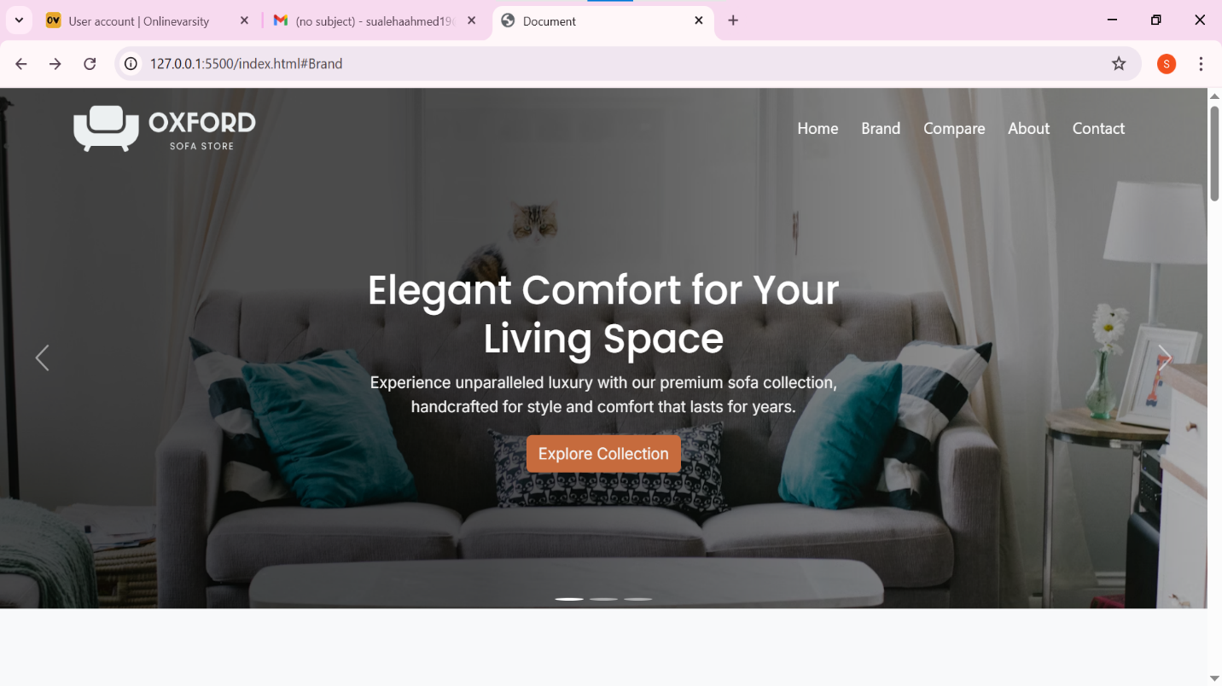

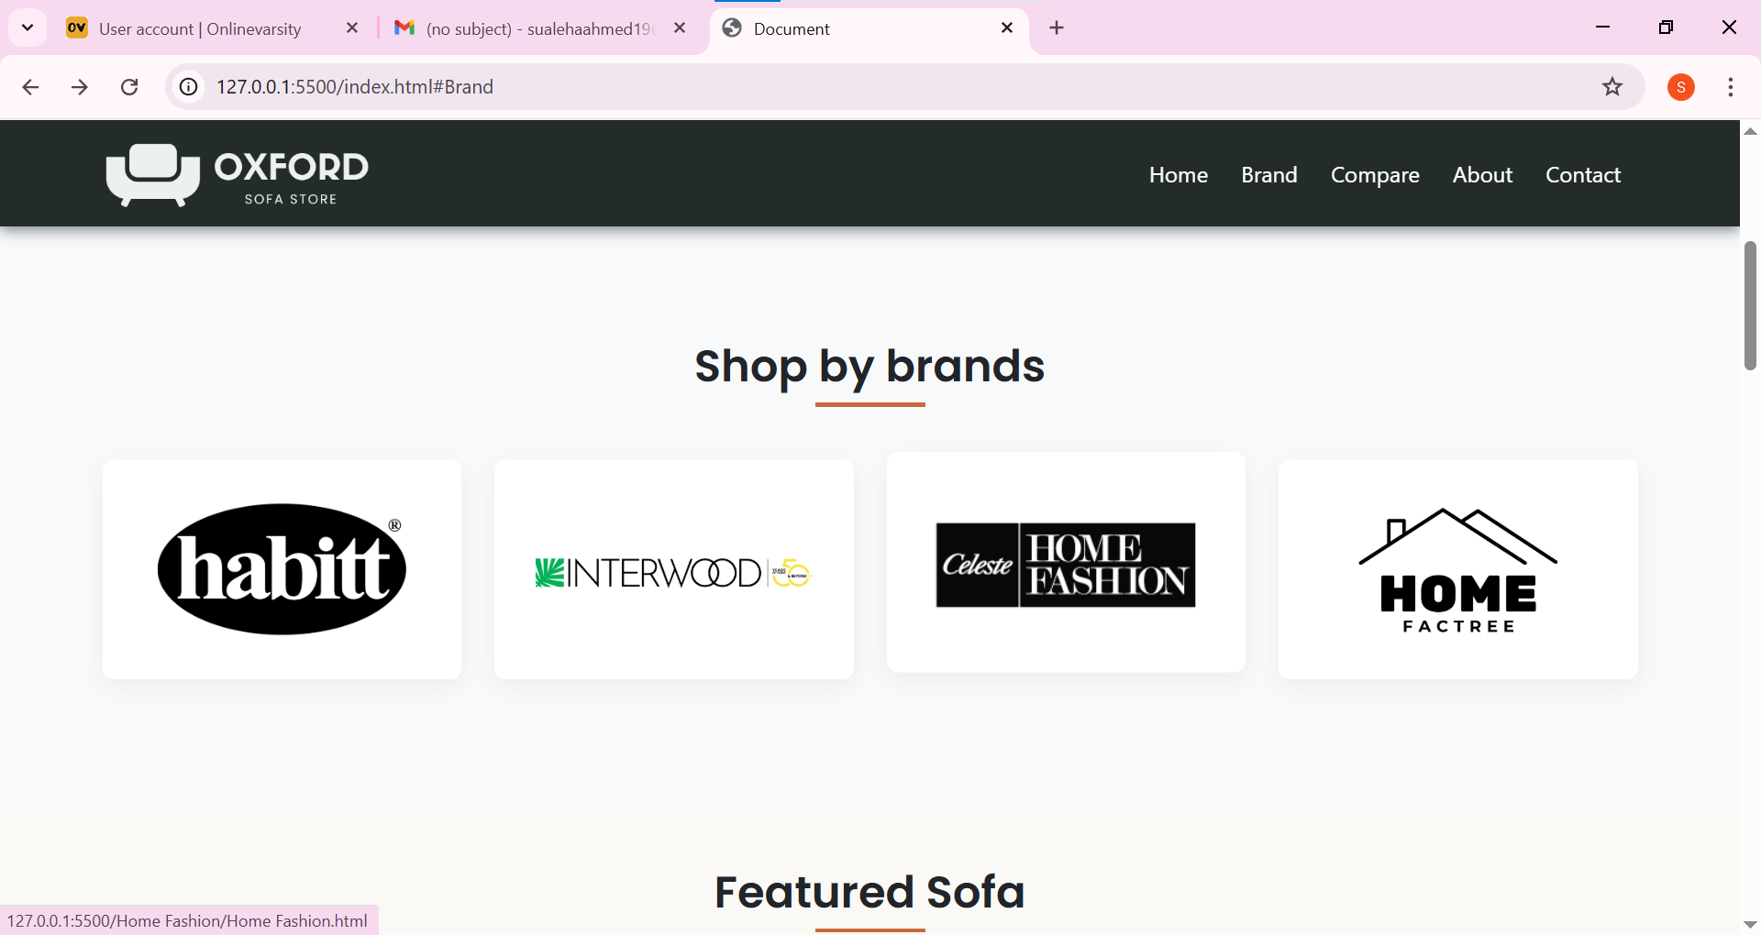

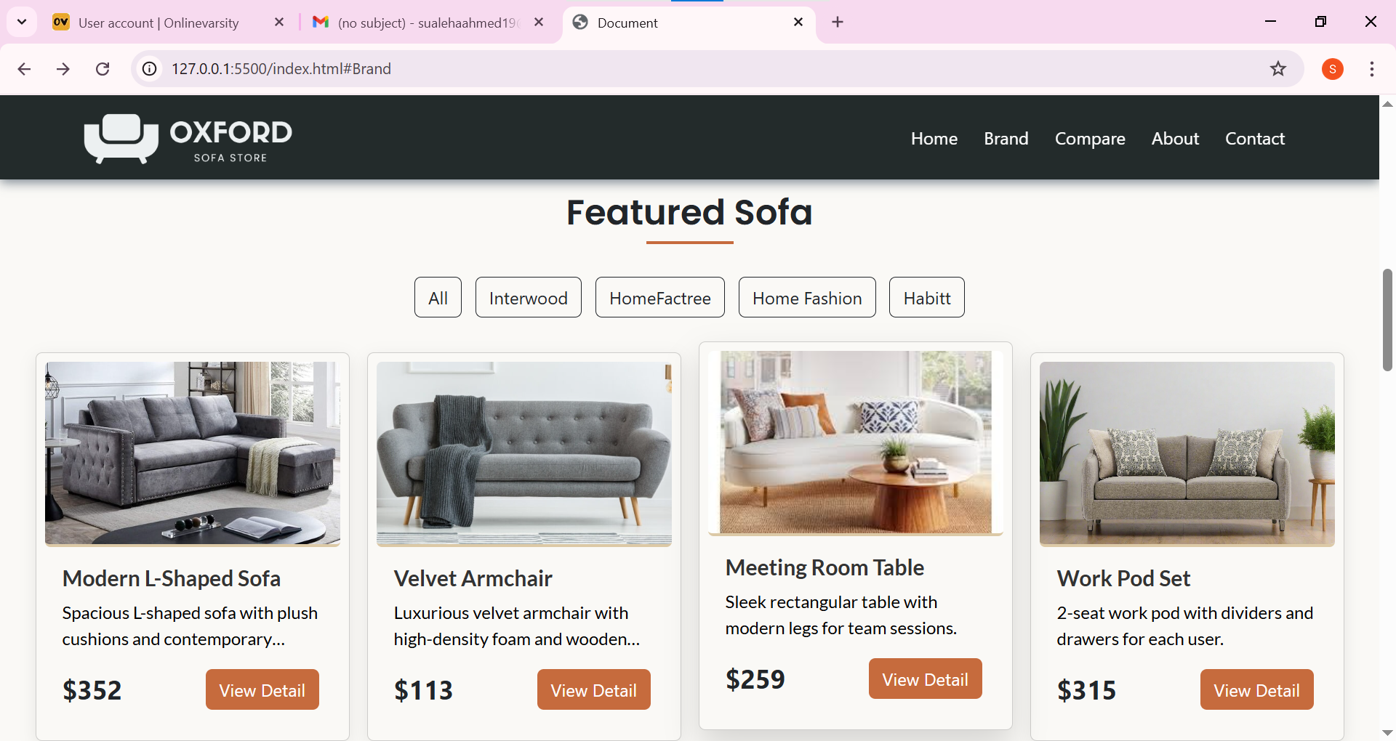

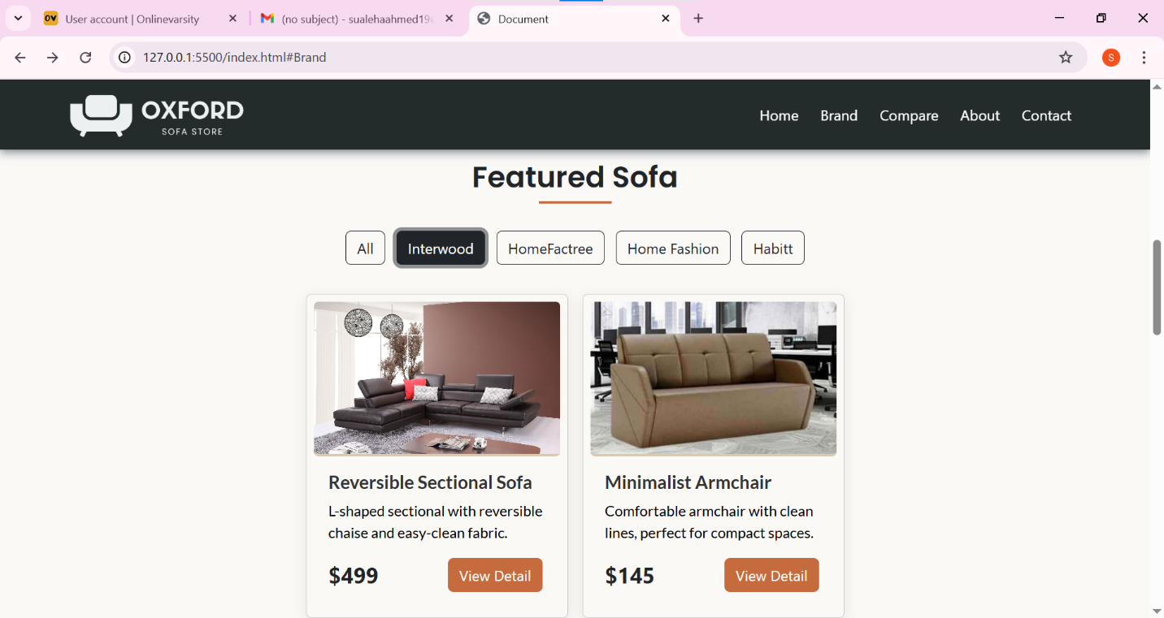

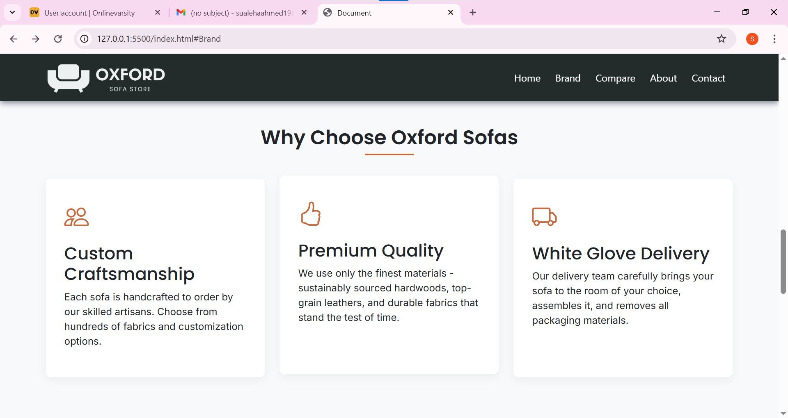

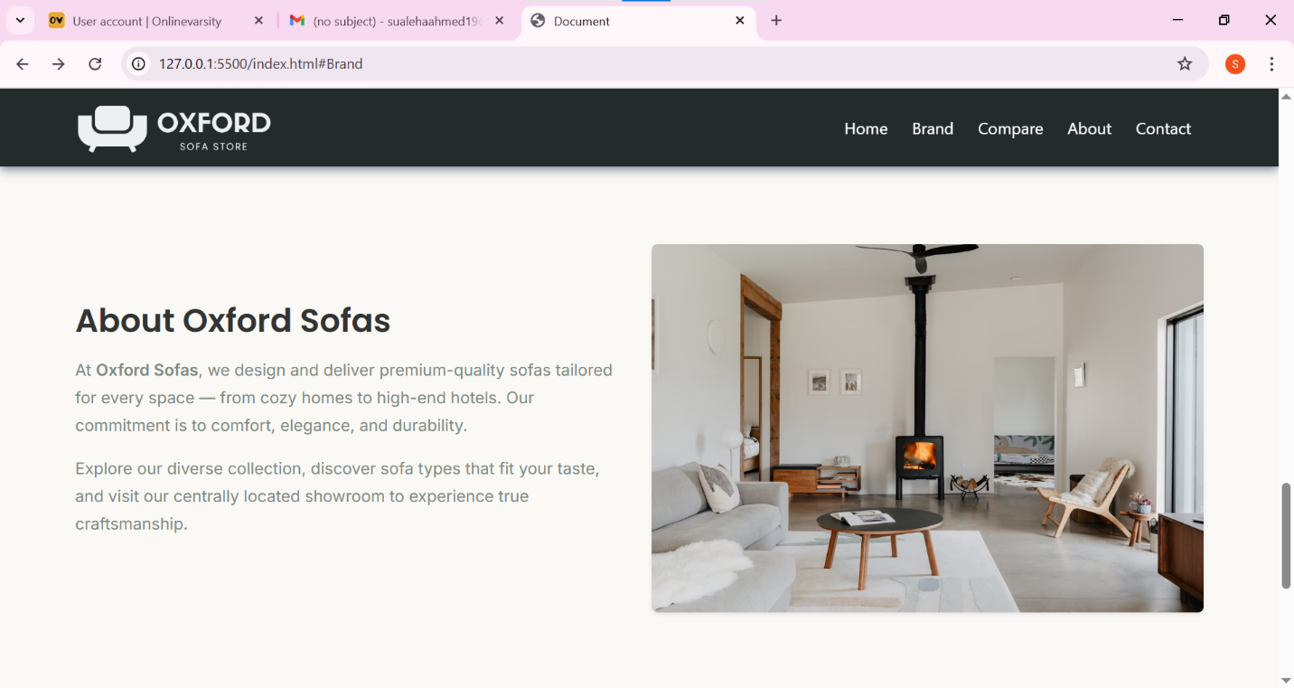

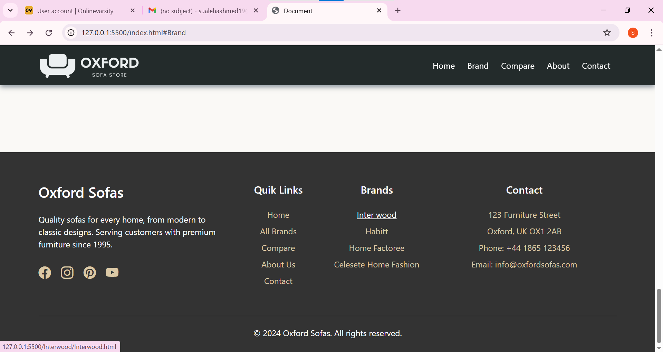

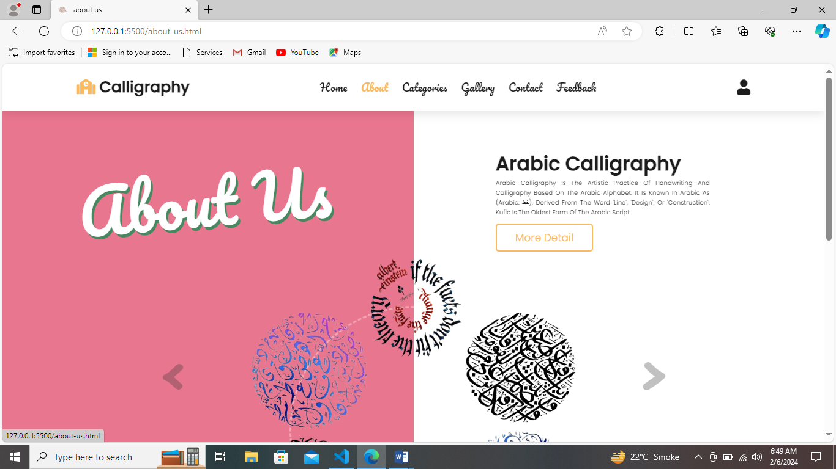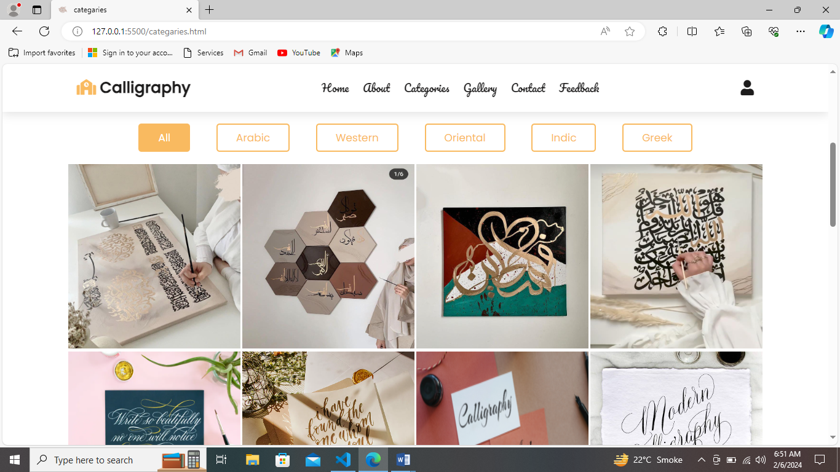**Habitt Brand Page**

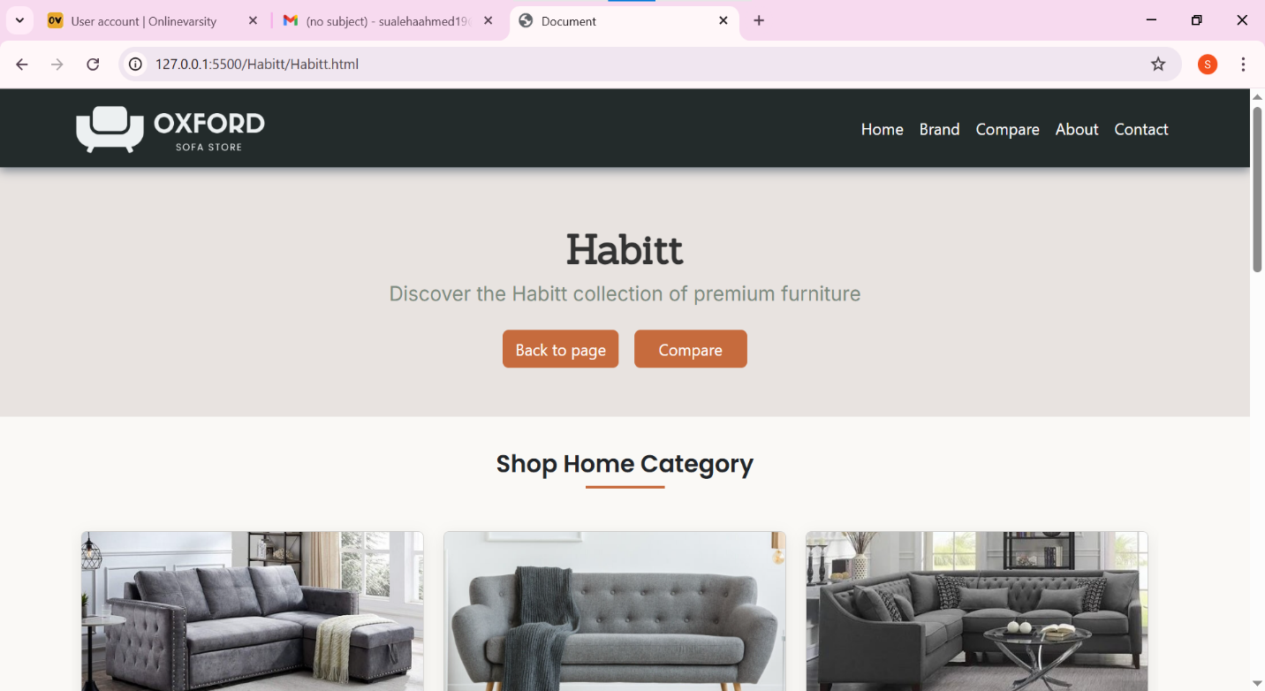

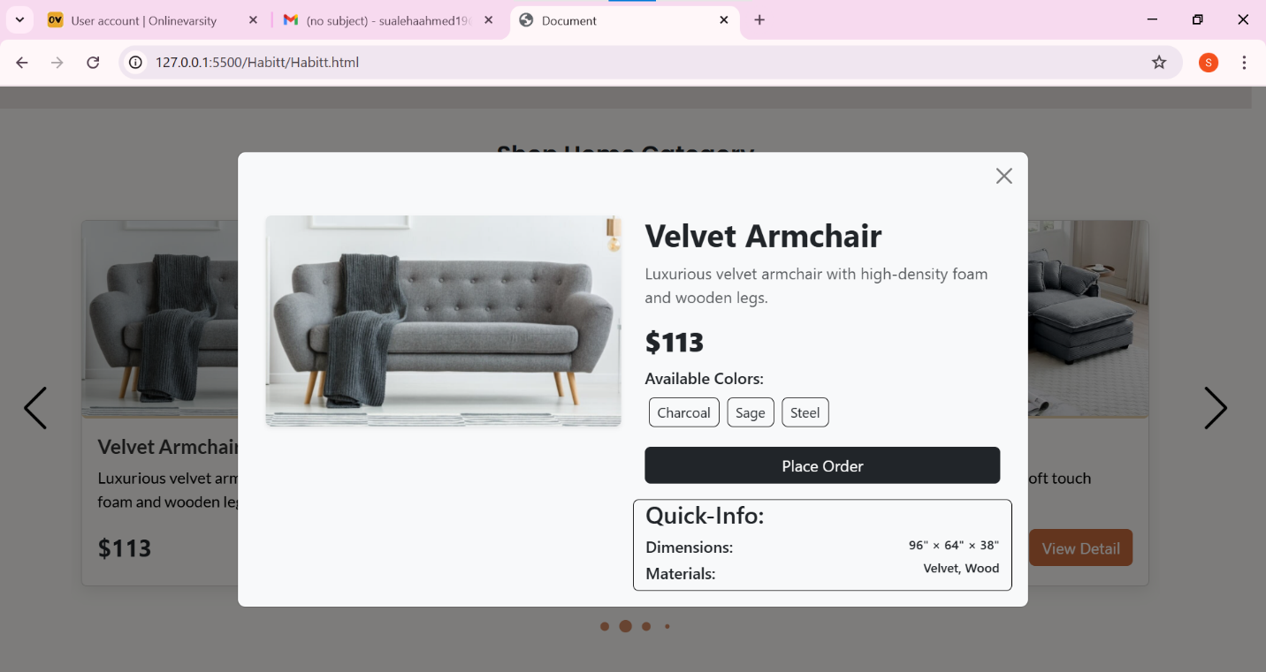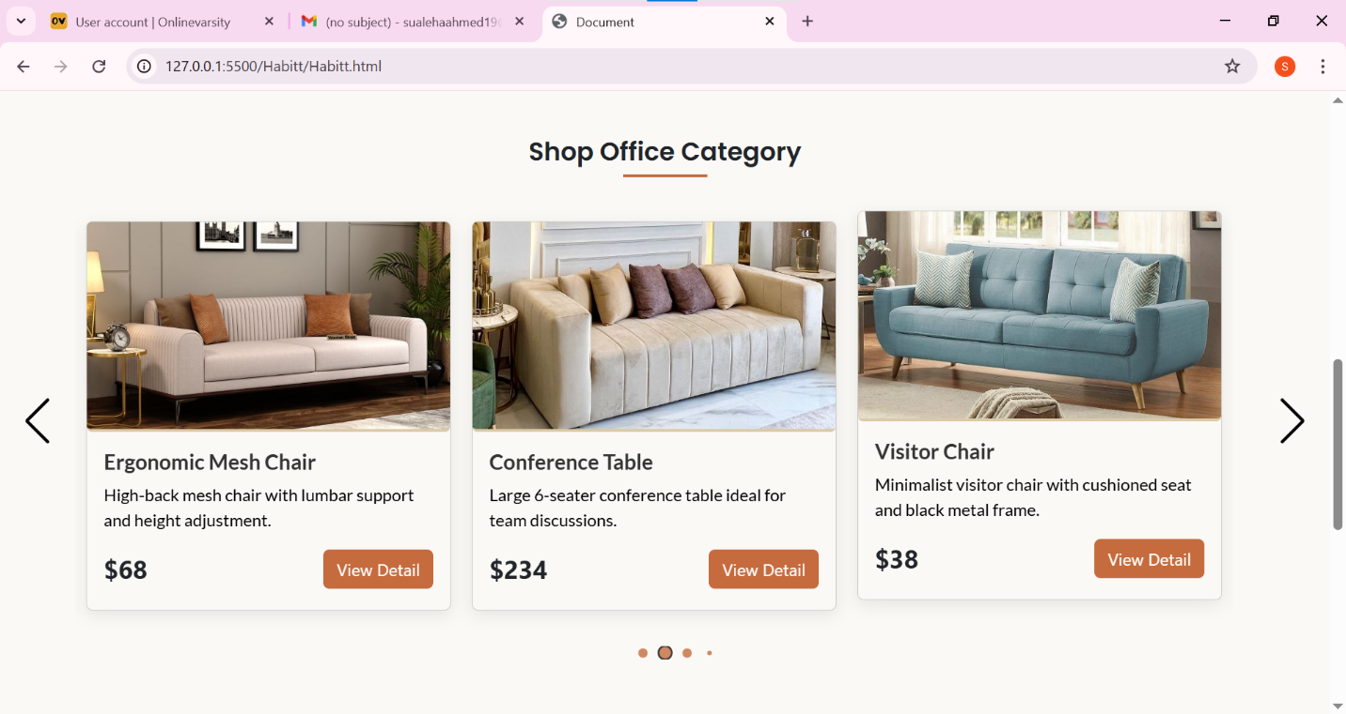

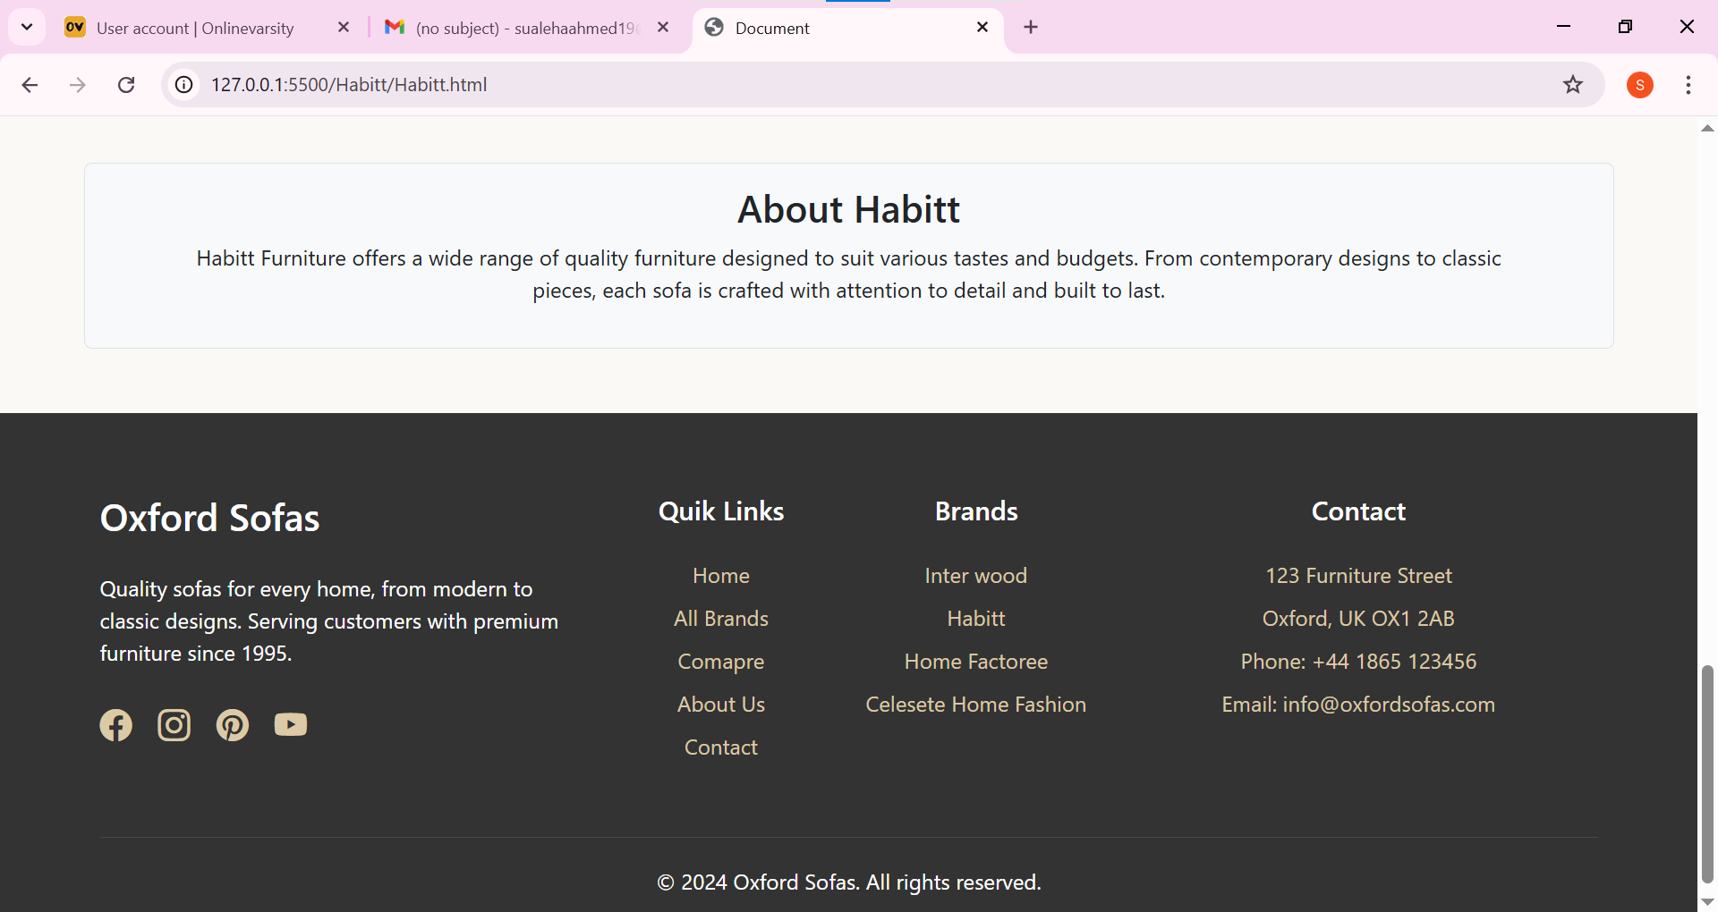

Compare Page

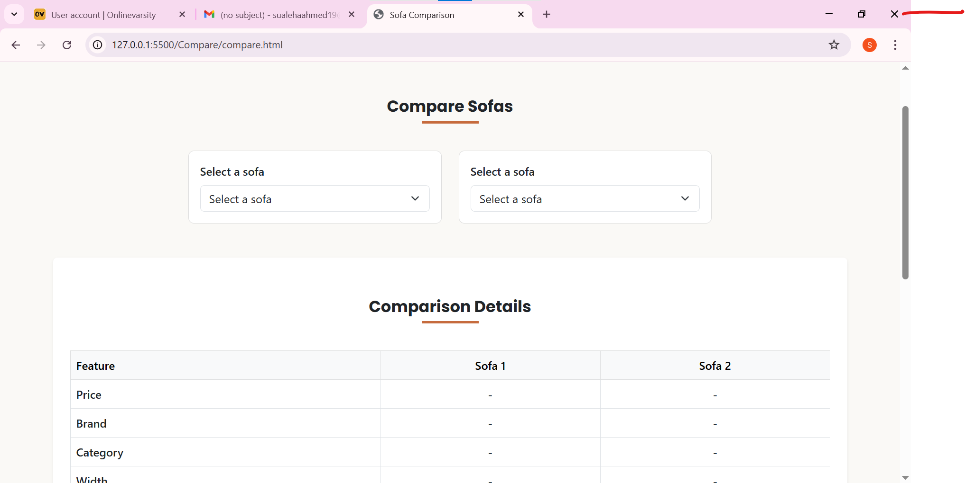

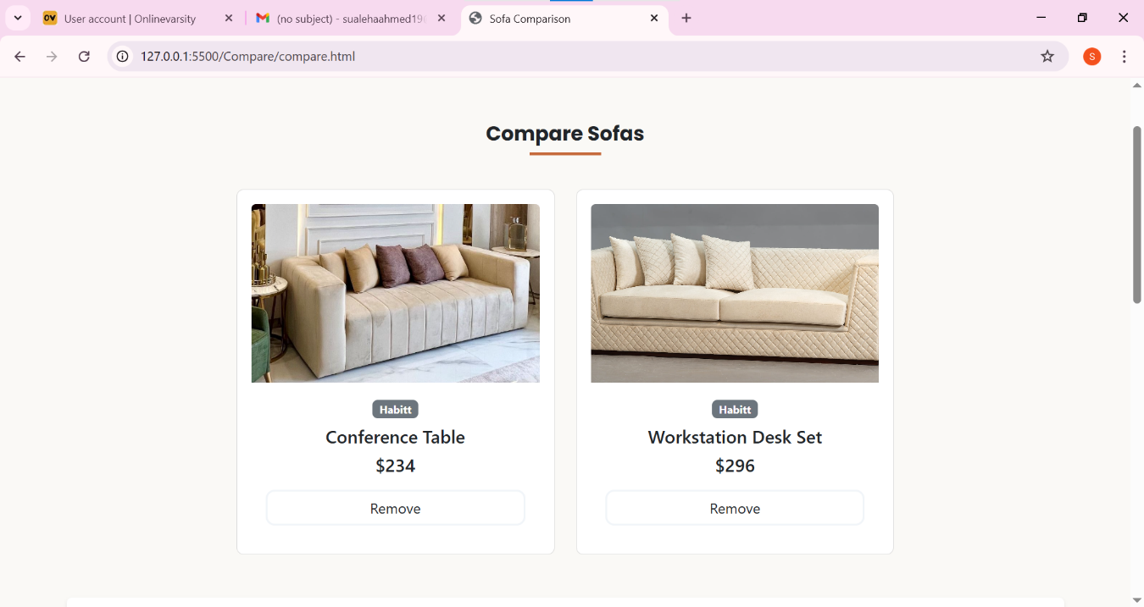

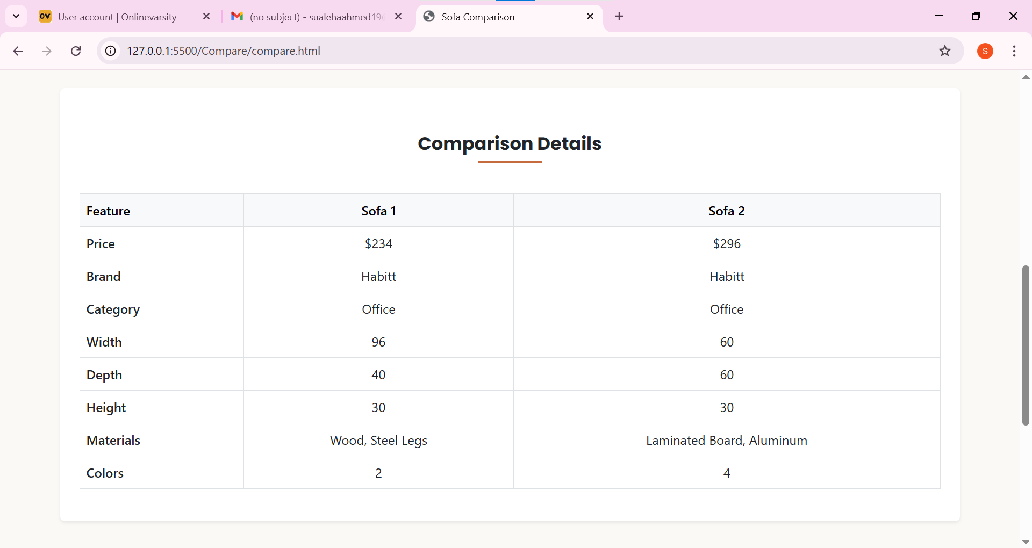

**Contact Page**

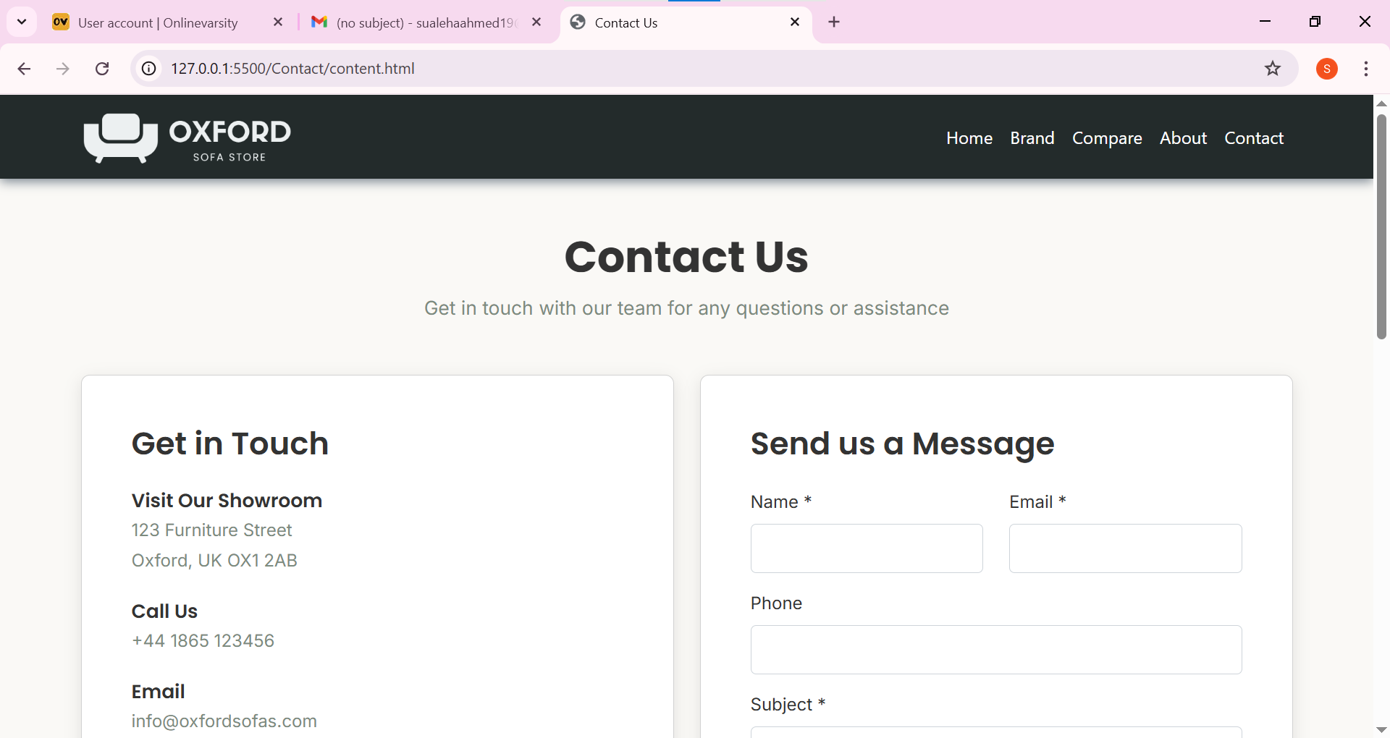

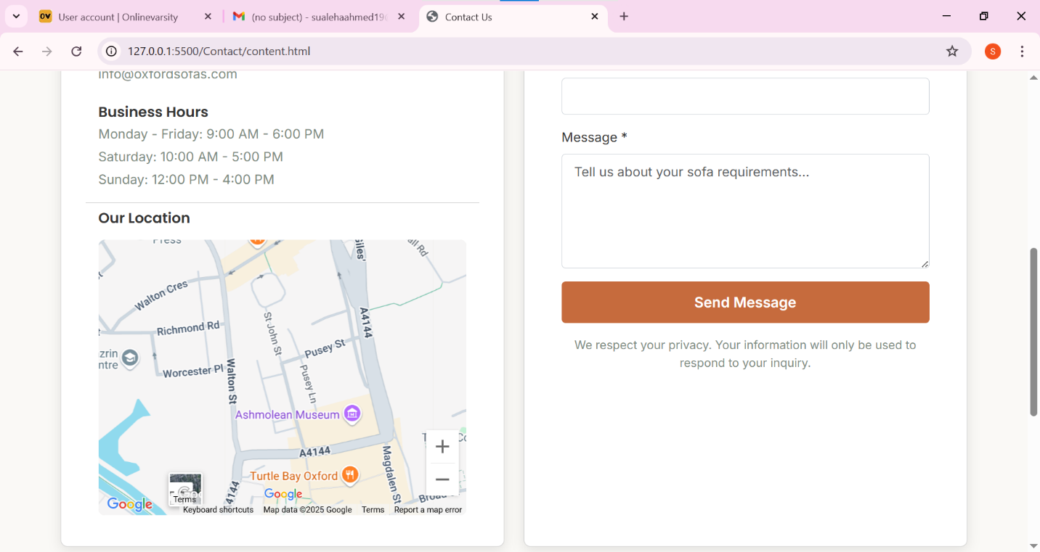

**Source Code**

<!DOCTYPE html>

<html lang="en">

<head>

    <meta charset="UTF-8">

    <meta name="viewport" content="width=device-width, initial-scale=1.0">

    <title>Document</title>

    <!-- BootStrap Links -->

    <link href="https://cdn.jsdelivr.net/npm/bootstrap@5.3.6/dist/css/bootstrap.min.css" rel="stylesheet">

    <link rel="stylesheet" href="https://cdn.jsdelivr.net/npm/bootstrap-icons@1.10.0/font/bootstrap-icons.css">

    <!-- Custom CSS -->

    <link href="https://cdn.jsdelivr.net/npm/aos@2.3.4/dist/aos.css" rel="stylesheet">

    <link href="https://unpkg.com/aos@2.3.1/dist/aos.css" rel="stylesheet">

    <link rel="stylesheet" href="style.css">

    <link rel="stylesheet" href="media.css">

</head>

<body>

    <!-- ====================================================================================================

                                                    NAVIGATION

    ======================================================================================================-->

    <nav class="navbar navbar-expand-lg navbar-dark fixed-top" aria-label="Offcanvas navbar large">

        <div class="container">

            <div class="d-flex justify-content-between align-items-center mx-auto" style="width: 100%;">

                <!-- Logo -->

                <a href="#" class="nav-logo">

                    <img src="Images/Logo.png" alt="logo" class="img-fluid">

                </a>

                <!-- Toggle Button -->

                <button class="navbar-toggler border-0 fs-3" type="button" data-bs-toggle="offcanvas"

                    data-bs-target="#offcanvasNavbar2" aria-controls="offcanvasNavbar2" aria-label="Toggle navigation">

                    <span class="navbar-toggler-icon"></span>

                </button>

            </div>

            <div class="side-bar offcanvas offcanvas-end" tabindex="-1" id="offcanvasNavbar2"

                aria-labelledby="offcanvasNavbar2Label">

                <!-- OffCanvas Header -->

                <div class="offcanvas-header border-bottom">

                    <img class="" src="Images/logo.png" alt="Logo" width="60%">

                    <button type="button" class="btn-close btn-close-white fs-5" data-bs-dismiss="offcanvas"

                        aria-label="Close"></button>

                </div>

                <!-- OffCanvas Body -->

                <div class="offcanvas-body d-flex justify-content-center">

                    <ul

                        class="navbar-nav justify-content-center justify-content-lg-end align-items-center flex-grow-1 ">

                        <li class="nav-item mx-1">

                            <a class="nav-link" aria-current="page" href="#Banner">Home</a>

                        </li>

                        <li class="nav-item mx-1">

                            <a class="nav-link" href="#Brand">Brand</a>

                        </li>

                        <li class="nav-item mx-1">

                            <a class="nav-link" href="Compare/compare.html">Compare</a>

                        </li>

                        <li class="nav-item mx-1">

                            <a class="nav-link" href="#About-Us">About</a>

                        </li>

                        <li class="nav-item mx-1">

                            <a class="nav-link" href="Contact/content.html">Contact</a>

                        </li>

                    </ul>

                </div>

            </div>

        </div>

    </nav>

    <!-- ====================================================================================================

                                                    HEADER

    ======================================================================================================-->

    <header>

        <section id="Banner" class="carousel-container">

            <div id="sofaCarousel" class="carousel slide" data-bs-ride="carousel">

                <div class="carousel-indicators">

                    <button type="button" data-bs-target="#sofaCarousel" data-bs-slide-to="0" class="active"

                        aria-current="true" aria-label="Slide 1"></button>

                    <button type="button" data-bs-target="#sofaCarousel" data-bs-slide-to="1"

                        aria-label="Slide 2"></button>

                    <button type="button" data-bs-target="#sofaCarousel" data-bs-slide-to="2"

                        aria-label="Slide 3"></button>

                </div>

                <div class="carousel-inner">

                    <!-- Slide 1 -->

                    <div class="carousel-item active"

                        style="background-image: url('https://images.unsplash.com/photo-1493663284031-b7e3aefcae8e?ixlib=rb-4.0.3&ixid=M3wxMjA3fDB8MHxwaG90by1wYWdlfHx8fGVufDB8fHx8fA%3D%3D&auto=format&fit=crop&w=1770&q=80');">

                        <div class="carousel-overlay"></div>

                        <div class="carousel-caption text-center">

                            <h1 class="carousel-title" data-aos="fade-right" data-aos-duration="800">

                                Elegant Comfort for Your Living Space

                            </h1>

                            <p class="carousel-description" data-aos="fade-right" data-aos-duration="800"

                                data-aos-delay="200">

                                Experience unparalleled luxury with our premium sofa collection, handcrafted for style

                                and

                                comfort that lasts for years.

                            </p>

                            <a href="#Featured-Sofas" class="btn btn-banner" data-aos="fade-right" data-aos-duration="800"

                                data-aos-delay="400">

                                Explore Collection

                            </a>

                        </div>

                    </div>

                    <!-- Slide 2 -->

                    <div class="carousel-item"

                        style="background-image: url('https://images.unsplash.com/photo-1555041469-a586c61ea9bc?ixlib=rb-4.0.3&ixid=M3wxMjA3fDB8MHxwaG90by1wYWdlfHx8fGVufDB8fHx8fA%3D%3D&auto=format&fit=crop&w=1770&q=80');">

                        <div class="carousel-overlay"></div>

                        <div class="carousel-caption text-center">

                            <h1 class="carousel-title">

                                Modern Designs for Contemporary Homes

                            </h1>

                            <p class="carousel-description">

                                Discover our range of modern sofas that combine sleek aesthetics with ergonomic design

                                for

                                the perfect living experience.

                            </p>

                        </div>

                    </div>

                    <!-- Slide 3 -->

                    <div class="carousel-item"

                        style="background-image: url('https://images.unsplash.com/photo-1540574163026-643ea20ade25?ixlib=rb-4.0.3&ixid=M3wxMjA3fDB8MHxwaG90by1wYWdlfHx8fGVufDB8fHx8fA%3D%3D&auto=format&fit=crop&w=1770&q=80');">

                        <div class="carousel-overlay"></div>

                        <div class="carousel-caption text-center">

                            <h1 class="carousel-title">

                                Premium Quality, Sustainable Materials

                            </h1>

                            <p class="carousel-description">

                                Crafted with eco-friendly materials and sustainable practices, our sofas are as kind to

                                the

                                environment as they are comfortable.

                            </p>

                        </div>

                    </div>

                </div>

                <button class="carousel-control-prev" type="button" data-bs-target="#sofaCarousel" data-bs-slide="prev">

                    <span class="carousel-control-prev-icon" aria-hidden="true"></span>

                    <span class="visually-hidden">Previous</span>

                </button>

                <button class="carousel-control-next" type="button" data-bs-target="#sofaCarousel" data-bs-slide="next">

                    <span class="carousel-control-next-icon" aria-hidden="true"></span>

                    <span class="visually-hidden">Next</span>

                </button>

            </div>

        </section>

    </header>

    <!-- ====================================================================================================

                                                    Main

    ======================================================================================================-->

    <main>

        <!-- ====================================== Brand Cards =============================================== -->

        <section id="Brand" class="pb-5 bg-light">

            <div class="container py-5">

                <h2 class="section-title mb-5">Shop by brands</h2>

                <div class="row">

                    <!-- INTERWOOD -->

                    <div class="col-lg-3 mb-3 mb-lg-0">

                        <a href="Habitt/Habitt.html" class="text-decoration-none">

                            <div class="brand-card text-center">

                                <div class="brand-logo">

                                    <img src="Images/Brands Logo/Habitt.png" alt="Interwood Logo"

                                        class="img-fluid brand-img">

                                </div>

                            </div>

                        </a>

                    </div>

                    <!-- HABITT -->

                    <div class="col-lg-3 mb-3 mb-lg-0">

                        <a href="Interwood/Interwood.html" class="text-decoration-none">

                            <div class="brand-card text-center">

                                <div class="brand-logo">

                                    <img src="Images/Brands Logo/Interwood.png" alt="Interwood Logo"

                                        class="img-fluid brand-img" style="margin-top: 35px;">

                                </div>

                            </div>

                        </a>

                    </div>

                    <!-- Home Fashion -->

                    <div class="col-lg-3 mb-3 mb-lg-0">

                        <a href="Home Fashion/Home Fashion.html" class="text-decoration-none">

                            <div class="brand-card text-center">

                                <div class="brand-logo">

                                    <img src="Images/Brands Logo/Home  fashion.png" alt="Interwood Logo"

                                        class="img-fluid brand-img mt-3">

                                </div>

                            </div>

                        </a>

                    </div>

                    <!-- Home Factree -->

                    <div class="col-lg-3 mb-3 mb-lg-0">

                        <a href="Home Factree/Home Facree.html" class="text-decoration-none">

                            <div class="brand-card text-center">

                                <div class="brand-logo">

                                    <img src="Images/Brands Logo/HomeFactree.png" alt="Interwood Logo"

                                        class="img-fluid brand-img">

                                </div>

                            </div>

                        </a>

                    </div>

                </div>

            </div>

        </section>

        <!-- ====================================== Featured Sofas =============================================== -->

        <section id="Featured-Sofas">

            <div class="container-fluid">

                <h2 class="section-title">Featured Sofa</h2>

                <!-- Filter Button -->

                 <div class="text-center mb-2">

                    <button class="btn btn-outline-dark mb-3 mx-1 filter-btn" data-brand="all">All</button>

                    <button class="btn btn-outline-dark mb-3 mx-1 filter-btn" data-brand="InterWood">Interwood</button>

                    <button class="btn btn-outline-dark mb-3 mx-1 filter-btn" data-brand="Home Factree">HomeFactree</button>

                    <button class="btn btn-outline-dark mb-3 mx-1 filter-btn" data-brand="Home Fashion">Home Fashion</button>

                    <button class="btn btn-outline-dark mb-3 mx-1 filter-btn" data-brand="Habitt">Habitt</button>

                 </div>

                <!-- Crads Container -->

                <div class="cards-container d-flex justify-content-center flex-wrap">

                    <!-- Cards Injected by JavaSript -->

                </div>

                <!-- <button class="btn btn-primary loadmore"></button> -->

                <div class="modal-container">

                    <!-- Modals injected by Javascript-->

                </div>

        </section>

        <!-- ====================================== Featured Section =============================================== -->

        <section id="features" class="pt-5 bg-light">

            <div class="container py-5">

                <h2 class="section-title mb-5">Why Choose Oxford Sofas</h2>

                <div class="row">

                    <div class="col-lg-4 mb-4">

                        <div class="feature-card">

                            <div class="feature-icon">

                                <i class="bi bi-people"></i>

                            </div>

                            <h3>Custom Craftsmanship</h3>

                            <p>Each sofa is handcrafted to order by our skilled artisans. Choose from hundreds of

                                fabrics

                                and customization options.</p>

                        </div>

                    </div>

                    <div class="col-lg-4 mb-4">

                        <div class="feature-card">

                            <div class="feature-icon">

                                <i class="bi bi-hand-thumbs-up"></i>

                            </div>

                            <h3>Premium Quality</h3>

                            <p>We use only the finest materials - sustainably sourced hardwoods, top-grain leathers, and

                                durable fabrics that stand the test of time.</p>

                        </div>

                    </div>

                    <div class="col-lg-4 mb-4">

                        <div class="feature-card">

                            <div class="feature-icon">

                                <i class="bi bi-truck"></i>

                            </div>

                            <h3>White Glove Delivery</h3>

                            <p>Our delivery team carefully brings your sofa to the room of your choice, assembles it,

                                and

                                removes all packaging materials.</p>

                        </div>

                    </div>

                </div>

            </div>

        </section>

        <!-- ====================================== About US =============================================== -->

        <section id="About-Us" class="about-us-section py-5">

            <div class="container py-5">

                <div class="row align-items-center py-5">

                    <!-- Text Content -->

                    <div class="col-lg-6 mb-4 mb-lg-0">

                        <h2 class="mb-3"

                            style="color: var(--primary-color); font-family: var(--font-heading); font-weight: 600;">

                            About Oxford Sofas

                        </h2>

                        <p style="color: var(--Secondry-Color); font-family: var(--font-body); line-height: 1.7;">

                            At <strong>Oxford Sofas</strong>, we design and deliver premium-quality sofas tailored for

                            every

                            space — from cozy homes to high-end hotels. Our commitment is to comfort, elegance, and

                            durability.

                        </p>

                        <p style="color: var(--Secondry-Color); font-family: var(--font-body); line-height: 1.7;">

                            Explore our diverse collection, discover sofa types that fit your taste, and visit our

                            centrally

                            located showroom to experience true craftsmanship.

                        </p>

                    </div>

                    <!-- Image -->

                    <div class="col-lg-6">

                        <img src="https://images.unsplash.com/photo-1712927172789-0efc8d22dedb?q=80&w=1171&auto=format&fit=crop&ixlib=rb-4.1.0&ixid=M3wxMjA3fDB8MHxwaG90by1wYWdlfHx8fGVufDB8fHx8fA%3D%3D"

                            alt="About Oxford Sofas" class="img-fluid rounded shadow-sm"

                            style="max-height: 400px; object-fit: cover; width: 100%;">

                    </div>

                </div>

            </div>

        </section>

    </main>

    <!-- ====================================================================================================

                                                    FOOTER

    ======================================================================================================-->

    <footer class="footer">

        <div class="container">

            <div class="row">

                <div class="col-lg-4 mb-5 mb-lg-0">

                    <h3 class="mb-4">Oxford Sofas</h3>

                    <p>Quality sofas for every home, from modern to classic designs. Serving customers with premium

                        furniture since 1995. </p>

                    <div class="mt-4">

                        <a href="#" class="social-icon"><i class="bi bi-facebook"></i></a>

                        <a href="#" class="social-icon"><i class="bi bi-instagram"></i></a>

                        <a href="#" class="social-icon"><i class="bi bi-pinterest"></i></a>

                        <a href="#" class="social-icon"><i class="bi bi-youtube"></i></a>

                    </div>

                </div>

                <div class="col-lg-2  mb-5 mb-md-0 text-start text-lg-center">

                    <h5 class="mb-4">Quik Links</h5>

                    <ul class="list-unstyled">

                        <li class="mb-2"><a href="index.html">Home</a></li>

                        <li class="mb-2"><a href="#Brand">All Brands</a></li>

                        <li class="mb-2"><a href="Compare/compare.html">Compare</a></li>

                        <li class="mb-2"><a href="#About-Us">About Us</a></li>

                        <li class="mb-2"><a href="Contact/content.html">Contact</a></li>

                    </ul>

                </div>

                <div class="col-lg-2  mb-5 mb-md-0 text-start text-lg-center">

                    <h5 class="mb-4">Brands</h5>

                    <ul class="list-unstyled">

                        <li class="mb-2"><a href="Interwood/Interwood.html">Inter wood</a></li>

                        <li class="mb-2"><a href="Habitt/Habitt.html">Habitt</a></li>

                        <li class="mb-2"><a href="Home Factree/Home Facree.html">Home Factoree</a></li>

                        <li class="mb-2"><a href="Home Fashion/Home Fashion.html">Celesete Home Fashion</a>

                    </ul>

                </div>

                <div class="col-lg-4 text-start text-lg-center">

                    <h5 class="mb-4">Contact</h5>

                    <ul class="list-unstyled">

                        <li class="mb-2">123 Furniture Street</li>

                        <li class="mb-2">Oxford, UK OX1 2AB</li>

                        <li class="mb-2">Phone: +44 1865 123456</li>

                        <li class="mb-2">Email: info@oxfordsofas.com</li>

                    </ul>

                </div>

            </div>

            <div class="copyright text-center">

                <p>© 2024 Oxford Sofas. All rights reserved.</p>

            </div>

        </div>

    </footer>

    <!-- ====================================================================================================

                                                SCRIPTING SECTION

    ======================================================================================================-->

    <script src="script.js"></script>

    <script src="https://cdn.jsdelivr.net/npm/bootstrap@5.3.6/dist/js/bootstrap.bundle.min.js" integrity="sha384-j1CDi7MgGQ12Z7Qab0qlWQ/Qqz24Gc6BM0thvEMVjHnfYGF0rmFCozFSxQBxwHKO" crossorigin="anonymous"></script>

    <script src="https://unpkg.com/aos@2.3.1/dist/aos.js"></script>

    <script src="animation.js"></script>

</body>

</html>

<!DOCTYPE html>

<html lang="en">

<head>

    <meta charset="UTF-8">

    <meta name="viewport" content="width=device-width, initial-scale=1.0">

    <title>Document</title>

    <!-- Bootstrap -->

    <link href="https://cdn.jsdelivr.net/npm/bootstrap@5.3.6/dist/css/bootstrap.min.css" rel="stylesheet">

    <link rel="stylesheet" href="https://cdn.jsdelivr.net/npm/bootstrap-icons@1.10.0/font/bootstrap-icons.css">

    <!-- Custom CSS -->

     <link rel="stylesheet" href="https://cdn.jsdelivr.net/npm/swiper@11/swiper-bundle.min.css">

     <link rel="stylesheet" href="styel.css">

</head>

<body>

    <!-- ====================================================================================================

                                                NAVIGATION BAR

    ======================================================================================================-->

    <nav class="navbar navbar-expand-lg navbar-dark" aria-label="Offcanvas navbar large">

        <div class="container">

            <div class="d-flex justify-content-between align-items-center mx-auto" style="width: 100%;">

                <!-- Logo -->

                <a href="#" class="nav-logo">

                    <img src="Images/Logo.png" alt="logo" class="img-fluid">

                </a>

                <!-- Toggle Button -->

                <button class="navbar-toggler border-0 fs-3" type="button" data-bs-toggle="offcanvas"

                    data-bs-target="#offcanvasNavbar2" aria-controls="offcanvasNavbar2" aria-label="Toggle navigation">

                    <span class="navbar-toggler-icon"></span>

                </button>

            </div>

            <div class="side-bar offcanvas offcanvas-end" tabindex="-1" id="offcanvasNavbar2"

                aria-labelledby="offcanvasNavbar2Label">

                <!-- OffCanvas Header -->

                <div class="offcanvas-header border-bottom">

                    <img class="" src="Images/logo.png" alt="Logo" width="60%">

                    <button type="button" class="btn-close btn-close-white fs-5" data-bs-dismiss="offcanvas"

                        aria-label="Close"></button>

                </div>

                <!-- OffCanvas Body -->

                <div class="offcanvas-body d-flex justify-content-center">

                    <ul

                        class="navbar-nav justify-content-center justify-content-lg-end align-items-center flex-grow-1 ">

                        <li class="nav-item ">

                            <a class="nav-link" aria-current="page" href="../index.html">Home</a>

                        </li>

                        <li class="nav-item ">

                            <a class="nav-link" href="../index.html#Brand">Brand</a>

                        </li>

                        <li class="nav-item ">

                            <a class="nav-link" href="../Compare/compare.html">Compare</a>

                        </li>

                        <li class="nav-item ">

                            <a class="nav-link" href="../index.html#About-Us">About</a>

                        </li>

                        <li class="nav-item ">

                            <a class="nav-link" href="../Contact/content.html">Contact</a>

                        </li>

                    </ul>

                </div>

            </div>

        </div>

    </nav>

    <!-- ====================================================================================================

                                                    HEADER

    ======================================================================================================-->

    <header>

        <div class="container-fluid py-5 py-md-5 head">

            <h1 class="text-center my-2">Habitt</h1>

            <h5 class="text-center my-2">Discover the Habitt collection of premium furniture</h5>

            <div class="d-flex justify-content-center mt-4">

              <a href="../index.html#Brand" class="btn mx-2" style="background-color: var(--cta); color: white;">Back to page</a>

              <a href="../Compare/compare.html" class="btn mx-2 px-4"  style="background-color: var(--cta); color: white;">Compare</a>

            </div>

        </div>

    </header>

    <!-- ====================================================================================================

                                                    CARDS

    ======================================================================================================-->

    <section id="Featured-Sofas">

        <div class="container-fluid">

            <!-- Home Container -->

            <div>

                <h4 class="section-title">Shop Home Category</h4>

                <div class="swiper ">

                    <div class="card-wrapper home-swiper">

                        <div class="swiper-wrapper cards-container" id="home-cards-container"></div>

                        <div class="swiper-button-prev home-prev"></div>

                        <div class="swiper-button-next home-next"></div>

                        <div class="swiper-pagination home-pagination"></div>

                    </div>

                </div>

            </div>

            <!-- Office Container -->

            <div class="mt-5">

                <h4 class="section-title">Shop Office Category</h4>

                <div class="swiper">

                    <div class="card-wrapper office-swiper">

                        <div class="swiper-wrapper cards-container" id="office-cards-container">

                            <!-- Cards Injected By JavaScript -->

                        </div>

                        <!-- Slider Functions -->

                        <div class="swiper-button-prev office-prev"></div>

                        <div class="swiper-button-next office-next"></div>

                        <div class="swiper-pagination office-pagination"></div>

                    </div>

                </div>

            </div>

            <!-- Modals Section -->

            <div class="modal-container">

                <!-- Modal injected by JavaScript -->

            </div>

    </section>

    <!-- ====================================================================================================

                                                About Company

    ======================================================================================================-->

    <section>

        <div class="container bg-light border rounded my-3 my-lg-5 py-3">

            <h3 class="text-center mx-1 mx-lg-5">About Habitt</h3>

            <p class="text-center mx-1 mx-lg-5">Habitt Furniture offers a wide range of quality furniture designed to suit various tastes and budgets. From contemporary designs to classic pieces, each sofa is crafted with attention to detail and built to last.</p>

        </div>

    </section>

    <!-- ====================================================================================================

                                                    Footer

    ======================================================================================================-->

    <footer class="footer">

        <div class="container">

            <div class="row">

                <div class="col-lg-4 mb-5 mb-lg-0">

                    <h3 class="mb-4">Oxford Sofas</h3>

                    <p>Quality sofas for every home, from modern to classic designs. Serving customers with premium

                        furniture since 1995. </p>

                    <div class="mt-4">

                        <a href="#" class="social-icon"><i class="bi bi-facebook"></i></a>

                        <a href="#" class="social-icon"><i class="bi bi-instagram"></i></a>

                        <a href="#" class="social-icon"><i class="bi bi-pinterest"></i></a>

                        <a href="#" class="social-icon"><i class="bi bi-youtube"></i></a>

                    </div>

                </div>

                <div class="col-lg-2  mb-5 mb-md-0 text-start text-lg-center">

                    <h5 class="mb-4">Quik Links</h5>

                    <ul class="list-unstyled">

                        <li class="mb-2"><a href="../index.html">Home</a></li>

                        <li class="mb-2"><a href="../index.html#Brand">All Brands</a></li>

                        <li class="mb-2"><a href="../Compare/compare.html">Comapre</a></li>

                        <li class="mb-2"><a href="../index.html#About-Us">About Us</a></li>

                        <li class="mb-2"><a href="../Contact/content.html">Contact</a></li>

                    </ul>

                </div>

                <div class="col-lg-2  mb-5 mb-md-0 text-start text-lg-center">

                    <h5 class="mb-4">Brands</h5>

                    <ul class="list-unstyled">

                        <li class="mb-2"><a href="../Interwood/Interwood.html">Inter wood</a></li>

                        <li class="mb-2"><a href="../Habitt/Habitt.html">Habitt</a></li>

                        <li class="mb-2"><a href="../Home Factree/Home Facree.html">Home Factoree</a></li>

                        <li class="mb-2"><a href="../Home Fashion/Home Fashion.html">Celesete Home Fashion</a>

                    </ul>

                </div>

                <div class="col-lg-4 text-start text-lg-center">

                    <h5 class="mb-4">Contact</h5>

                    <ul class="list-unstyled">

                        <li class="mb-2">123 Furniture Street</li>

                        <li class="mb-2">Oxford, UK OX1 2AB</li>

                        <li class="mb-2">Phone: +44 1865 123456</li>

                        <li class="mb-2">Email: info@oxfordsofas.com</li>

                    </ul>

                </div>

            </div>

            <div class="copyright text-center">

                <p>© 2024 Oxford Sofas. All rights reserved.</p>

            </div>

        </div>

    </footer>

    <!-- JavaScript -->

    <script src="https://cdn.jsdelivr.net/npm/bootstrap@5.3.6/dist/js/bootstrap.bundle.min.js" integrity="sha384-j1CDi7MgGQ12Z7Qab0qlWQ/Qqz24Gc6BM0thvEMVjHnfYGF0rmFCozFSxQBxwHKO" crossorigin="anonymous"></script>

    <script src="https://cdn.jsdelivr.net/npm/swiper@11/swiper-bundle.min.js"></script>

    <script type="module" src="script.js"></script>

</body>

</html>

<!DOCTYPE html>

<html lang="en">

<head>

    <meta charset="UTF-8">

    <meta name="viewport" content="width=device-width, initial-scale=1.0">

    <title>Document</title>

    <!-- Bootstrap -->

    <link href="https://cdn.jsdelivr.net/npm/bootstrap@5.3.6/dist/css/bootstrap.min.css" rel="stylesheet">

    <link rel="stylesheet" href="https://cdn.jsdelivr.net/npm/bootstrap-icons@1.10.0/font/bootstrap-icons.css">

    <!-- Custom CSS -->

     <link rel="stylesheet" href="https://cdn.jsdelivr.net/npm/swiper@11/swiper-bundle.min.css">

     <link rel="stylesheet" href="styel.css">

</head>

<body>

    <!-- ====================================================================================================

                                                NAVIGATION BAR

    ======================================================================================================-->

    <nav class="navbar navbar-expand-lg navbar-dark" aria-label="Offcanvas navbar large">

        <div class="container">

            <div class="d-flex justify-content-between align-items-center mx-auto" style="width: 100%;">

                <!-- Logo -->

                <a href="#" class="nav-logo">

                    <img src="Images/Logo.png" alt="logo" class="img-fluid">

                </a>

                <!-- Toggle Button -->

                <button class="navbar-toggler border-0 fs-3" type="button" data-bs-toggle="offcanvas"

                    data-bs-target="#offcanvasNavbar2" aria-controls="offcanvasNavbar2" aria-label="Toggle navigation">

                    <span class="navbar-toggler-icon"></span>

                </button>

            </div>

            <div class="side-bar offcanvas offcanvas-end" tabindex="-1" id="offcanvasNavbar2"

                aria-labelledby="offcanvasNavbar2Label">

                <!-- OffCanvas Header -->

                <div class="offcanvas-header border-bottom">

                    <img class="" src="Images/logo.png" alt="Logo" width="60%">

                    <button type="button" class="btn-close btn-close-white fs-5" data-bs-dismiss="offcanvas"

                        aria-label="Close"></button>

                </div>

                <!-- OffCanvas Body -->

                <div class="offcanvas-body d-flex justify-content-center">

                    <ul

                        class="navbar-nav justify-content-center justify-content-lg-end align-items-center flex-grow-1 ">

                        <li class="nav-item ">

                            <a class="nav-link" aria-current="page" href="../index.html">Home</a>

                        </li>

                        <li class="nav-item ">

                            <a class="nav-link" href="../index.html#Brand">Brand</a>

                        </li>

                        <li class="nav-item ">

                            <a class="nav-link" href="../Compare/compare.html">Compare</a>

                        </li>

                        <li class="nav-item ">

                            <a class="nav-link" href="../index.html#About-Us">About</a>

                        </li>

                        <li class="nav-item ">

                            <a class="nav-link" href="../Contact/content.html">Contact</a>

                        </li>

                    </ul>

                </div>

            </div>

        </div>

    </nav>

    <!-- ====================================================================================================

                                                    HEADER

    ======================================================================================================-->

    <header>

        <div class="container-fluid py-5 py-md-5 head">

            <h1 class="text-center my-2">Home Factree</h1>

            <h5 class="text-center my-2">Discover the Habitt collection of premium furniture</h5>

            <div class="d-flex justify-content-center mt-4">

              <a href="../index.html#Brand" class="btn mx-2" style="background-color: var(--cta); color: white;">Back to page</a>

              <a href="../Compare/compare.html" class="btn mx-2 px-4"  style="background-color: var(--cta); color: white;">Compare</a>

            </div>

        </div>

    </header>

    <!-- ====================================================================================================

                                                    CARDS

    ======================================================================================================-->

    <section id="Featured-Sofas">

        <div class="container-fluid">

            <!-- Home Container -->

            <div>

                <h4 class="section-title">Shop Home Category</h4>

                <div class="swiper ">

                    <div class="card-wrapper home-swiper">

                        <div class="swiper-wrapper cards-container" id="home-cards-container"></div>

                        <div class="swiper-button-prev home-prev"></div>

                        <div class="swiper-button-next home-next"></div>

                        <div class="swiper-pagination home-pagination"></div>

                    </div>

                </div>

            </div>

            <!-- Office Container -->

            <div class="mt-5">

                <h4 class="section-title">Shop Office Category</h4>

                <div class="swiper">

                    <div class="card-wrapper office-swiper">

                        <div class="swiper-wrapper cards-container" id="office-cards-container">

                            <!-- Cards Injected By JavaScript -->

                        </div>

                        <!-- Slider Functions -->

                        <div class="swiper-button-prev office-prev"></div>

                        <div class="swiper-button-next office-next"></div>

                        <div class="swiper-pagination office-pagination"></div>

                    </div>

                </div>

            </div>

            <!-- Modals Section -->

            <div class="modal-container">

                <!-- Modal injected by JavaScript -->

            </div>

    </section>

    <!-- ====================================================================================================

                                                About Company

    ======================================================================================================-->

    <section>

        <div class="container bg-light border rounded my-3 my-lg-5 py-3">

            <h3 class="text-center mx-1 mx-lg-5">Home Factree</h3>

            <p class="text-center mx-1 mx-lg-5">Habitt Furniture offers a wide range of quality furniture designed to suit various tastes and budgets. From contemporary designs to classic pieces, each sofa is crafted with attention to detail and built to last.</p>

        </div>

    </section>

    <!-- ====================================================================================================

                                                    Footer

    ======================================================================================================-->

    <footer class="footer">

        <div class="container">

            <div class="row">

                <div class="col-lg-4 mb-5 mb-lg-0">

                    <h3 class="mb-4">Oxford Sofas</h3>

                    <p>Quality sofas for every home, from modern to classic designs. Serving customers with premium

                        furniture since 1995. </p>

                    <div class="mt-4">

                        <a href="#" class="social-icon"><i class="bi bi-facebook"></i></a>

                        <a href="#" class="social-icon"><i class="bi bi-instagram"></i></a>

                        <a href="#" class="social-icon"><i class="bi bi-pinterest"></i></a>

                        <a href="#" class="social-icon"><i class="bi bi-youtube"></i></a>

                    </div>

                </div>

                <div class="col-lg-2  mb-5 mb-md-0 text-start text-lg-center">

                    <h5 class="mb-4">Quik Links</h5>

                    <ul class="list-unstyled">

                        <li class="mb-2"><a href="../index.html">Home</a></li>

                        <li class="mb-2"><a href="../index.html#Brand">All Brands</a></li>

                        <li class="mb-2"><a href="../Compare/compare.html">Comapre</a></li>

                        <li class="mb-2"><a href="../index.html#About-Us">About Us</a></li>

                        <li class="mb-2"><a href="../Contact/content.html">Contact</a></li>

                    </ul>

                </div>

                <div class="col-lg-2  mb-5 mb-md-0 text-start text-lg-center">

                    <h5 class="mb-4">Brands</h5>

                    <ul class="list-unstyled">

                        <li class="mb-2"><a href="../Interwood/Interwood.html">Inter wood</a></li>

                        <li class="mb-2"><a href="../Habitt/Habitt.html">Habitt</a></li>

                        <li class="mb-2"><a href="../Home Factree/Home Facree.html">Home Factoree</a></li>

                        <li class="mb-2"><a href="../Home Fashion/Home Fashion.html">Celesete Home Fashion</a>

                    </ul>

                </div>

                <div class="col-lg-4 text-start text-lg-center">

                    <h5 class="mb-4">Contact</h5>

                    <ul class="list-unstyled">

                        <li class="mb-2">123 Furniture Street</li>

                        <li class="mb-2">Oxford, UK OX1 2AB</li>

                        <li class="mb-2">Phone: +44 1865 123456</li>

                        <li class="mb-2">Email: info@oxfordsofas.com</li>

                    </ul>

                </div>

            </div>

            <div class="copyright text-center">

                <p>© 2024 Oxford Sofas. All rights reserved.</p>

            </div>

        </div>

    </footer>

    <!-- JavaScript -->

    <script src="https://cdn.jsdelivr.net/npm/bootstrap@5.3.6/dist/js/bootstrap.bundle.min.js" integrity="sha384-j1CDi7MgGQ12Z7Qab0qlWQ/Qqz24Gc6BM0thvEMVjHnfYGF0rmFCozFSxQBxwHKO" crossorigin="anonymous"></script>

    <script src="https://cdn.jsdelivr.net/npm/swiper@11/swiper-bundle.min.js"></script>

    <script type="module" src="script.js"></script>

</body>

</html>

<!DOCTYPE html>

<html lang="en">

<head>

    <meta charset="UTF-8">

    <meta name="viewport" content="width=device-width, initial-scale=1.0">

    <title>Document</title>

    <!-- Bootstrap -->

    <link href="https://cdn.jsdelivr.net/npm/bootstrap@5.3.6/dist/css/bootstrap.min.css" rel="stylesheet">

    <link rel="stylesheet" href="https://cdn.jsdelivr.net/npm/bootstrap-icons@1.10.0/font/bootstrap-icons.css">

    <!-- Custom CSS -->

     <link rel="stylesheet" href="https://cdn.jsdelivr.net/npm/swiper@11/swiper-bundle.min.css">

     <link rel="stylesheet" href="styel.css">

</head>

<body>

    <!-- ====================================================================================================

                                                NAVIGATION BAR

    ======================================================================================================-->

    <nav class="navbar navbar-expand-lg navbar-dark" aria-label="Offcanvas navbar large">

        <div class="container">

            <div class="d-flex justify-content-between align-items-center mx-auto" style="width: 100%;">

                <!-- Logo -->

                <a href="#" class="nav-logo">

                    <img src="Images/Logo.png" alt="logo" class="img-fluid">

                </a>

                <!-- Toggle Button -->

                <button class="navbar-toggler border-0 fs-3" type="button" data-bs-toggle="offcanvas"

                    data-bs-target="#offcanvasNavbar2" aria-controls="offcanvasNavbar2" aria-label="Toggle navigation">

                    <span class="navbar-toggler-icon"></span>

                </button>

            </div>

            <div class="side-bar offcanvas offcanvas-end" tabindex="-1" id="offcanvasNavbar2"

                aria-labelledby="offcanvasNavbar2Label">

                <!-- OffCanvas Header -->

                <div class="offcanvas-header border-bottom">

                    <img class="" src="Images/logo.png" alt="Logo" width="60%">

                    <button type="button" class="btn-close btn-close-white fs-5" data-bs-dismiss="offcanvas"

                        aria-label="Close"></button>

                </div>

                <!-- OffCanvas Body -->

                <div class="offcanvas-body d-flex justify-content-center">

                    <ul

                        class="navbar-nav justify-content-center justify-content-lg-end align-items-center flex-grow-1 ">

                        <li class="nav-item ">

                            <a class="nav-link" aria-current="page" href="../index.html">Home</a>

                        </li>

                        <li class="nav-item ">

                            <a class="nav-link" href="../index.html#Brand">Brand</a>

                        </li>

                        <li class="nav-item ">

                            <a class="nav-link" href="../Compare/compare.html">Compare</a>

                        </li>

                        <li class="nav-item ">

                            <a class="nav-link" href="../index.html#About-Us">About</a>

                        </li>

                        <li class="nav-item ">

                            <a class="nav-link" href="../Contact/content.html">Contact</a>

                        </li>

                    </ul>

                </div>

            </div>

        </div>

    </nav>

    <!-- ====================================================================================================

                                                    HEADER

    ======================================================================================================-->

    <header>

        <div class="container-fluid py-5 py-md-5 head">

            <h1 class="text-center my-2">Home Fashion</h1>

            <h5 class="text-center my-2">Discover the Home Fashion collection of premium furniture</h5>

            <div class="d-flex justify-content-center mt-4">

              <a href="../index.html#Brand" class="btn mx-2" style="background-color: var(--cta); color: white;">Back to page</a>

              <a href="../Compare/compare.html" class="btn mx-2 px-4"  style="background-color: var(--cta); color: white;">Compare</a>

            </div>

        </div>

    </header>

    <!-- ====================================================================================================

                                                    CARDS

    ======================================================================================================-->

    <section id="Featured-Sofas">

        <div class="container-fluid">

            <!-- Home Container -->

            <div>

                <h4 class="section-title">Shop Home Category</h4>

                <div class="swiper ">

                    <div class="card-wrapper home-swiper">

                        <div class="swiper-wrapper cards-container" id="home-cards-container"></div>

                        <div class="swiper-button-prev home-prev"></div>

                        <div class="swiper-button-next home-next"></div>

                        <div class="swiper-pagination home-pagination"></div>

                    </div>

                </div>

            </div>

            <!-- Office Container -->

            <div class="mt-5">

                <h4 class="section-title">Shop Office Category</h4>

                <div class="swiper">

                    <div class="card-wrapper office-swiper">

                        <div class="swiper-wrapper cards-container" id="office-cards-container">

                            <!-- Cards Injected By JavaScript -->

                        </div>

                        <!-- Slider Functions -->

                        <div class="swiper-button-prev office-prev"></div>

                        <div class="swiper-button-next office-next"></div>

                        <div class="swiper-pagination office-pagination"></div>

                    </div>

                </div>

            </div>

            <!-- Modals Section -->

            <div class="modal-container">

                <!-- Modal injected by JavaScript -->

            </div>

    </section>

    <!-- ====================================================================================================

                                                About Company

    ======================================================================================================-->

    <section>

        <div class="container bg-light border rounded my-3 my-lg-5 py-3">

            <h3 class="text-center mx-1 mx-lg-5">Home Fashion</h3>

            <p class="text-center mx-1 mx-lg-5">Home Fashion Furniture offers a wide range of quality furniture designed to suit various tastes and budgets. From contemporary designs to classic pieces, each sofa is crafted with attention to detail and built to last.</p>

        </div>

    </section>

    <!-- ====================================================================================================

                                                    Footer

    ======================================================================================================-->

    <footer class="footer">

        <div class="container">

            <div class="row">

                <div class="col-lg-4 mb-5 mb-lg-0">

                    <h3 class="mb-4">Oxford Sofas</h3>

                    <p>Quality sofas for every home, from modern to classic designs. Serving customers with premium

                        furniture since 1995. </p>

                    <div class="mt-4">

                        <a href="#" class="social-icon"><i class="bi bi-facebook"></i></a>

                        <a href="#" class="social-icon"><i class="bi bi-instagram"></i></a>

                        <a href="#" class="social-icon"><i class="bi bi-pinterest"></i></a>

                        <a href="#" class="social-icon"><i class="bi bi-youtube"></i></a>

                    </div>

                </div>

                <div class="col-lg-2  mb-5 mb-md-0 text-start text-lg-center">

                    <h5 class="mb-4">Quik Links</h5>

                    <ul class="list-unstyled">

                        <li class="mb-2"><a href="../index.html">Home</a></li>

                        <li class="mb-2"><a href="../index.html#Brand">All Brands</a></li>

                        <li class="mb-2"><a href="../Compare/compare.html">Comapre</a></li>

                        <li class="mb-2"><a href="../index.html#About-Us">About Us</a></li>

                        <li class="mb-2"><a href="../Contact/content.html">Contact</a></li>

                    </ul>

                </div>

                <div class="col-lg-2  mb-5 mb-md-0 text-start text-lg-center">

                    <h5 class="mb-4">Brands</h5>

                    <ul class="list-unstyled">

                        <li class="mb-2"><a href="../Interwood/Interwood.html">Inter wood</a></li>

                        <li class="mb-2"><a href="../Habitt/Habitt.html">Habitt</a></li>

                        <li class="mb-2"><a href="../Home Factree/Home Facree.html">Home Factoree</a></li>

                        <li class="mb-2"><a href="../Home Fashion/Home Fashion.html">Celesete Home Fashion</a>

                    </ul>

                </div>

                <div class="col-lg-4 text-start text-lg-center">

                    <h5 class="mb-4">Contact</h5>

                    <ul class="list-unstyled">

                        <li class="mb-2">123 Furniture Street</li>

                        <li class="mb-2">Oxford, UK OX1 2AB</li>

                        <li class="mb-2">Phone: +44 1865 123456</li>

                        <li class="mb-2">Email: info@oxfordsofas.com</li>

                    </ul>

                </div>

            </div>

            <div class="copyright text-center">

                <p>© 2024 Oxford Sofas. All rights reserved.</p>

            </div>

        </div>

    </footer>

    <!-- JavaScript -->

    <script src="https://cdn.jsdelivr.net/npm/bootstrap@5.3.6/dist/js/bootstrap.bundle.min.js" integrity="sha384-j1CDi7MgGQ12Z7Qab0qlWQ/Qqz24Gc6BM0thvEMVjHnfYGF0rmFCozFSxQBxwHKO" crossorigin="anonymous"></script>

    <script src="https://cdn.jsdelivr.net/npm/swiper@11/swiper-bundle.min.js"></script>

    <script type="module" src="script.js"></script>

</body>

</html>

<!DOCTYPE html>

<html lang="en">

<head>

    <meta charset="UTF-8">

    <meta name="viewport" content="width=device-width, initial-scale=1.0">

    <title>Document</title>

    <!-- Bootstrap -->

    <link href="https://cdn.jsdelivr.net/npm/bootstrap@5.3.6/dist/css/bootstrap.min.css" rel="stylesheet">

    <link rel="stylesheet" href="https://cdn.jsdelivr.net/npm/bootstrap-icons@1.10.0/font/bootstrap-icons.css">

    <!-- Custom CSS -->

     <link rel="stylesheet" href="https://cdn.jsdelivr.net/npm/swiper@11/swiper-bundle.min.css">

     <link rel="stylesheet" href="styel.css">

</head>

<body>

    <!-- ====================================================================================================

                                                NAVIGATION BAR

    ======================================================================================================-->

    <nav class="navbar navbar-expand-lg navbar-dark" aria-label="Offcanvas navbar large">

        <div class="container">

            <div class="d-flex justify-content-between align-items-center mx-auto" style="width: 100%;">

                <!-- Logo -->

                <a href="#" class="nav-logo">

                    <img src="Images/Logo.png" alt="logo" class="img-fluid">

                </a>

                <!-- Toggle Button -->

                <button class="navbar-toggler border-0 fs-3" type="button" data-bs-toggle="offcanvas"

                    data-bs-target="#offcanvasNavbar2" aria-controls="offcanvasNavbar2" aria-label="Toggle navigation">

                    <span class="navbar-toggler-icon"></span>

                </button>

            </div>

            <div class="side-bar offcanvas offcanvas-end" tabindex="-1" id="offcanvasNavbar2"

                aria-labelledby="offcanvasNavbar2Label">

                <!-- OffCanvas Header -->

                <div class="offcanvas-header border-bottom">

                    <img class="" src="Images/logo.png" alt="Logo" width="60%">

                    <button type="button" class="btn-close btn-close-white fs-5" data-bs-dismiss="offcanvas"

                        aria-label="Close"></button>

                </div>

                <!-- OffCanvas Body -->

                <div class="offcanvas-body d-flex justify-content-center">

                    <ul

                        class="navbar-nav justify-content-center justify-content-lg-end align-items-center flex-grow-1 ">

                        <li class="nav-item ">

                            <a class="nav-link" aria-current="page" href="../index.html">Home</a>

                        </li>

                        <li class="nav-item ">

                            <a class="nav-link" href="../index.html#Brand">Brand</a>

                        </li>

                        <li class="nav-item ">

                            <a class="nav-link" href="../Compare/compare.html">Compare</a>

                        </li>

                        <li class="nav-item ">

                            <a class="nav-link" href="../index.html#About-Us">About</a>

                        </li>

                        <li class="nav-item ">

                            <a class="nav-link" href="../Contact/content.html">Contact</a>

                        </li>

                    </ul>

                </div>

            </div>

        </div>

    </nav>

    <!-- ====================================================================================================

                                                    HEADER

    ======================================================================================================-->

    <header>

        <div class="container-fluid py-5 py-md-5 head">

            <h1 class="text-center my-2">Home Fashion</h1>

            <h5 class="text-center my-2">Discover the Home Fashion collection of premium furniture</h5>

            <div class="d-flex justify-content-center mt-4">

              <a href="../index.html#Brand" class="btn mx-2" style="background-color: var(--cta); color: white;">Back to page</a>

              <a href="../Compare/compare.html" class="btn mx-2 px-4"  style="background-color: var(--cta); color: white;">Compare</a>

            </div>

        </div>

    </header>

    <!-- ====================================================================================================

                                                    CARDS

    ======================================================================================================-->

    <section id="Featured-Sofas">

        <div class="container-fluid">

            <!-- Home Container -->

            <div>

                <h4 class="section-title">Shop Home Category</h4>

                <div class="swiper ">

                    <div class="card-wrapper home-swiper">

                        <div class="swiper-wrapper cards-container" id="home-cards-container"></div>

                        <div class="swiper-button-prev home-prev"></div>

                        <div class="swiper-button-next home-next"></div>

                        <div class="swiper-pagination home-pagination"></div>

                    </div>

                </div>

            </div>

            <!-- Office Container -->

            <div class="mt-5">

                <h4 class="section-title">Shop Office Category</h4>

                <div class="swiper">

                    <div class="card-wrapper office-swiper">

                        <div class="swiper-wrapper cards-container" id="office-cards-container">

                            <!-- Cards Injected By JavaScript -->

                        </div>

                        <!-- Slider Functions -->

                        <div class="swiper-button-prev office-prev"></div>

                        <div class="swiper-button-next office-next"></div>

                        <div class="swiper-pagination office-pagination"></div>

                    </div>

                </div>

            </div>

            <!-- Modals Section -->

            <div class="modal-container">

                <!-- Modal injected by JavaScript -->

            </div>

    </section>

    <!-- ====================================================================================================

                                                About Company

    ======================================================================================================-->

    <section>

        <div class="container bg-light border rounded my-3 my-lg-5 py-3">

            <h3 class="text-center mx-1 mx-lg-5">Home Fashion</h3>

            <p class="text-center mx-1 mx-lg-5">Home Fashion Furniture offers a wide range of quality furniture designed to suit various tastes and budgets. From contemporary designs to classic pieces, each sofa is crafted with attention to detail and built to last.</p>

        </div>

    </section>

    <!-- ====================================================================================================

                                                    Footer

    ======================================================================================================-->

    <footer class="footer">

        <div class="container">

            <div class="row">

                <div class="col-lg-4 mb-5 mb-lg-0">

                    <h3 class="mb-4">Oxford Sofas</h3>

                    <p>Quality sofas for every home, from modern to classic designs. Serving customers with premium

                        furniture since 1995. </p>

                    <div class="mt-4">

                        <a href="#" class="social-icon"><i class="bi bi-facebook"></i></a>

                        <a href="#" class="social-icon"><i class="bi bi-instagram"></i></a>

                        <a href="#" class="social-icon"><i class="bi bi-pinterest"></i></a>

                        <a href="#" class="social-icon"><i class="bi bi-youtube"></i></a>

                    </div>

                </div>

                <div class="col-lg-2  mb-5 mb-md-0 text-start text-lg-center">

                    <h5 class="mb-4">Quik Links</h5>

                    <ul class="list-unstyled">

                        <li class="mb-2"><a href="../index.html">Home</a></li>

                        <li class="mb-2"><a href="../index.html#Brand">All Brands</a></li>

                        <li class="mb-2"><a href="../Compare/compare.html">Comapre</a></li>

                        <li class="mb-2"><a href="../index.html#About-Us">About Us</a></li>

                        <li class="mb-2"><a href="../Contact/content.html">Contact</a></li>

                    </ul>

                </div>

                <div class="col-lg-2  mb-5 mb-md-0 text-start text-lg-center">

                    <h5 class="mb-4">Brands</h5>

                    <ul class="list-unstyled">

                        <li class="mb-2"><a href="../Interwood/Interwood.html">Inter wood</a></li>

                        <li class="mb-2"><a href="../Habitt/Habitt.html">Habitt</a></li>

                        <li class="mb-2"><a href="../Home Factree/Home Facree.html">Home Factoree</a></li>

                        <li class="mb-2"><a href="../Home Fashion/Home Fashion.html">Celesete Home Fashion</a>

                    </ul>

                </div>

                <div class="col-lg-4 text-start text-lg-center">

                    <h5 class="mb-4">Contact</h5>

                    <ul class="list-unstyled">

                        <li class="mb-2">123 Furniture Street</li>

                        <li class="mb-2">Oxford, UK OX1 2AB</li>

                        <li class="mb-2">Phone: +44 1865 123456</li>

                        <li class="mb-2">Email: info@oxfordsofas.com</li>

                    </ul>

                </div>

            </div>

            <div class="copyright text-center">

                <p>© 2024 Oxford Sofas. All rights reserved.</p>

            </div>

        </div>

    </footer>

    <!-- JavaScript -->

    <script src="https://cdn.jsdelivr.net/npm/bootstrap@5.3.6/dist/js/bootstrap.bundle.min.js" integrity="sha384-j1CDi7MgGQ12Z7Qab0qlWQ/Qqz24Gc6BM0thvEMVjHnfYGF0rmFCozFSxQBxwHKO" crossorigin="anonymous"></script>

    <script src="https://cdn.jsdelivr.net/npm/swiper@11/swiper-bundle.min.js"></script>

    <script type="module" src="script.js"></script>

</body>

</html>

<!DOCTYPE html>

<html lang="en">

<head>

    <meta charset="UTF-8">

    <meta name="viewport" content="width=device-width, initial-scale=1.0">

    <title>Document</title>

    <!-- Bootstrap -->

    <link href="https://cdn.jsdelivr.net/npm/bootstrap@5.3.6/dist/css/bootstrap.min.css" rel="stylesheet">

    <link rel="stylesheet" href="https://cdn.jsdelivr.net/npm/bootstrap-icons@1.10.0/font/bootstrap-icons.css">

    <!-- Custom CSS -->

     <link rel="stylesheet" href="https://cdn.jsdelivr.net/npm/swiper@11/swiper-bundle.min.css">

     <link rel="stylesheet" href="styel.css">

</head>

<body>

    <!-- ====================================================================================================

                                                NAVIGATION BAR

    ======================================================================================================-->

    <nav class="navbar navbar-expand-lg navbar-dark" aria-label="Offcanvas navbar large">

        <div class="container">

            <div class="d-flex justify-content-between align-items-center mx-auto" style="width: 100%;">

                <!-- Logo -->

                <a href="#" class="nav-logo">

                    <img src="Images/Logo.png" alt="logo" class="img-fluid">

                </a>

                <!-- Toggle Button -->

                <button class="navbar-toggler border-0 fs-3" type="button" data-bs-toggle="offcanvas"

                    data-bs-target="#offcanvasNavbar2" aria-controls="offcanvasNavbar2" aria-label="Toggle navigation">

                    <span class="navbar-toggler-icon"></span>

                </button>

            </div>

            <div class="side-bar offcanvas offcanvas-end" tabindex="-1" id="offcanvasNavbar2"

                aria-labelledby="offcanvasNavbar2Label">

                <!-- OffCanvas Header -->

                <div class="offcanvas-header border-bottom">

                    <img class="" src="Images/logo.png" alt="Logo" width="60%">

                    <button type="button" class="btn-close btn-close-white fs-5" data-bs-dismiss="offcanvas"

                        aria-label="Close"></button>

                </div>

                <!-- OffCanvas Body -->

                <div class="offcanvas-body d-flex justify-content-center">

                    <ul

                        class="navbar-nav justify-content-center justify-content-lg-end align-items-center flex-grow-1 ">

                        <li class="nav-item ">

                            <a class="nav-link" aria-current="page" href="../index.html">Home</a>

                        </li>

                        <li class="nav-item ">

                            <a class="nav-link" href="../index.html#Brand">Brand</a>

                        </li>

                        <li class="nav-item ">

                            <a class="nav-link" href="../Compare/compare.html">Compare</a>

                        </li>

                        <li class="nav-item ">

                            <a class="nav-link" href="../index.html#About-Us">About</a>

                        </li>

                        <li class="nav-item ">

                            <a class="nav-link" href="../Contact/content.html">Contact</a>

                        </li>

                    </ul>

                </div>

            </div>

        </div>

    </nav>

    <!-- ====================================================================================================

                                                    HEADER

    ======================================================================================================-->

    <header>

        <div class="container-fluid py-5 py-md-5 head">

            <h1 class="text-center my-2">Interwood</h1>

            <h5 class="text-center my-2">Discover the Habitt collection of premium furniture</h5>

            <div class="d-flex justify-content-center mt-4">

              <a href="../index.html#Brand" class="btn mx-2" style="background-color: var(--cta); color: white;">Back to page</a>

              <a href="../Compare/compare.html" class="btn mx-2 px-4"  style="background-color: var(--cta); color: white;">Compare</a>

            </div>

        </div>

    </header>

    <!-- ====================================================================================================

                                                    CARDS

    =====================================================================```````=================================-->

    <section id="Featured-Sofas">

        <div class="container-fluid">

            <!-- Home Container -->

            <div>

                <h4 class="section-title">Shop Home Category</h4>

                <div class="swiper ">

                    <div class="card-wrapper home-swiper">

                        <div class="swiper-wrapper cards-container" id="home-cards-container"></div>

                        <div class="swiper-button-prev home-prev"></div>

                        <div class="swiper-button-next home-next"></div>

                        <div class="swiper-pagination home-pagination"></div>

                    </div>

                </div>

            </div>

            <!-- Office Container -->

            <div class="mt-5">

                <h4 class="section-title">Shop Office Category</h4>

                <div class="swiper">

                    <div class="card-wrapper office-swiper">

                        <div class="swiper-wrapper cards-container" id="office-cards-container">

                            <!-- Cards Injected By JavaScript -->

                        </div>

                        <!-- Slider Functions -->

                        <div class="swiper-button-prev office-prev"></div>

                        <div class="swiper-button-next office-next"></div>

                        <div class="swiper-pagination office-pagination"></div>

                    </div>

                </div>

            </div>

            <!-- Modals Section -->

            <div class="modal-container">

                <!-- Modal injected by JavaScript -->

            </div>

    </section>

    <!-- ====================================================================================================

                                                About Company

    ======================================================================================================-->

    <section>

        <div class="container bg-light border rounded my-3 my-lg-5 py-3">

            <h3 class="text-center mx-1 mx-lg-5">Interwood</h3>

            <p class="text-center mx-1 mx-lg-5">Interwood Furniture offers a wide range of quality furniture designed to suit various tastes and budgets. From contemporary designs to classic pieces, each sofa is crafted with attention to detail and built to last.</p>

        </div>

    </section>

    <!-- ====================================================================================================

                                                    Footer

    ======================================================================================================-->

    <footer class="footer">

        <div class="container">

            <div class="row">

                <div class="col-lg-4 mb-5 mb-lg-0">

                    <h3 class="mb-4">Oxford Sofas</h3>

                    <p>Quality sofas for every home, from modern to classic designs. Serving customers with premium

                        furniture since 1995. </p>

                    <div class="mt-4">

                        <a href="#" class="social-icon"><i class="bi bi-facebook"></i></a>

                        <a href="#" class="social-icon"><i class="bi bi-instagram"></i></a>

                        <a href="#" class="social-icon"><i class="bi bi-pinterest"></i></a>

                        <a href="#" class="social-icon"><i class="bi bi-youtube"></i></a>

                    </div>

                </div>

                <div class="col-lg-2  mb-5 mb-md-0 text-start text-lg-center">

                    <h5 class="mb-4">Quik Links</h5>

                    <ul class="list-unstyled">

                        <li class="mb-2"><a href="../index.html">Home</a></li>

                        <li class="mb-2"><a href="../index.html#Brand">All Brands</a></li>

                        <li class="mb-2"><a href="../Compare/compare.html">Comapre</a></li>

                        <li class="mb-2"><a href="../index.html#About-Us">About Us</a></li>

                        <li class="mb-2"><a href="../Contact/content.html">Contact</a></li>

                    </ul>

                </div>

                <div class="col-lg-2  mb-5 mb-md-0 text-start text-lg-center">

                    <h5 class="mb-4">Brands</h5>

                    <ul class="list-unstyled">

                        <li class="mb-2"><a href="../Interwood/Interwood.html">Inter wood</a></li>

                        <li class="mb-2"><a href="../Habitt/Habitt.html">Habitt</a></li>

                        <li class="mb-2"><a href="../Home Factree/Home Facree.html">Home Factoree</a></li>

                        <li class="mb-2"><a href="../Home Fashion/Home Fashion.html">Celesete Home Fashion</a>

                    </ul>

                </div>

                <div class="col-lg-4 text-start text-lg-center">

                    <h5 class="mb-4">Contact</h5>

                    <ul class="list-unstyled">

                        <li class="mb-2">123 Furniture Street</li>

                        <li class="mb-2">Oxford, UK OX1 2AB</li>

                        <li class="mb-2">Phone: +44 1865 123456</li>

                        <li class="mb-2">Email: info@oxfordsofas.com</li>

                    </ul>

                </div>

            </div>

            <div class="copyright text-center">

                <p>© 2024 Oxford Sofas. All rights reserved.</p>

            </div>

        </div>

    </footer>

    <!-- JavaScript -->

    <script src="https://cdn.jsdelivr.net/npm/bootstrap@5.3.6/dist/js/bootstrap.bundle.min.js" integrity="sha384-j1CDi7MgGQ12Z7Qab0qlWQ/Qqz24Gc6BM0thvEMVjHnfYGF0rmFCozFSxQBxwHKO" crossorigin="anonymous"></script>

    <script src="https://cdn.jsdelivr.net/npm/swiper@11/swiper-bundle.min.js"></script>

    <script type="module" src="script.js"></script>

</body>

</html><!DOCTYPE html>

<html lang="en">

<head>

  <meta charset="UTF-8">

  <title>Sofa Comparison</title>

  <meta name="viewport" content="width=device-width, initial-scale=1">

  <link href="https://cdn.jsdelivr.net/npm/bootstrap@5.3.0/dist/css/bootstrap.min.css" rel="stylesheet">

  <link rel="stylesheet" href="style.css">

</head>

<body>

  <!-- ==========================================================================================================================================

                                                          Comapreison Section

  =========================================================================================================================================== -->

  <nav class="navbar navbar-expand-lg navbar-dark" aria-label="Offcanvas navbar large">

    <div class="container">

      <div class="d-flex justify-content-between align-items-center mx-auto" style="width: 100%;">

        <!-- Logo -->

        <a href="#" class="nav-logo">

          <img src="Logo.png" alt="logo" class="img-fluid">

        </a>

        <!-- Toggle Button -->

        <button class="navbar-toggler border-0 fs-3" type="button" data-bs-toggle="offcanvas"

          data-bs-target="#offcanvasNavbar2" aria-controls="offcanvasNavbar2" aria-label="Toggle navigation">

          <span class="navbar-toggler-icon"></span>

        </button>

      </div>

      <div class="side-bar offcanvas offcanvas-end" tabindex="-1" id="offcanvasNavbar2"

        aria-labelledby="offcanvasNavbar2Label">

        <!-- OffCanvas Header -->

        <div class="offcanvas-header border-bottom">

          <img class="" src="Logo.png" alt="Logo" width="60%">

          <button type="button" class="btn-close btn-close-white fs-5" data-bs-dismiss="offcanvas"

            aria-label="Close"></button>

        </div>

        <!-- OffCanvas Body -->

        <div class="offcanvas-body d-flex justify-content-center">

          <ul class="navbar-nav justify-content-center justify-content-lg-end align-items-center flex-grow-1 ">

            <li class="nav-item ">

              <a class="nav-link" aria-current="page" href="../index.html">Home</a>

            </li>

            <li class="nav-item ">

              <a class="nav-link" href="../index.html#Brand">Brand</a>

            </li>

            <li class="nav-item ">

              <a class="nav-link" href="../Compare/compare.html">Compare</a>

            </li>

            <li class="nav-item ">

              <a class="nav-link" href="../index.html#About-Us">About</a>

            </li>

            <li class="nav-item ">

              <a class="nav-link" href="../Contact/content.html">Contact</a>

            </li>

          </ul>

        </div>

      </div>

    </div>

  </nav>

  <!-- ==========================================================================================================================================

                                                          Comapreison Section

  =========================================================================================================================================== -->

  <div class="container py-5">

    <h1 class="section-title mb-5">Compare Sofas</h1>

    <!-- Selection Boxes -->

    <div class="row g-4 justify-content-center">

      <div class="col-md-4" id="box1"></div>

      <div class="col-md-4" id="box2"></div>

    </div>

    <!-- Comparison Details -->

    <div class="mt-5 bg-white p-4 rounded shadow-sm">

      <h4 class="section-title mb-5">Comparison Details</h4>

      <div class="table-responsive">

        <table class="table table-bordered">

          <thead class="table-light">

            <tr>

              <th>Feature</th>

              <th class="text-center">Sofa 1</th>

              <th class="text-center">Sofa 2</th>

            </tr>

          </thead>

          <tbody id="comparison-table"></tbody>

        </table>

      </div>

    </div>

  </div>

  <!-- ==========================================================================================================================================

                                                               Footer

  =========================================================================================================================================== -->

  <footer class="footer">

    <div class="container">

      <div class="row">

        <div class="col-lg-4 mb-5 mb-lg-0">

          <h3 class="mb-4">Oxford Sofas</h3>

          <p>Quality sofas for every home, from modern to classic designs. Serving customers with premium

            furniture since 1995. </p>

          <div class="mt-4">

            <a href="#" class="social-icon"><i class="bi bi-facebook"></i></a>

            <a href="#" class="social-icon"><i class="bi bi-instagram"></i></a>

            <a href="#" class="social-icon"><i class="bi bi-pinterest"></i></a>

            <a href="#" class="social-icon"><i class="bi bi-youtube"></i></a>

          </div>

        </div>

        <div class="col-lg-2  mb-5 mb-md-0 text-start text-lg-center">

          <h5 class="mb-4">Quik Links</h5>

          <ul class="list-unstyled">

            <li class="mb-2"><a href="../index.html">Home</a></li>

            <li class="mb-2"><a href="../index.html#Brand">All Brands</a></li>

            <li class="mb-2"><a href="../Compare/compare.html">Comapre</a></li>

            <li class="mb-2"><a href="../index.html#About-Us">About Us</a></li>

            <li class="mb-2"><a href="../Contact/content.html">Contact</a></li>

          </ul>

        </div>

        <div class="col-lg-2  mb-5 mb-md-0 text-start text-lg-center">

          <h5 class="mb-4">Brands</h5>

          <ul class="list-unstyled">

            <li class="mb-2"><a href="../Interwood/Interwood.html">Inter wood</a></li>

            <li class="mb-2"><a href="../Habitt/Habitt.html">Habitt</a></li>

            <li class="mb-2"><a href="../Home Factree/Home Facree.html">Home Factoree</a></li>

            <li class="mb-2"><a href="../Home Fashion/Home Fashion.html">Celesete Home Fashion</a>

          </ul>

        </div>

        <div class="col-lg-4 text-start text-lg-center">

          <h5 class="mb-4">Contact</h5>

          <ul class="list-unstyled">

            <li class="mb-2">123 Furniture Street</li>

            <li class="mb-2">Oxford, UK OX1 2AB</li>

            <li class="mb-2">Phone: +44 1865 123456</li>

            <li class="mb-2">Email: info@oxfordsofas.com</li>

          </ul>

        </div>

      </div>

      <div class="copyright text-center">

        <p>© 2024 Oxford Sofas. All rights reserved.</p>

      </div>

    </div>

  </footer>

  <!-- Scripting Area -->

  <script type="module" src="script.js"></script>

</body>

</html>

<!DOCTYPE html>

<html lang="en">

<head>

    <meta charset="UTF-8">

    <meta name="viewport" content="width=device-width, initial-scale=1.0">

    <title>Contact Us</title>

    <link href="https://cdn.jsdelivr.net/npm/bootstrap@5.3.0/dist/css/bootstrap.min.css" rel="stylesheet">

    <link rel="stylesheet" href="style.css">

</head>

<body>

    <nav class="navbar navbar-expand-lg navbar-dark" aria-label="Offcanvas navbar large">

        <div class="container">

            <div class="d-flex justify-content-between align-items-center mx-auto" style="width: 100%;">

                <a href="#" class="nav-logo">

                    <img src="Logo.png" alt="logo" class="img-fluid">

                </a>

                <button class="navbar-toggler border-0 fs-3" type="button" data-bs-toggle="offcanvas"

                    data-bs-target="#offcanvasNavbar2" aria-controls="offcanvasNavbar2" aria-label="Toggle navigation">

                    <span class="navbar-toggler-icon"></span>

                </button>

            </div>

            <div class="side-bar offcanvas offcanvas-end" tabindex="-1" id="offcanvasNavbar2"

                aria-labelledby="offcanvasNavbar2Label">

                <div class="offcanvas-header border-bottom">

                    <img class="" src="Logo.png" alt="Logo" width="60%">

                    <button type="button" class="btn-close btn-close-white fs-5" data-bs-dismiss="offcanvas"

                        aria-label="Close"></button>

                </div>

                <div class="offcanvas-body d-flex justify-content-center">

                    <ul

                        class="navbar-nav justify-content-center justify-content-lg-end align-items-center flex-grow-1 ">

                        <li class="nav-item ">

                            <a class="nav-link" aria-current="page" href="../index.html">Home</a>

                        </li>

                        <li class="nav-item ">

                            <a class="nav-link" href="../index.html#Brand">Brand</a>

                        </li>

                        <li class="nav-item ">

                            <a class="nav-link" href="../Compare/compare.html">Compare</a>

                        </li>

                        <li class="nav-item ">

                            <a class="nav-link" href="../index.html#About-Us">About</a>

                        </li>

                        <li class="nav-item ">

                            <a class="nav-link" href="../Contact/content.html">Contact</a>

                        </li>

                    </ul>

                </div>

            </div>

        </div>

    </nav>

    <section class="contact-us py-5">

        <div class="container">

            <div class="text-center mb-5">

                <h2 class="contact-title">Contact Us</h2>

                <p class="contact-subtitle">Get in touch with our team for any questions or assistance</p>

            </div>

            <div class="row g-4">

                <div class="col-lg-6">

                    <div class="card h-100 contact-info-card">

                        <div class="card-body">

                            <h4 class="card-title mb-4">Get in Touch</h4>

                            <div class="mb-4">

                                <h6 class="info-heading">Visit Our Showroom</h6>

                                <p class="info-text mb-1">123 Furniture Street</p>

                                <p class="info-text mb-0">Oxford, UK OX1 2AB</p>

                            </div>

                            <div class="mb-4">

                                <h6 class="info-heading">Call Us</h6>

                                <p class="info-text mb-0">+44 1865 123456</p>

                            </div>

                            <div class="mb-4">

                                <h6 class="info-heading">Email</h6>

                                <p class="info-text mb-0">info@oxfordsofas.com</p>

                            </div>

                            <div class="mb-0">

                                <h6 class="info-heading">Business Hours</h6>

                                <p class="info-text mb-1">Monday - Friday: 9:00 AM - 6:00 PM</p>

                                <p class="info-text mb-1">Saturday: 10:00 AM - 5:00 PM</p>

                                <p class="info-text mb-0">Sunday: 12:00 PM - 4:00 PM</p>

                            </div>

                        </div>

                        <div class="card-footer mt-auto contact-map-card">

                            <h6 class="info-heading mb-3">Our Location</h6>

                            <div class="map-responsive">

                                <iframe src="https://www.google.com/maps/embed?pb=!1m18!1m12!1m3!1d2482.7230403064437!2d-1.261899184229415!3d51.75620957977699!2m3!1f0!2f0!3f0!3m2!1i1024!2i768!4f13.1!3m3!1m2!1s0x4876c6a9ddcf0f01%3A0x6b4c3e8a7c2e0b51!2sOxford%20University%20Museum%20of%20Natural%20History!5e0!3m2!1sen!2suk!4v1678201200000!5m2!1sen!2suk" width="600" height="450" style="border:0;" allowfullscreen="" loading="lazy" referrerpolicy="no-referrer-when-downgrade"></iframe>

                            </div>

                        </div>

                    </div>

                </div>

                <div class="col-lg-6">

                    <div class="card h-100 contact-form-card">

                        <div class="card-body">

                            <h4 class="card-title mb-4">Send us a Message</h4>

                            <form>

                                <div class="row mb-3">

                                    <div class="col-md-6">

                                        <label for="name" class="form-label">Name *</label>

                                        <input type="text" class="form-control" id="name" required>

                                    </div>

                                    <div class="col-md-6">

                                        <label for="email" class="form-label">Email *</label>

                                        <input type="email" class="form-control" id="email" required>

                                    </div>

                                </div>

                                <div class="mb-3">

                                    <label for="phone" class="form-label">Phone</label>

                                    <input type="tel" class="form-control" id="phone">

                                </div>

                                <div class="mb-3">

                                    <label for="subject" class="form-label">Subject *</label>

                                    <input type="text" class="form-control" id="subject" required>

                                </div>

                                <div class="mb-3">

                                    <label for="message" class="form-label">Message *</label>

                                    <textarea class="form-control" id="message" rows="5" placeholder="Tell us about your sofa requirements..." required></textarea>

                                </div>

                                <div class="d-grid">

                                    <button type="submit" class="btn btn-send-message">Send Message</button>

                                </div>

                                <p class="text-center mt-3 form-privacy-note">We respect your privacy. Your information will only be used to respond to your inquiry.</p>

                            </form>

                        </div>

                    </div>

                </div>

            </div>

        </div>

    </section>

    <footer class="footer">

        <div class="container">

            <div class="row">

                <div class="col-lg-4 mb-5 mb-lg-0">

                    <h3 class="mb-4">Oxford Sofas</h3>

                    <p>Quality sofas for every home, from modern to classic designs. Serving customers with premium

                        furniture since 1995. </p>

                    <div class="mt-4">

                        <a href="#" class="social-icon"><i class="bi bi-facebook"></i></a>

                        <a href="#" class="social-icon"><i class="bi bi-instagram"></i></a>

                        <a href="#" class="social-icon"><i class="bi bi-pinterest"></i></a>

                        <a href="#" class="social-icon"><i class="bi bi-youtube"></i></a>

                    </div>

                </div>

                <div class="col-lg-2  mb-5 mb-md-0 text-start text-lg-center">

                    <h5 class="mb-4">Quik Links</h5>

                    <ul class="list-unstyled">

                        <li class="mb-2"><a href="../index.html">Home</a></li>

                        <li class="mb-2"><a href="../index.html#Brand">All Brands</a></li>

                        <li class="mb-2"><a href="../Compare/compare.html">Comapre</a></li>

                        <li class="mb-2"><a href="../index.html#About-Us">About Us</a></li>

                        <li class="mb-2"><a href="../Contact/content.html">Contact</a></li>

                    </ul>

                </div>

                <div class="col-lg-2  mb-5 mb-md-0 text-start text-lg-center">

                    <h5 class="mb-4">Brands</h5>

                    <ul class="list-unstyled">

                        <li class="mb-2"><a href="../Interwood/Interwood.html">Inter wood</a></li>

                        <li class="mb-2"><a href="../Habitt/Habitt.html">Habitt</a></li>

                        <li class="mb-2"><a href="../Home Factree/Home Facree.html">Home Factoree</a></li>

                        <li class="mb-2"><a href="../Home Fashion/Home Fashion.html">Celesete Home Fashion</a>

                    </ul>

                </div>

                <div class="col-lg-4 text-start text-lg-center">

                    <h5 class="mb-4">Contact</h5>

                    <ul class="list-unstyled">

                        <li class="mb-2">123 Furniture Street</li>

                        <li class="mb-2">Oxford, UK OX1 2AB</li>

                        <li class="mb-2">Phone: +44 1865 123456</li>

                        <li class="mb-2">Email: info@oxfordsofas.com</li>

                    </ul>

                </div>

            </div>

            <div class="copyright text-center">

                <p>© 2024 Oxford Sofas. All rights reserved.</p>

            </div>

        </div>

    </footer>

    <script src="https://cdn.jsdelivr.net/npm/bootstrap@5.3.0/dist/js/bootstrap.bundle.min.js"></script>

</body>

</html>

**Source Code CSS**

@import url('https://fonts.googleapis.com/css2?family=Inter:wght@400;600&family=Playfair+Display:wght@700&display=swap');

@import url('https://fonts.googleapis.com/css2?family=Poppins:ital,wght@0,100;0,200;0,300;0,400;0,500;0,600;0,700;0,800;0,900;1,100;1,200;1,300;1,400;1,500;1,600;1,700;1,800;1,900&display=swap');

@import url('https://fonts.googleapis.com/css2?family=Lato:ital,wght@0,100;0,300;0,400;0,700;0,900;1,100;1,300;1,400;1,700;1,900&display=swap');

* {

  padding: 0;

  margin: 0;

  box-sizing: border-box;

}

:root {

  --primary-color: #333333; /* Main text, headings */

  --Secondry-Color: #7C8B7E; /* Subtext, paragraph text */

  --accent: #DCC9A6; /* Optional: borders, highlights */

  --background: #FAF9F6; /* Page Background */

  --cta: #C66B3D; /* Buttons*/

  --cta-hover: #A3542D; /* When mouse hovers over the button */

  --font-heading: "Poppins", sans-serif ;

  --font-body: 'Inter', sans-serif;

  --card: "Lato", sans-serif;

}

body {

  background-color: var(--background);

}

/* default */

.section-title {

  position: relative;

  margin-bottom: 2.5rem;

  margin-top: 2.5rem;

  text-align: center;

  font-weight: 600;

  font-family: var(--font-heading);

}

.section-title:after {

  content: '';

  position: absolute;

  bottom: -10px;

  left: 50%;

  transform: translateX(-50%);

  width: 80px;

  height: 3px;

  background: var(--cta);

}

/************************************************** Navigation Bar ***************************************************************/

.nav-link {

  color: white;

  font-weight: 400;

}

.nav-logo img {

  width: 50%;

}

.navbar-toggler-icon {

  font-size: 25px;

}

.navbar {

  transition: all 0.5s;

}

.navbar-scrolled {

  background-color: #232b2b;

  box-shadow: 0 3px 10px rgba(44, 62, 80, 0.6);

}

/************************************************** Banner Section ***************************************************************/

.carousel-container {

  position: relative;

  overflow: hidden;

  height: 87vh;

}

.carousel-item {

  height: 90vh;

  background-size: cover;

  background-position: center;

}

.carousel-overlay {

  position: absolute;

  top: 0;

  left: 0;

  width: 100%;

  height: 100%;

  background: linear-gradient(to right, rgba(0, 0, 0, 0.7) 40%, rgba(0, 0, 0, 0.3));

}

.carousel-caption {

  position: absolute;

  right: auto;

  left: 25%;

  top: 50%;

  transform: translateY(-50%);

  text-align: left;

  width: 50%;

  padding: 2rem;

}

.carousel-title {

  color: #ffffff;

  font-family: var(--font-heading);

}

.carousel-description {

  color: whitesmoke;

  font-family: var(--font-body);

}

.btn-banner {

  background-color: var(--cta);

  color: whitesmoke;

  font-family: var(--font-body);

}

.btn-banner:hover {

  background-color: var(--cta-hover);

  color: whitesmoke;

}

.carousel-indicators button {

  width: 12px;

  height: 12px;

  border-radius: 50%;

  margin: 0 5px;

}

.carousel-control-prev,

.carousel-control-next {

  width: 7%;

}

/************************************************** Brand Cards ***************************************************************/

.brand-card {

  background: white;

  border-radius: 8px;

  padding: 30px;

  height: 100%;

  box-shadow: 0 5px 15px rgba(0, 0, 0, 0.05);

  transition: transform 0.3s ease;

  cursor: pointer;

}

.brand-card:hover {

  transform: translateY(-5px);

}

.brand-img {

  max-height: 100px;

  object-fit: contain;

  width: 100%;

}

/************************************************** Featured sofa ***************************************************************/

.card {

  background-color: transparent;

  box-shadow: 0 5px 15px rgba(0, 0, 0, 0.08);

  transition: transform 0.5s ease;

}

.card:hover {

  transform: translateY(-10px);

  box-shadow: 0 15px 30px rgba(0, 0, 0, 0.15);

}

.card-img {

  height: 170px;

  width: 100%;

  overflow: hidden;

  position: relative;

  display: flex;

  align-items: center;

  justify-content: center;

  border-bottom: 3px solid var(--accent);

}

.card-img img {

  width: 100%;

  height: 100%;

  object-fit: cover;

}

.card-title {

  color: var(--primary-color);

  font-family: var(--card);

  font-weight: 600;

}

.card-text p{

  color: black;

  font-family: var(--card);

  overflow: hidden;

  text-overflow: ellipsis;

  display: -webkit-box;

  -webkit-line-clamp: 2;

  line-clamp: 2;

  -webkit-box-orient: vertical;

}

.product-price{

  font-weight: bold;

}

.card-btn{

  background-color: var(--cta);

  color: white;

}

.card-btn:hover{

  background-color: var(--cta-hover);

  color: white;

}

/************************************************** Featured Section ***************************************************************/

.feature-card {

  background: white;

  border-radius: 8px;

  padding: 30px;

  height: 100%;

  box-shadow: 0 5px 15px rgba(0, 0, 0, 0.05);

  transition: transform 0.3s ease;

  cursor: pointer;

}

.feature-card:hover {

  transform: translateY(-5px);

}

.feature-icon {

  font-size: 2.5rem;

  color: var(--cta);

  margin-bottom: 15px;

}

#features h3{

  font-family: var(--font-heading);

}

#features p{

  font-family: var(--font-body);

}

/************************************************** Featured Section ***************************************************************/

.about-us-section img {

  max-height: 400px;

  object-fit: cover;

  width: 100%;

}

/************************************************** Footer Section ***************************************************************/

.footer {

  background: #333;

  color: #fff;

  padding: 60px 0 10px;

}

.footer a {

  color: var(--accent);

  text-decoration: none;

  transition: color 0.3s;

}

.footer li {

  color: var(--accent);

}

.footer a:hover {

  color: white;

  text-decoration: underline;

}

.social-icon {

  font-size: 1.5rem;

  margin-right: 15px;

  color: var(--accent);

  transition: color 0.3s;

}

.social-icon:hover {

  color: white;

}

.copyright {

  border-top: 1px solid rgba(255, 255, 255, 0.1);

  padding-top: 20px;

  margin-top: 40px;

}

@media(max-width: 991px) {

  .side-bar {

    background-color: rgba(253, 245, 245, 0.074);

    backdrop-filter: blur(7px);

  }

  .navbar{

    padding-top: 10px;

  }

  .nav-logo img{

    width: 60%;

  }

  .banner-text {

    width: 90%;

  }

  .nav-link {

    color: white;

    font-weight: 500;

  }

}

/* Banner Section */

@media (max-width: 768px) {

  .carousel-container,

  .carousel-item {

    height: 70vh;

  }

  .carousel-caption {

    width: 80%;

    top: 50%;

    left: 50%;

    transform: translate(-50%, -50%);

    text-align: center;

  }

  .carousel-title {

    font-size: 2.3rem;

  }

  .carousel-description {

    font-size: 1rem;

  }

}

@media (max-width: 576px) {

  .carousel-container,

  .carousel-item {

    height: 60vh;

  }

  .carousel-caption {

    width: 95%;

  }

  .carousel-title {

    font-size: 1.6rem;

  }

  .card-title{

    font-size: 1.5rem;

  }

  .card-text{

    font-size: 1rem;

  }

  .product-price{

    font-size: 1.8rem;

    font-weight: bold;

  }

}

@import url('https://fonts.googleapis.com/css2?family=Inter:wght@400;600&family=Playfair+Display:wght@700&display=swap');

@import url('https://fonts.googleapis.com/css2?family=Poppins:ital,wght@0,100;0,200;0,300;0,400;0,500;0,600;0,700;0,800;0,900;1,100;1,200;1,300;1,400;1,500;1,600;1,700;1,800;1,900&display=swap');

@import url('https://fonts.googleapis.com/css2?family=Lato:ital,wght@0,100;0,300;0,400;0,700;0,900;1,100;1,300;1,400;1,700;1,900&display=swap');

@import url('https://fonts.googleapis.com/css2?family=Sanchez:ital@0;1&display=swap');

* {

  padding: 0;

  margin: 0;

  box-sizing: border-box;

}

:root {

  --primary-color: #333333; /* Main text, headings */

  --Secondry-Color: #7C8B7E; /* Subtext, paragraph text */

  --accent: #DCC9A6; /* Optional: borders, highlights */

  --background: #FAF9F6; /* Page Background */

  --cta: #C66B3D; /* Buttons*/

  --cta-hover: #A3542D; /* When mouse hovers over the button */

  --font-heading: "Poppins", sans-serif ;

  --font-body: 'Inter', sans-serif;

  --card: "Lato", sans-serif;

}

body {

  background-color: var(--background);

}

/* Default */

.section-title {

  position: relative;

  margin-bottom: 2rem;

  margin-top    : 2rem;

  text-align: center;

  font-weight: 600;

  font-family: var(--font-heading);

}

.section-title:after {

  content: '';

  position: absolute;

  bottom: -10px;

  left: 50%;

  transform: translateX(-50%);

  width: 80px;

  height: 3px;

  background: var(--cta);

}

/* ******************************************* Navigation Bar *************************************************** */

.nav-link {

  color: white;

  font-weight: 400;

}

.nav-logo img {

  width: 50%;

}

.navbar-toggler-icon {

  font-size: 25px;

}

.navbar {

  background-color: #232b2b;

  box-shadow: 0 3px 10px rgba(44, 62, 80, 0.6);

}

/* ******************************************* Header *************************************************** */

.head{

    background-color: #e8e3e0;

}

.head a i{

  font-size: 2.5rem;

  color: black;

  font-weight: bolder;

}

header h1{

    color: var(--primary-color);

    font-family: "Sanchez", serif;

    font-weight: bolder;

    font-size: 3.rem;

}

header h5{

    color: var(--Secondry-Color);

    font-family: var(--font-body);

}

/* ******************************************* CARDS *************************************************** */

.card-wrapper{

  max-width: 1100px;

  margin: 0 60px 35px;

  padding: 20px 10px;

  overflow: hidden;

}

.card {

  background-color: transparent;

  box-shadow: 0 5px 15px rgba(0, 0, 0, 0.08);

  transition: transform 0.5s ease;

  user-select: none;

  display: block;

}

.card:hover {

  transform: translateY(-10px);

}

.card-img {

  height: 200px;

  width: 100%;

  overflow: hidden;

  position: relative;

  display: flex;

  align-items: center;

  justify-content: center;

  border-bottom: 3px solid var(--accent);

}

.card-img img {

  width: 100%;

  height: 100%;

  object-fit: cover;

}

.card-title {

  color: var(--primary-color);

  font-family: var(--card);

  font-weight: 600;

}

.card-text p{

  color: black;

  font-family: var(--card);

  overflow: hidden;

  text-overflow: ellipsis;

  display: -webkit-box;

  -webkit-line-clamp: 2;

  line-clamp: 2;

  -webkit-box-orient: vertical;

}

.product-price{

  font-weight: bold;

}

.card-btn{

  background-color: var(--cta);

  color: white;

}

.card-btn:hover{

  background-color: var(--cta-hover);

  color: white;

}

.swiper-pagination-bullet{

  height: 13px;

  width: 13px;

  opacity: 0.8;

  background-color: var(--cta);

}

.swiper-button-prev, .swiper-button-next{

  color: black;

  margin-top: -35px;

}

/* ******************************************* Footer *************************************************** */

.footer {

  background: #333;

  color: #fff;

  padding: 60px 0 10px;

}

.footer a {

  color: var(--accent);

  text-decoration: none;

  transition: color 0.3s;

}

.footer li {

  color: var(--accent);

}

.footer a:hover {

  color: white;

  text-decoration: underline;

}

.social-icon {

  font-size: 1.5rem;

  margin-right: 15px;

  color: var(--accent);

  transition: color 0.3s;

}

.social-icon:hover {

  color: white;

}

.copyright {

  border-top: 1px solid rgba(255, 255, 255, 0.1);

  padding-top: 20px;

  margin-top: 40px;

}

/* ******************************************* Media Queries *************************************************** */

@media(max-width: 991px) {

  .side-bar {

    background-color: rgba(253, 245, 245, 0.074);

    backdrop-filter: blur(7px);

  }

  .navbar{

    padding-top: 10px;

  }

  .nav-logo img{

    width: 60%;

  }

  .nav-link {

    color: white;

    font-weight: 500;

  }

}

@media (max-width: 768px) {

  .card-title{

    font-size: 1.5rem;

  }

  .card-text{

    font-size: 1rem;

  }

  .product-price{

    font-size: 1.8rem;

    font-weight: bold;

  }

  .card-wrapper{

    margin: 0 10px 25px;

  }

  .swiper-button-prev, .swiper-button-next{

    display: none;

  }

}

@import url('https://fonts.googleapis.com/css2?family=Inter:wght@400;600&family=Playfair+Display:wght@700&display=swap');

@import url('https://fonts.googleapis.com/css2?family=Poppins:ital,wght@0,100;0,200;0,300;0,400;0,500;0,600;0,700;0,800;0,900;1,100;1,200;1,300;1,400;1,500;1,600;1,700;1,800;1,900&display=swap');

@import url('https://fonts.googleapis.com/css2?family=Lato:ital,wght@0,100;0,300;0,400;0,700;0,900;1,100;1,300;1,400;1,700;1,900&display=swap');

@import url('https://fonts.googleapis.com/css2?family=Sanchez:ital@0;1&display=swap');

* {

  padding: 0;

  margin: 0;

  box-sizing: border-box;

}

:root {

  --primary-color: #333333; /* Main text, headings */

  --Secondry-Color: #7C8B7E; /* Subtext, paragraph text */

  --accent: #DCC9A6; /* Optional: borders, highlights */

  --background: #FAF9F6; /* Page Background */

  --cta: #C66B3D; /* Buttons*/

  --cta-hover: #A3542D; /* When mouse hovers over the button */

  --font-heading: "Poppins", sans-serif ;

  --font-body: 'Inter', sans-serif;

  --card: "Lato", sans-serif;

}

body {

  background-color: var(--background);

}

/* Default */

.section-title {

  position: relative;

  margin-bottom: 2rem;

  margin-top    : 2rem;

  text-align: center;

  font-weight: 600;

  font-family: var(--font-heading);

}

.section-title:after {

  content: '';

  position: absolute;

  bottom: -10px;

  left: 50%;

  transform: translateX(-50%);

  width: 80px;

  height: 3px;

  background: var(--cta);

}

/* ******************************************* Navigation Bar *************************************************** */

.nav-link {

  color: white;

  font-weight: 400;

}

.nav-logo img {

  width: 50%;

}

.navbar-toggler-icon {

  font-size: 25px;

}

.navbar {

  background-color: #232b2b;

  box-shadow: 0 3px 10px rgba(44, 62, 80, 0.6);

}

/* ******************************************* Header *************************************************** */

.head{

    background-color: #e8e3e0;

}

.head a i{

  font-size: 2.5rem;

  color: black;

  font-weight: bolder;

}

header h1{

    color: var(--primary-color);

    font-family: "Sanchez", serif;

    font-weight: bolder;

    font-size: 3.rem;

}

header h5{

    color: var(--Secondry-Color);

    font-family: var(--font-body);

}

/* ******************************************* CARDS *************************************************** */

.card-wrapper{

  max-width: 1100px;

  margin: 0 60px 35px;

  padding: 20px 10px;

  overflow: hidden;

}

.card {

  background-color: transparent;

  box-shadow: 0 5px 15px rgba(0, 0, 0, 0.08);

  transition: transform 0.5s ease;

  user-select: none;

  display: block;

}

.card:hover {

  transform: translateY(-10px);

}

.card-img {

  height: 200px;

  width: 100%;

  overflow: hidden;

  position: relative;

  display: flex;

  align-items: center;

  justify-content: center;

  border-bottom: 3px solid var(--accent);

}

.card-img img {

  width: 100%;

  height: 100%;

  object-fit: cover;

}

.card-title {

  color: var(--primary-color);

  font-family: var(--card);

  font-weight: 600;

}

.card-text p{

  color: black;

  font-family: var(--card);

  overflow: hidden;

  text-overflow: ellipsis;

  display: -webkit-box;

  -webkit-line-clamp: 2;

  line-clamp: 2;

  -webkit-box-orient: vertical;

}

.product-price{

  font-weight: bold;

}

.card-btn{

  background-color: var(--cta);

  color: white;

}

.card-btn:hover{

  background-color: var(--cta-hover);

  color: white;

}

.swiper-pagination-bullet{

  height: 13px;

  width: 13px;

  opacity: 0.8;

  background-color: var(--cta);

}

.swiper-button-prev, .swiper-button-next{

  color: black;

  margin-top: -35px;

}

/* ******************************************* Footer *************************************************** */

.footer {

  background: #333;

  color: #fff;

  padding: 60px 0 10px;

}

.footer a {

  color: var(--accent);

  text-decoration: none;

  transition: color 0.3s;

}

.footer li {

  color: var(--accent);

}

.footer a:hover {

  color: white;

  text-decoration: underline;

}

.social-icon {

  font-size: 1.5rem;

  margin-right: 15px;

  color: var(--accent);

  transition: color 0.3s;

}

.social-icon:hover {

  color: white;

}

.copyright {

  border-top: 1px solid rgba(255, 255, 255, 0.1);

  padding-top: 20px;

  margin-top: 40px;

}

/* ******************************************* Media Queries *************************************************** */

@media(max-width: 991px) {

  .side-bar {

    background-color: rgba(253, 245, 245, 0.074);

    backdrop-filter: blur(7px);

  }

  .navbar{

    padding-top: 10px;

  }

  .nav-logo img{

    width: 60%;

  }

  .nav-link {

    color: white;

    font-weight: 500;

  }

}

@media (max-width: 768px) {

  .card-title{

    font-size: 1.5rem;

  }

  .card-text{

    font-size: 1rem;

  }

  .product-price{

    font-size: 1.8rem;

    font-weight: bold;

  }

  .card-wrapper{

    margin: 0 10px 25px;

  }

  .swiper-button-prev, .swiper-button-next{

    display: none;

  }

}

@import url('https://fonts.googleapis.com/css2?family=Inter:wght@400;600&family=Playfair+Display:wght@700&display=swap');

@import url('https://fonts.googleapis.com/css2?family=Poppins:ital,wght@0,100;0,200;0,300;0,400;0,500;0,600;0,700;0,800;0,900;1,100;1,200;1,300;1,400;1,500;1,600;1,700;1,800;1,900&display=swap');

@import url('https://fonts.googleapis.com/css2?family=Lato:ital,wght@0,100;0,300;0,400;0,700;0,900;1,100;1,300;1,400;1,700;1,900&display=swap');

@import url('https://fonts.googleapis.com/css2?family=Sanchez:ital@0;1&display=swap');

* {

  padding: 0;

  margin: 0;

  box-sizing: border-box;

}

:root {

  --primary-color: #333333; /* Main text, headings */

  --Secondry-Color: #7C8B7E; /* Subtext, paragraph text */

  --accent: #DCC9A6; /* Optional: borders, highlights */

  --background: #FAF9F6; /* Page Background */

  --cta: #C66B3D; /* Buttons*/

  --cta-hover: #A3542D; /* When mouse hovers over the button */

  --font-heading: "Poppins", sans-serif ;

  --font-body: 'Inter', sans-serif;

  --card: "Lato", sans-serif;

}

body {

  background-color: var(--background);

}

/* Default */

.section-title {

  position: relative;

  margin-bottom: 2rem;

  margin-top    : 2rem;

  text-align: center;

  font-weight: 600;

  font-family: var(--font-heading);

}

.section-title:after {

  content: '';

  position: absolute;

  bottom: -10px;

  left: 50%;

  transform: translateX(-50%);

  width: 80px;

  height: 3px;

  background: var(--cta);

}

/* ******************************************* Navigation Bar *************************************************** */

.nav-link {

  color: white;

  font-weight: 400;

}

.nav-logo img {

  width: 50%;

}

.navbar-toggler-icon {

  font-size: 25px;

}

.navbar {

  background-color: #232b2b;

  box-shadow: 0 3px 10px rgba(44, 62, 80, 0.6);

}

/* ******************************************* Header *************************************************** */

.head{

    background-color: #e8e3e0;

}

.head a i{

  font-size: 2.5rem;

  color: black;

  font-weight: bolder;

}

header h1{

    color: var(--primary-color);

    font-family: "Sanchez", serif;

    font-weight: bolder;

    font-size: 3.rem;

}

header h5{

    color: var(--Secondry-Color);

    font-family: var(--font-body);

}

/* ******************************************* CARDS *************************************************** */

.card-wrapper{

  max-width: 1100px;

  margin: 0 60px 35px;

  padding: 20px 10px;

  overflow: hidden;

}

.card {

  background-color: transparent;

  box-shadow: 0 5px 15px rgba(0, 0, 0, 0.08);

  transition: transform 0.5s ease;

  user-select: none;

  display: block;

}

.card:hover {

  transform: translateY(-10px);

}

.card-img {

  height: 200px;

  width: 100%;

  overflow: hidden;

  position: relative;

  display: flex;

  align-items: center;

  justify-content: center;

  border-bottom: 3px solid var(--accent);

}

.card-img img {

  width: 100%;

  height: 100%;

  object-fit: cover;

}

.card-title {

  color: var(--primary-color);

  font-family: var(--card);

  font-weight: 600;

}

.card-text p{

  color: black;

  font-family: var(--card);

  overflow: hidden;

  text-overflow: ellipsis;

  display: -webkit-box;

  -webkit-line-clamp: 2;

  line-clamp: 2;

  -webkit-box-orient: vertical;

}

.product-price{

  font-weight: bold;

}

.card-btn{

  background-color: var(--cta);

  color: white;

}

.card-btn:hover{

  background-color: var(--cta-hover);

  color: white;

}

.swiper-pagination-bullet{

  height: 13px;

  width: 13px;

  opacity: 0.8;

  background-color: var(--cta);

}

.swiper-button-prev, .swiper-button-next{

  color: black;

  margin-top: -35px;

}

/* ******************************************* Footer *************************************************** */

.footer {

  background: #333;

  color: #fff;

  padding: 60px 0 10px;

}

.footer a {

  color: var(--accent);

  text-decoration: none;

  transition: color 0.3s;

}

.footer li {

  color: var(--accent);

}

.footer a:hover {

  color: white;

  text-decoration: underline;

}

.social-icon {

  font-size: 1.5rem;

  margin-right: 15px;

  color: var(--accent);

  transition: color 0.3s;

}

.social-icon:hover {

  color: white;

}

.copyright {

  border-top: 1px solid rgba(255, 255, 255, 0.1);

  padding-top: 20px;

  margin-top: 40px;

}

/* ******************************************* Media Queries *************************************************** */

@media(max-width: 991px) {

  .side-bar {

    background-color: rgba(253, 245, 245, 0.074);

    backdrop-filter: blur(7px);

  }

  .navbar{

    padding-top: 10px;

  }

  .nav-logo img{

    width: 60%;

  }

  .nav-link {

    color: white;

    font-weight: 500;

  }

}

@media (max-width: 768px) {

  .card-title{

    font-size: 1.5rem;

  }

  .card-text{

    font-size: 1rem;

  }

  .product-price{

    font-size: 1.8rem;

    font-weight: bold;

  }

  .card-wrapper{

    margin: 0 10px 25px;

  }

  .swiper-button-prev, .swiper-button-next{

    display: none;

  }

}

@import url('https://fonts.googleapis.com/css2?family=Inter:wght@400;600&family=Playfair+Display:wght@700&display=swap');

@import url('https://fonts.googleapis.com/css2?family=Poppins:ital,wght@0,100;0,200;0,300;0,400;0,500;0,600;0,700;0,800;0,900;1,100;1,200;1,300;1,400;1,500;1,600;1,700;1,800;1,900&display=swap');

@import url('https://fonts.googleapis.com/css2?family=Lato:ital,wght@0,100;0,300;0,400;0,700;0,900;1,100;1,300;1,400;1,700;1,900&display=swap');

@import url('https://fonts.googleapis.com/css2?family=Sanchez:ital@0;1&display=swap');

* {

  padding: 0;

  margin: 0;

  box-sizing: border-box;

}

:root {

  --primary-color: #333333; /* Main text, headings */

  --Secondry-Color: #7C8B7E; /* Subtext, paragraph text */

  --accent: #DCC9A6; /* Optional: borders, highlights */

  --background: #FAF9F6; /* Page Background */

  --cta: #C66B3D; /* Buttons*/

  --cta-hover: #A3542D; /* When mouse hovers over the button */

  --font-heading: "Poppins", sans-serif ;

  --font-body: 'Inter', sans-serif;

  --card: "Lato", sans-serif;

}

body {

  background-color: var(--background);

}

/* Default */

.section-title {

  position: relative;

  margin-bottom: 2rem;

  margin-top    : 2rem;

  text-align: center;

  font-weight: 600;

  font-family: var(--font-heading);

}

.section-title:after {

  content: '';

  position: absolute;

  bottom: -10px;

  left: 50%;

  transform: translateX(-50%);

  width: 80px;

  height: 3px;

  background: var(--cta);

}

/* ******************************************* Navigation Bar *************************************************** */

.nav-link {

  color: white;

  font-weight: 400;

}

.nav-logo img {

  width: 50%;

}

.navbar-toggler-icon {

  font-size: 25px;

}

.navbar {

  background-color: #232b2b;

  /* box-shadow: 0 3px 10px rgba(44, 62, 80, 0.6); */

}

/* ******************************************* Header *************************************************** */

.head{

    background-color: #e8e3e0;

}

.head a i{

  font-size: 2.5rem;

  color: black;

  font-weight: bolder;

}

header h1{

    color: var(--primary-color);

    font-family: "Sanchez", serif;

    font-weight: bolder;

    font-size: 3.rem;

}

header h5{

    color: var(--Secondry-Color);

    font-family: var(--font-body);

}

/* ******************************************* CARDS *************************************************** */

.card-wrapper{

  max-width: 1100px;

  margin: 0 60px 35px;

  padding: 20px 10px;

  overflow: hidden;

}

.card {

  background-color: transparent;

  box-shadow: 0 5px 15px rgba(0, 0, 0, 0.08);

  transition: transform 0.5s ease;

  user-select: none;

  display: block;

}

.card:hover {

  transform: translateY(-10px);

}

.card-img {

  height: 200px;

  width: 100%;

  overflow: hidden;

  position: relative;

  display: flex;

  align-items: center;

  justify-content: center;

  border-bottom: 3px solid var(--accent);

}

.card-img img {

  width: 100%;

  height: 100%;

  object-fit: cover;

}

.card-title {

  color: var(--primary-color);

  font-family: var(--card);

  font-weight: 600;

}

.card-text p{

  color: black;

  font-family: var(--card);

  overflow: hidden;

  text-overflow: ellipsis;

  display: -webkit-box;

  -webkit-line-clamp: 2;

  line-clamp: 2;

  -webkit-box-orient: vertical;

}

.product-price{

  font-weight: bold;

}

.card-btn{

  background-color: var(--cta);

  color: white;

}

.card-btn:hover{

  background-color: var(--cta-hover);

  color: white;

}

.swiper-pagination-bullet{

  height: 13px;

  width: 13px;

  opacity: 0.8;

  background-color: var(--cta);

}

.swiper-button-prev, .swiper-button-next{

  color: black;

  margin-top: -35px;

}

/* ******************************************* Footer *************************************************** */

.footer {

  background: #333;

  color: #fff;

  padding: 60px 0 10px;

}

.footer a {

  color: var(--accent);

  text-decoration: none;

  transition: color 0.3s;

}

.footer li {

  color: var(--accent);

}

.footer a:hover {

  color: white;

  text-decoration: underline;

}

.social-icon {

  font-size: 1.5rem;

  margin-right: 15px;

  color: var(--accent);

  transition: color 0.3s;

}

.social-icon:hover {

  color: white;

}

.copyright {

  border-top: 1px solid rgba(255, 255, 255, 0.1);

  padding-top: 20px;

  margin-top: 40px;

}

/* ******************************************* Media Queries *************************************************** */

@media(max-width: 991px) {

  .side-bar {

    background-color: rgba(253, 245, 245, 0.074);

    backdrop-filter: blur(7px);

  }

  .navbar{

    padding-top: 10px;

  }

  .nav-logo img{

    width: 60%;

  }

  .nav-link {

    color: white;

    font-weight: 500;

  }

}

@media (max-width: 768px) {

  .card-title{

    font-size: 1.5rem;

  }

  .card-text{

    font-size: 1rem;

  }

  .product-price{

    font-size: 1.8rem;

    font-weight: bold;

  }

  .card-wrapper{

    margin: 0 10px 25px;

  }

  .swiper-button-prev, .swiper-button-next{

    display: none;

  }

}

@import url('https://fonts.googleapis.com/css2?family=Inter:wght@400;600&family=Playfair+Display:wght@700&display=swap');

@import url('https://fonts.googleapis.com/css2?family=Poppins:ital,wght@0,100;0,200;0,300;0,400;0,500;0,600;0,700;0,800;0,900;1,100;1,200;1,300;1,400;1,500;1,600;1,700;1,800;1,900&display=swap');

@import url('https://fonts.googleapis.com/css2?family=Lato:ital,wght@0,100;0,300;0,400;0,700;0,900;1,100;1,300;1,400;1,700;1,900&display=swap');

@import url('https://fonts.googleapis.com/css2?family=Sanchez:ital@0;1&display=swap');

* {

  padding: 0;

  margin: 0;

  box-sizing: border-box;

}

:root {

  --primary-color: #333333; /* Main text, headings */

  --Secondry-Color: #7C8B7E; /* Subtext, paragraph text */

  --accent: #DCC9A6; /* Optional: borders, highlights */

  --background: #FAF9F6; /* Page Background */

  --cta: #C66B3D; /* Buttons*/

  --cta-hover: #A3542D; /* When mouse hovers over the button */

  --font-heading: "Poppins", sans-serif ;

  --font-body: 'Inter', sans-serif;

  --card: "Lato", sans-serif;

}

body {

  background-color: var(--background);

}

/* Default */

.section-title {

  position: relative;

  margin-bottom: 2rem;

  margin-top    : 2rem;

  text-align: center;

  font-weight: 600;

  font-family: var(--font-heading);

}

.section-title:after {

  content: '';

  position: absolute;

  bottom: -10px;

  left: 50%;

  transform: translateX(-50%);

  width: 80px;

  height: 3px;

  background: var(--cta);

}

/* ******************************************* Navigation Bar *************************************************** */

.nav-link {

  color: white;

  font-weight: 400;

}

.nav-logo img {

  width: 50%;

}

.navbar-toggler-icon {

  font-size: 25px;

}

.navbar {

  background-color: #232b2b;

  box-shadow: 0 3px 10px rgba(44, 62, 80, 0.6);

}

/* ******************************************* Comapreison Section *************************************************** */

.sofa-card img {

    height: 200px;

    object-fit: cover;

}

.card-body {

    text-align: center;

}

.comparison-box {

    background: #fff;

    border: 1px solid #ddd;

    border-radius: 8px;

    padding: 1rem;

    min-height: 30px;

}

.section-title {

    font-weight: bold;

    font-size: 1.4rem;

    margin-bottom: 1rem;

}

table th {

    font-weight: 500;

}

.btn {

    width: 100%;

    border: 2px solid #F1F5F9;

    border-radius: 10px;

}

.btn:hover {

    background-color: #F1F5F9;

}

/* ******************************************* Footer *************************************************** */

.footer {

  background: #333;

  color: #fff;

  padding: 60px 0 10px;

}

.footer a {

  color: var(--accent);

  text-decoration: none;

  transition: color 0.3s;

}

.footer li {

  color: var(--accent);

}

.footer a:hover {

  color: white;

  text-decoration: underline;

}

.social-icon {

  font-size: 1.5rem;

  margin-right: 15px;

  color: var(--accent);

  transition: color 0.3s;

}

.social-icon:hover {

  color: white;

}

.copyright {

  border-top: 1px solid rgba(255, 255, 255, 0.1);

  padding-top: 20px;

  margin-top: 40px;

}

/* ******************************************* Media Queries *************************************************** */

@media(max-width: 991px) {

  .side-bar {

    background-color: rgba(253, 245, 245, 0.074);

    backdrop-filter: blur(7px);

  }

  .navbar{

    padding-top: 10px;

  }

  .nav-logo img{

    width: 60%;

  }

  .nav-link {

    color: white;

    font-weight: 500;

  }

}

@import url('https://fonts.googleapis.com/css2?family=Inter:wght@400;600&family=Playfair+Display:wght@700&display=swap');

@import url('https://fonts.googleapis.com/css2?family=Poppins:ital,wght@0,100;0,200;0,300;0,400;0,500;0,600;0,700;0,800;0,900;1,100;1,200;1,300;1,400;1,500;1,600;1,700;1,800;1,900&display=swap');

@import url('https://fonts.googleapis.com/css2?family=Lato:ital,wght@0,100;0,300;0,400;0,700;0,900;1,100;1,300;1,400;1,700;1,900&display=swap');

@import url('https://fonts.googleapis.com/css2?family=Sanchez:ital@0;1&display=swap');

* {

    padding: 0;

    margin: 0;

    box-sizing: border-box;

}

:root {

    --primary-color: #333333;

    /* Main text, headings */

    --Secondry-Color: #7C8B7E;

    /* Subtext, paragraph text */

    --accent: #DCC9A6;

    /* Optional: borders, highlights */

    --background: #FAF9F6;

    /* Page Background */

    --cta: #C66B3D;

    /* Buttons*/

    --cta-hover: #A3542D;

    /* When mouse hovers over the button */

    --font-heading: "Poppins", sans-serif;

    --font-body: 'Inter', sans-serif;

    --card: "Lato", sans-serif;

}

body {

    background-color: var(--background);

}

/* ******************************************* Navigation Bar *************************************************** */

.nav-link {

  color: white;

  font-weight: 400;

}

.nav-logo img {

  width: 50%;

}

.navbar-toggler-icon {

  font-size: 25px;

}

.navbar {

  background-color: #232b2b;

  box-shadow: 0 3px 10px rgba(44, 62, 80, 0.6);

}

/* ******************************************* Form *************************************************** */

.contact-us {

    font-family: var(--font-body);

    color: var(--primary-color);

}

.contact-title {

    font-family: var(--font-heading);

    font-size: 2.5rem;

    font-weight: 700;

    color: var(--primary-color);

    margin-bottom: 10px;

}

.contact-subtitle {

    font-size: 1.1rem;

    color: var(--Secondry-Color);

}

.contact-info-card, .contact-form-card {

    border-radius: 8px;

    box-shadow: 0 4px 15px rgba(0, 0, 0, 0.1);

    background-color: #fff;

    padding: 30px;

}

.contact-info-card .card-title,

.contact-form-card .card-title {

    font-family: var(--font-heading);

    font-size: 1.8rem;

    font-weight: 600;

    color: var(--primary-color);

}

.info-heading {

    font-family: var(--font-heading);

    font-size: 1.1rem;

    font-weight: 600;

    color: var(--primary-color);

    margin-bottom: 5px;

}

.info-text {

    font-size: 1rem;

    color: var(--Secondry-Color);

}

.interactive-map {

    background-color: #f8f9fa;

    border: 1px solid #dee2e6;

    color: #6c757d;

}

.contact-map-card {

    background-color: #fff;

}

.map-responsive {

    overflow:hidden;

    padding-bottom:75%;

    position:relative;

    height:0;

}

.map-responsive iframe {

    left:0;

    top:0;

    height:100%;

    width:100%;

    position:absolute;

    border-radius: 8px;

}

.form-label {

    font-weight: 500;

    color: var(--primary-color);

}

.form-control {

    border-radius: 5px;

    border: 1px solid #ced4da;

    padding: 10px 15px;

}

.form-control:focus {

    border-color: var(--accent);

    box-shadow: 0 0 0 0.25rem rgba(220, 201, 166, 0.25);

}

.btn-send-message {

    background-color: var(--cta);

    color: #fff;

    padding: 12px 25px;

    border-radius: 5px;

    font-size: 1.1rem;

    font-weight: 600;

    transition: background-color 0.3s ease;

}

.btn-send-message:hover {

    background-color: var(--cta-hover);

    color: #fff;

}

.form-privacy-note {

    font-size: 0.9rem;

    color: var(--Secondry-Color);

}

/* ******************************************* Footer *************************************************** */

.footer {

  background: #333;

  color: #fff;

  padding: 60px 0 10px;

}

.footer a {

  color: var(--accent);

  text-decoration: none;

  transition: color 0.3s;

}

.footer li {

  color: var(--accent);

}

.footer a:hover {

  color: white;

  text-decoration: underline;

}

.social-icon {

  font-size: 1.5rem;

  margin-right: 15px;

  color: var(--accent);

  transition: color 0.3s;

}

.social-icon:hover {

  color: white;

}

.copyright {

  border-top: 1px solid rgba(255, 255, 255, 0.1);

  padding-top: 20px;

  margin-top: 40px;

}

/* ******************************************* Media Queries *************************************************** */

@media(max-width: 991px) {

  .side-bar {

    background-color: rgba(253, 245, 245, 0.074);

    backdrop-filter: blur(7px);

  }

  .navbar{

    padding-top: 10px;

  }

  .nav-logo img{

    width: 60%;

  }

  .nav-link {

    color: white;

    font-weight: 500;

  }

}

**Source Code JS**

const navEl = document.querySelector(".navbar")

window.addEventListener('scroll', () => {

    if (window.scrollY >= 56) {

        navEl.classList.add("navbar-scrolled");

    }

    else if (window.scrollY <= 56) {

        navEl.classList.remove("navbar-scrolled");

    }

})

// Featured cards

const CardsData = [

    {

    button_id: 1,

    brand_name: "Habitt",

    category: "Home",

    imageUrl: "../Habitt/Images/3.jpg",

    title: "Modern L-Shaped Sofa",

    description: "Spacious L-shaped sofa with plush cushions and contemporary fabric.",

    price: "$352",

    materials: "Fabric, Wood Frame",

    dimensions: "96\" × 64\" × 38\"",

    width: 84,

    depth: 60,

    height: 32,

    colors: 3

  },

  {

    button_id: 2,

    brand_name: "Habitt",

    category: "Home",

    imageUrl: "../Habitt/Images/2.jpg",

    title: "Velvet Armchair",

    description: "Luxurious velvet armchair with high-density foam and wooden legs.",

    price: "$113",

    materials: "Velvet, Wood",

    dimensions: "96\" × 64\" × 38\"",

    width: 34,

    depth: 30,

    height: 35,

    colors: 2

  },

    {

    button_id: 39,

    brand_name: "Home Factree",

    category: "Office",

    imageUrl: "../Home Factree/Images/9.jpg",

    title: "Meeting Room Table",

    description: "Sleek rectangular table with modern legs for team sessions.",

    price: "$259",

    materials: "Plywood, Metal Base",

    dimensions: "96\" × 64\" × 38\"",

    width: 84,

    depth: 36,

    height: 30,

    colors: 2

  },

  {

    button_id: 40,

    brand_name: "Home Factree",

    category: "Office",

    imageUrl: "../Home Factree/Images/10.jpg",

    title: "Work Pod Set",

    description: "2-seat work pod with dividers and drawers for each user.",

    price: "$315",

    materials: "Laminated Board, Aluminum",

    dimensions: "96\" × 64\" × 38\"",

    width: 60,

    depth: 60,

    height: 30,

    colors: 4

  },

    {

    button_id: 26,

    brand_name: "Home Fashion",

    category: "Office",

    imageUrl: "../Home Fashion/Images/6.jpg",

    title: "Adjustable Task Chair",

    description: "Comfortable task chair with swivel base and breathable mesh.",

    price: "$78",

    materials: "Mesh, Plastic, Steel",

    dimensions: "96\" × 64\" × 38\"",

    width: 22,

    depth: 24,

    height: 42,

    colors: 3

  },

  {

    button_id: 27,

    brand_name: "Home Fashion",

    category: "Office",

    imageUrl: "../Home Fashion/Images/7.jpg",

    title: "Office Writing Desk",

    description: "Simple and compact desk with pull-out drawer and wood finish.",

    price: "$135",

    materials: "Laminated MDF, Metal Legs",

    dimensions: "96\" × 64\" × 38\"",

    width: 48,

    depth: 24,

    height: 30,

    colors: 2

  },

  {

    button_id: 13,

    brand_name: "InterWood",

    category: "Home",

    imageUrl: "../Interwood/Images/3.jpg",

    title: "Reversible Sectional Sofa",

    description: "L-shaped sectional with reversible chaise and easy-clean fabric.",

    price: "$499",

    materials: "Polyester, Metal Frame",

    dimensions: "96\" × 64\" × 38\"",

    width: 90,

    depth: 60,

    height: 34,

    colors: 4

  },

  {

    button_id: 14,

    brand_name: "InterWood",

    category: "Home",

    imageUrl: "../Interwood/Images/4.jpg",

    title: "Minimalist Armchair",

    description: "Comfortable armchair with clean lines, perfect for compact spaces.",

    price: "$145",

    materials: "Cotton Fabric, Solid Wood",

    dimensions: "96\" × 64\" × 38\"",

    width: 32,

    depth: 28,

    height: 34,

    colors: 2

  },

]

const CardContainer = document.querySelector('.cards-container')

const functionCards = () => {

    CardsData.map((data) => {

        // console.log(data)

        CardContainer.innerHTML += `

        <div class="card p-2 m-2" style="width: 18rem;" data-brand="${data.brand_name}">

            <div class="card-img">

                <img src="${data.imageUrl}" class="card-img-top" alt="...">

            </div>

            <div class="card-body">

                <h5 class="card-title">${data.title}</h5>

                <div class="card-text">

                   <p>${data.description}</p>

                </div>

                <div class="row">

                    <div class="col pt-1"><h4 class="product-price">${data.price}</h4></div>

                    <div class="col"><button type="button" class="btn card-btn" data-bs-toggle="modal" data-bs-target="#${data.button_id}">View Detail</button></div>

                </div>

            </div>

        </div> `

    })

}

functionCards()

const modalcontainer = document.querySelector('.modal-container')

const modalfunction = () => {

    CardsData.map((data) => {

        modalcontainer.innerHTML += `

        <div class="modal fade" id="${data.button_id}" tabindex="-1" aria-labelledby="sofaModalLabel" aria-hidden="true">

            <div class="modal-dialog modal-lg modal-dialog-centered modal-dialog-scrollable">

                <div class="modal-content" style="background-color: #f8f9fa;">

                    <div class="modal-header border-0">

                        <button type="button" class="btn-close" data-bs-dismiss="modal" aria-label="Close"></button>

                    </div>

                    <div class="modal-body">

                        <div class="container-fluid">

                            <div class="row">

                                <div class="col-lg-6 mb-3 mb-lg-0">

                                    <img src="${data.imageUrl}" alt="Sofa Image" class="img-fluid rounded w-100 shadow-sm">

                                </div>

                                <div class="col-lg-6">

                                    <h2 class="fw-bold">${data.title}</h2>

                                    <p class="text-muted">${data.description}</p>

                                    <h3 class="fw-bold"><strong>${data.price}</strong></h3>

                                    <p class="fw-semibold mt-2 mb-1">Available Colors:</p>

                                    <div class="btn-group mb-3" role="group" aria-label="Color selection">

                                        <input type="radio" class="btn-check" name="colorOptions" id="colorCharcoal">

                                        <label class="btn btn-outline-dark btn-sm m-1 border rounded border-black"

                                            for="colorCharcoal">Charcoal</label>

                                        <input type="radio" class="btn-check" name="colorOptions" id="colorSage">

                                        <label class="btn btn-outline-dark btn-sm m-1 border rounded border-black"

                                            for="colorSage">Sage</label>

                                        <input type="radio" class="btn-check" name="colorOptions" id="colorSteel" autocomplete="off">

                                        <label class="btn btn-outline-dark btn-sm m-1 border rounded border-black"

                                            for="colorSteel">Steel</label>

                                    </div>

                                    <button class="btn btn-dark w-100 mb-3">Place Order</button>

                                    <div class="row border rounded border-black">

                                        <h4>Quick-Info:</h4>

                                        <div class="col">

                                            <h6>Dimensions:</h6>

                                            <h6>Materials:</h6>

                                        </div>

                                        <div class="col">

                                            <h6 class="text-end" style="font-size: 0.8rem;">${data.dimensions}</h6>

                                            <h6 class="text-end" style="font-size: 0.8rem;">${data.materials}</h6>

                                        </div>

                                    </div>

                                </div>

                            </div>

                        </div>

                    </div>

                </div>

            </div>

        </div>

        `;

    });

};

modalfunction();

// Filter Button

const buttons = document.querySelectorAll(".filter-btn")

const cards = document.querySelectorAll(".card");

buttons.forEach(button =>{

    button.addEventListener('click', () => {

        const brand = button.getAttribute('data-brand');

        cards.forEach(card => {

            if(brand == 'all' || card.getAttribute('data-brand') === brand){

                card.style.display = 'block';

            }

            else{

                card.style.display = 'none';

            }

        });

    });

});

import { habittData } from "../Data/habittdata.js";

const homeCardContainer = document.getElementById('home-cards-container');

const officeCardContainer = document.getElementById('office-cards-container');

const functionCards = () => {

    habittData.forEach((data) => {

        const cardHTML = `

        <div class="card swiper-slide px-auto" style="width: 15rem;" data-category="${data.category}">

            <div class="card-img">

                <img src="${data.imageUrl}" class="card-img-top" alt="...">

            </div>

            <div class="card-body">

                <h5 class="card-title">${data.title}</h5>

                <div class="card-text">

                   <p>${data.description}</p>

                </div>

                <div class="row">

                    <div class="col pt-1"><h4 class="product-price">${data.price}</h4></div>

                    <div class="col text-end"><button type="button" class="btn card-btn" data-bs-toggle="modal" data-bs-target="#${data.button_id}">View Detail</button></div>

                </div>

            </div>

        </div> `;

        if (data.category === "Home") {

            homeCardContainer.innerHTML += cardHTML;

        } else if (data.category === "Office") {

            officeCardContainer.innerHTML += cardHTML;

        }

    });

};

functionCards();

const modalcontainer = document.querySelector('.modal-container');

const modalfunction = () => {

    habittData.map((data) => {

        modalcontainer.innerHTML += `

        <div class="modal fade" id="${data.button_id}" tabindex="-1" aria-labelledby="sofaModalLabel" aria-hidden="true">

            <div class="modal-dialog modal-lg modal-dialog-centered modal-dialog-scrollable">

                <div class="modal-content" style="background-color: #f8f9fa;">

                    <div class="modal-header border-0">

                        <button type="button" class="btn-close" data-bs-dismiss="modal" aria-label="Close"></button>

                    </div>

                    <div class="modal-body">

                        <div class="container-fluid">

                            <div class="row">

                                <div class="col-lg-6 mb-3 mb-lg-0">

                                    <img src="${data.imageUrl}" alt="Sofa Image" class="img-fluid rounded w-100 shadow-sm">

                                </div>

                                <div class="col-lg-6">

                                    <h2 class="fw-bold">${data.title}</h2>

                                    <p class="text-muted">${data.description}</p>

                                    <h3 class="fw-bold"><strong>${data.price}</strong></h3>

                                    <p class="fw-semibold mt-2 mb-1">Available Colors:</p>

                                    <div class="btn-group mb-3" role="group" aria-label="Color selection">

                                        <input type="radio" class="btn-check" name="colorOptions" id="colorCharcoal${data.button_id}">

                                        <label class="btn btn-outline-dark btn-sm m-1 border rounded border-black"

                                            for="colorCharcoal${data.button_id}">Charcoal</label>

                                        <input type="radio" class="btn-check" name="colorOptions" id="colorSage${data.button_id}">

                                        <label class="btn btn-outline-dark btn-sm m-1 border rounded border-black"

                                            for="colorSage${data.button_id}">Sage</label>

                                        <input type="radio" class="btn-check" name="colorOptions" id="colorSteel${data.button_id}" autocomplete="off">

                                        <label class="btn btn-outline-dark btn-sm m-1 border rounded border-black"

                                            for="colorSteel${data.button_id}">Steel</label>

                                    </div>

                                    <button class="btn btn-dark w-100 mb-3">Place Order</button>

                                    <div class="row border rounded border-black">

                                        <h4>Quick-Info:</h4>

                                        <div class="col">

                                            <h6>Dimensions:</h6>

                                            <h6>Materials:</h6>

                                        </div>

                                        <div class="col">

                                            <h6 class="text-end" style="font-size: 0.8rem;">${data.dimensions}</h6>

                                            <h6 class="text-end" style="font-size: 0.8rem;">${data.materials}</h6>

                                        </div>

                                    </div>

                                </div>

                            </div>

                        </div>

                    </div>

                </div>

            </div>

        </div>

        `;

    });

};

modalfunction();

// Initialize Home Swiper

const homeSwiper = new Swiper('.home-swiper', {

  slidesPerView: 3,

  spaceBetween: 20,

  loop: true,

  pagination: {

    el: '.home-pagination',

    clickable: true,

    dynamicBullets: true

  },

  navigation: {

    nextEl: '.home-next',

    prevEl: '.home-prev',

  },

  breakpoints: {

    0:   { slidesPerView: 1 },

    768: { slidesPerView: 2 },

    1024:{ slidesPerView: 3 },

  },

});

// Initialize Office Swiper

const officeSwiper = new Swiper('.office-swiper', {

    slidesPerView: 3,

    spaceBetween: 20,

    loop: true,

    pagination: {

      el: '.office-pagination',

      clickable: true,

      dynamicBullets: true

    },

    navigation: {

      nextEl: '.office-next',

      prevEl: '.office-prev',

    },

    breakpoints: {

      0:   { slidesPerView: 1 },

      768: { slidesPerView: 2 },

      1024:{ slidesPerView: 3 },

    },

});

import { homeFactreeData } from "../Data/homefactreedata.js";

const homeCardContainer = document.getElementById('home-cards-container');

const officeCardContainer = document.getElementById('office-cards-container');

const functionCards = () => {

    homeFactreeData.forEach((data) => {

        const cardHTML = `

        <div class="card swiper-slide px-auto" style="width: 15rem;" data-category="${data.category}">

            <div class="card-img">

                <img src="${data.imageUrl}" class="card-img-top" alt="...">

            </div>

            <div class="card-body">

                <h5 class="card-title">${data.title}</h5>

                <div class="card-text">

                   <p>${data.description}</p>

                </div>

                <div class="row">

                    <div class="col pt-1"><h4 class="product-price">${data.price}</h4></div>

                    <div class="col text-end"><button type="button" class="btn card-btn" data-bs-toggle="modal" data-bs-target="#${data.button_id}">View Detail</button></div>

                </div>

            </div>

        </div> `;

        if (data.category === "Home") {

            homeCardContainer.innerHTML += cardHTML;

        } else if (data.category === "Office") {

            officeCardContainer.innerHTML += cardHTML;

        }

    });

};

functionCards();

const modalcontainer = document.querySelector('.modal-container');

const modalfunction = () => {

    homeFactreeData.map((data) => {

        modalcontainer.innerHTML += `

        <div class="modal fade" id="${data.button_id}" tabindex="-1" aria-labelledby="sofaModalLabel" aria-hidden="true">

            <div class="modal-dialog modal-lg modal-dialog-centered modal-dialog-scrollable">

                <div class="modal-content" style="background-color: #f8f9fa;">

                    <div class="modal-header border-0">

                        <button type="button" class="btn-close" data-bs-dismiss="modal" aria-label="Close"></button>

                    </div>

                    <div class="modal-body">

                        <div class="container-fluid">

                            <div class="row">

                                <div class="col-lg-6 mb-3 mb-lg-0">

                                    <img src="${data.imageUrl}" alt="Sofa Image" class="img-fluid rounded w-100 shadow-sm">

                                </div>

                                <div class="col-lg-6">

                                    <h2 class="fw-bold">${data.title}</h2>

                                    <p class="text-muted">${data.description}</p>

                                    <h3 class="fw-bold"><strong>${data.price}</strong></h3>

                                    <p class="fw-semibold mt-2 mb-1">Available Colors:</p>

                                    <div class="btn-group mb-3" role="group" aria-label="Color selection">

                                        <input type="radio" class="btn-check" name="colorOptions" id="colorCharcoal${data.button_id}">

                                        <label class="btn btn-outline-dark btn-sm m-1 border rounded border-black"

                                            for="colorCharcoal${data.button_id}">Charcoal</label>

                                        <input type="radio" class="btn-check" name="colorOptions" id="colorSage${data.button_id}">

                                        <label class="btn btn-outline-dark btn-sm m-1 border rounded border-black"

                                            for="colorSage${data.button_id}">Sage</label>

                                        <input type="radio" class="btn-check" name="colorOptions" id="colorSteel${data.button_id}" autocomplete="off">

                                        <label class="btn btn-outline-dark btn-sm m-1 border rounded border-black"

                                            for="colorSteel${data.button_id}">Steel</label>

                                    </div>

                                    <button class="btn btn-dark w-100 mb-3">Place Order</button>

                                    <div class="row border rounded border-black">

                                        <h4>Quick-Info:</h4>

                                        <div class="col">

                                            <h6>Dimensions:</h6>

                                            <h6>Materials:</h6>

                                        </div>

                                        <div class="col">

                                            <h6 class="text-end" style="font-size: 0.8rem;">${data.dimensions}</h6>

                                            <h6 class="text-end" style="font-size: 0.8rem;">${data.materials}</h6>

                                        </div>

                                    </div>

                                </div>

                            </div>

                        </div>

                    </div>

                </div>

            </div>

        </div>

        `;

    });

};

modalfunction();

// Initialize Home Swiper

const homeSwiper = new Swiper('.home-swiper', {

  slidesPerView: 3,

  spaceBetween: 20,

  loop: true,

  pagination: {

    el: '.home-pagination',

    clickable: true,

    dynamicBullets: true

  },

  navigation: {

    nextEl: '.home-next',

    prevEl: '.home-prev',

  },

  breakpoints: {

    0:   { slidesPerView: 1 },

    768: { slidesPerView: 2 },

    1024:{ slidesPerView: 3 },

  },

});

// Initialize Office Swiper

const officeSwiper = new Swiper('.office-swiper', {

    slidesPerView: 3,

    spaceBetween: 20,

    loop: true,

    pagination: {

      el: '.office-pagination',

      clickable: true,

      dynamicBullets: true

    },

    navigation: {

      nextEl: '.office-next',

      prevEl: '.office-prev',

    },

    breakpoints: {

      0:   { slidesPerView: 1 },

      768: { slidesPerView: 2 },

      1024:{ slidesPerView: 3 },

    },

});

import { homeFashionData } from "../Data/homefashiondata.js";

const homeCardContainer = document.getElementById('home-cards-container');

const officeCardContainer = document.getElementById('office-cards-container');

const functionCards = () => {

    homeFashionData.forEach((data) => {

        const cardHTML = `

        <div class="card swiper-slide px-auto" style="width: 15rem;" data-category="${data.category}">

            <div class="card-img">

                <img src="${data.imageUrl}" class="card-img-top" alt="...">

            </div>

            <div class="card-body">

                <h5 class="card-title">${data.title}</h5>

                <div class="card-text">

                   <p>${data.description}</p>

                </div>

                <div class="row">

                    <div class="col pt-1"><h4 class="product-price">${data.price}</h4></div>

                    <div class="col text-end"><button type="button" class="btn card-btn" data-bs-toggle="modal" data-bs-target="#${data.button_id}">View Detail</button></div>

                </div>

            </div>

        </div> `;

        if (data.category === "Home") {

            homeCardContainer.innerHTML += cardHTML;

        } else if (data.category === "Office") {

            officeCardContainer.innerHTML += cardHTML;

        }

    });

};

functionCards();

const modalcontainer = document.querySelector('.modal-container');

const modalfunction = () => {

    homeFashionData.map((data) => {

        modalcontainer.innerHTML += `

        <div class="modal fade" id="${data.button_id}" tabindex="-1" aria-labelledby="sofaModalLabel" aria-hidden="true">

            <div class="modal-dialog modal-lg modal-dialog-centered modal-dialog-scrollable">

                <div class="modal-content" style="background-color: #f8f9fa;">

                    <div class="modal-header border-0">

                        <button type="button" class="btn-close" data-bs-dismiss="modal" aria-label="Close"></button>

                    </div>

                    <div class="modal-body">

                        <div class="container-fluid">

                            <div class="row">

                                <div class="col-lg-6 mb-3 mb-lg-0">

                                    <img src="${data.imageUrl}" alt="Sofa Image" class="img-fluid rounded w-100 shadow-sm">

                                </div>

                                <div class="col-lg-6">

                                    <h2 class="fw-bold">${data.title}</h2>

                                    <p class="text-muted">${data.description}</p>

                                    <h3 class="fw-bold"><strong>${data.price}</strong></h3>

                                    <p class="fw-semibold mt-2 mb-1">Available Colors:</p>

                                    <div class="btn-group mb-3" role="group" aria-label="Color selection">

                                        <input type="radio" class="btn-check" name="colorOptions" id="colorCharcoal${data.button_id}">

                                        <label class="btn btn-outline-dark btn-sm m-1 border rounded border-black"

                                            for="colorCharcoal${data.button_id}">Charcoal</label>

                                        <input type="radio" class="btn-check" name="colorOptions" id="colorSage${data.button_id}">

                                        <label class="btn btn-outline-dark btn-sm m-1 border rounded border-black"

                                            for="colorSage${data.button_id}">Sage</label>

                                        <input type="radio" class="btn-check" name="colorOptions" id="colorSteel${data.button_id}" autocomplete="off">

                                        <label class="btn btn-outline-dark btn-sm m-1 border rounded border-black"

                                            for="colorSteel${data.button_id}">Steel</label>

                                    </div>

                                    <button class="btn btn-dark w-100 mb-3">Place Order</button>

                                    <div class="row border rounded border-black">

                                        <h4>Quick-Info:</h4>

                                        <div class="col">

                                            <h6>Dimensions:</h6>

                                            <h6>Materials:</h6>

                                        </div>

                                        <div class="col">

                                            <h6 class="text-end" style="font-size: 0.8rem;">${data.dimensions}</h6>

                                            <h6 class="text-end" style="font-size: 0.8rem;">${data.materials}</h6>

                                        </div>

                                    </div>

                                </div>

                            </div>

                        </div>

                    </div>

                </div>

            </div>

        </div>

        `;

    });

};

modalfunction();

// Initialize Home Swiper

const homeSwiper = new Swiper('.home-swiper', {

  slidesPerView: 3,

  spaceBetween: 20,

  loop: true,

  pagination: {

    el: '.home-pagination',

    clickable: true,

    dynamicBullets: true

  },

  navigation: {

    nextEl: '.home-next',

    prevEl: '.home-prev',

  },

  breakpoints: {

    0:   { slidesPerView: 1 },

    768: { slidesPerView: 2 },

    1024:{ slidesPerView: 3 },

  },

});

// Initialize Office Swiper

const officeSwiper = new Swiper('.office-swiper', {

    slidesPerView: 3,

    spaceBetween: 20,

    loop: true,

    pagination: {

      el: '.office-pagination',

      clickable: true,

      dynamicBullets: true

    },

    navigation: {

      nextEl: '.office-next',

      prevEl: '.office-prev',

    },

    breakpoints: {

      0:   { slidesPerView: 1 },

      768: { slidesPerView: 2 },

      1024:{ slidesPerView: 3 },

    },

});

import { interwoodData } from "../Data/interwooddata.js";

const homeCardContainer = document.getElementById('home-cards-container');

const officeCardContainer = document.getElementById('office-cards-container');

const functionCards = () => {

    interwoodData.forEach((data) => {

        const cardHTML = `

        <div class="card swiper-slide px-auto" style="width: 15rem;" data-category="${data.category}">

            <div class="card-img">

                <img src="${data.imageUrl}" class="card-img-top" alt="...">

            </div>

            <div class="card-body">

                <h5 class="card-title">${data.title}</h5>

                <div class="card-text">

                   <p>${data.description}</p>

                </div>

                <div class="row">

                    <div class="col pt-1"><h4 class="product-price">${data.price}</h4></div>

                    <div class="col text-end"><button type="button" class="btn card-btn" data-bs-toggle="modal" data-bs-target="#${data.button_id}">View Detail</button></div>

                </div>

            </div>

        </div> `;

        if (data.category === "Home") {

            homeCardContainer.innerHTML += cardHTML;

        } else if (data.category === "Office") {

            officeCardContainer.innerHTML += cardHTML;

        }

    });

};

functionCards();

const modalcontainer = document.querySelector('.modal-container');

const modalfunction = () => {

    interwoodData.map((data) => {

        modalcontainer.innerHTML += `

        <div class="modal fade" id="${data.button_id}" tabindex="-1" aria-labelledby="sofaModalLabel" aria-hidden="true">

            <div class="modal-dialog modal-lg modal-dialog-centered modal-dialog-scrollable">

                <div class="modal-content" style="background-color: #f8f9fa;">

                    <div class="modal-header border-0">

                        <button type="button" class="btn-close" data-bs-dismiss="modal" aria-label="Close"></button>

                    </div>

                    <div class="modal-body">

                        <div class="container-fluid">

                            <div class="row">

                                <div class="col-lg-6 mb-3 mb-lg-0">

                                    <img src="${data.imageUrl}" alt="Sofa Image" class="img-fluid rounded w-100 shadow-sm">

                                </div>

                                <div class="col-lg-6">

                                    <h2 class="fw-bold">${data.title}</h2>

                                    <p class="text-muted">${data.description}</p>

                                    <h3 class="fw-bold"><strong>${data.price}</strong></h3>

                                    <p class="fw-semibold mt-2 mb-1">Available Colors:</p>

                                    <div class="btn-group mb-3" role="group" aria-label="Color selection">

                                        <input type="radio" class="btn-check" name="colorOptions" id="colorCharcoal${data.button_id}">

                                        <label class="btn btn-outline-dark btn-sm m-1 border rounded border-black"

                                            for="colorCharcoal${data.button_id}">Charcoal</label>

                                        <input type="radio" class="btn-check" name="colorOptions" id="colorSage${data.button_id}">

                                        <label class="btn btn-outline-dark btn-sm m-1 border rounded border-black"

                                            for="colorSage${data.button_id}">Sage</label>

                                        <input type="radio" class="btn-check" name="colorOptions" id="colorSteel${data.button_id}" autocomplete="off">

                                        <label class="btn btn-outline-dark btn-sm m-1 border rounded border-black"

                                            for="colorSteel${data.button_id}">Steel</label>

                                    </div>

                                    <button class="btn btn-dark w-100 mb-3">Place Order</button>

                                    <div class="row border rounded border-black">

                                        <h4>Quick-Info:</h4>

                                        <div class="col">

                                            <h6>Dimensions:</h6>

                                            <h6>Materials:</h6>

                                        </div>

                                        <div class="col">

                                            <h6 class="text-end" style="font-size: 0.8rem;">${data.dimensions}</h6>

                                            <h6 class="text-end" style="font-size: 0.8rem;">${data.materials}</h6>

                                        </div>

                                    </div>

                                </div>

                            </div>

                        </div>

                    </div>

                </div>

            </div>

        </div>

        `;

    });

};

modalfunction();

// Initialize Home Swiper

const homeSwiper = new Swiper('.home-swiper', {

  slidesPerView: 3,

  spaceBetween: 20,

  loop: true,

  pagination: {

    el: '.home-pagination',

    clickable: true,

    dynamicBullets: true

  },

  navigation: {

    nextEl: '.home-next',

    prevEl: '.home-prev',

  },

  breakpoints: {

    0:   { slidesPerView: 1 },

    768: { slidesPerView: 2 },

    1024:{ slidesPerView: 3 },

  },

});

// Initialize Office Swiper

const officeSwiper = new Swiper('.office-swiper', {

    slidesPerView: 3,

    spaceBetween: 20,

    loop: true,

    pagination: {

      el: '.office-pagination',

      clickable: true,

      dynamicBullets: true

    },

    navigation: {

      nextEl: '.office-next',

      prevEl: '.office-prev',

    },

    breakpoints: {

      0:   { slidesPerView: 1 },

      768: { slidesPerView: 2 },

      1024:{ slidesPerView: 3 },

    },

});

import { habittData } from "../Data/habittdata.js";

import { homeFactreeData } from "../Data/homefactreedata.js";

import { homeFashionData } from "../Data/homefashiondata.js";

import { interwoodData } from "../Data/interwooddata.js";

export const sofas =[

    ...habittData,

    ...homeFactreeData,

    ...homeFashionData,

    ...interwoodData

]

export const habittData = [

  // --- Home Category ---

  {

    button_id: 1,

    brand: "Habitt",

    category: "Home",

    imageUrl: "../Habitt/Images/3.jpg",

    title: "Modern L-Shaped Sofa",

    description: "Spacious L-shaped sofa with plush cushions and contemporary fabric.",

    price: "$352",

    materials: "Fabric, Wood Frame",

    dimensions: "96\" × 64\" × 38\"",

    width: 84,

    depth: 60,

    height: 32,

    colors: 3

  },

  {

    button_id: 2,

    brand: "Habitt",

    category: "Home",

    imageUrl: "../Habitt/Images/2.jpg",

    title: "Velvet Armchair",

    description: "Luxurious velvet armchair with high-density foam and wooden legs.",

    price: "$113",

    materials: "Velvet, Wood",

    dimensions: "96\" × 64\" × 38\"",

    width: 34,

    depth: 30,

    height: 35,

    colors: 2

  },

  {

    button_id: 3,

    brand: "Habitt",

    category: "Home",

    imageUrl: "../Habitt/Images/1.jpg",

    title: "Recliner Sofa",

    description: "Manual recliner with cozy padding, ideal for home cinema experience.",

    price: "$210",

    materials: "Leatherette, Metal Frame",

    dimensions: "96\" × 64\" × 38\"",

    width: 78,

    depth: 38,

    height: 40,

    colors: 2

  },

  {

    button_id: 4,

    brand: "Habitt",

    category: "Home",

    imageUrl: "../Habitt/Images/4.jpg",

    title: "Fabric Ottoman",

    description: "Multi-purpose ottoman with soft touch fabric and storage inside.",

    price: "$55",

    materials: "Fabric, Foam, Wood",

    dimensions: "96\" × 64\" × 38\"",

    width: 24,

    depth: 24,

    height: 16,

    colors: 4

  },

  {

    button_id: 5,

    brand: "Habitt",

    category: "Home",

    imageUrl: "../Habitt/Images/5.jpg",

    title: "Classic 3-Seater Sofa",

    description: "Elegant three-seater with tufted back and solid wood frame.",

    price: "$268",

    materials: "Linen, Solid Wood",

    dimensions: "96\" × 64\" × 38\"",

    width: 78,

    depth: 34,

    height: 34,

    colors: 3

  },

  // --- Office Category ---

  {

    button_id: 6,

    brand: "Habitt",

    category: "Office",

    imageUrl: "../Habitt/Images/6.jpg",

    title: "Executive Office Desk",

    description: "Spacious desk with side drawers and a walnut laminate finish.",

    price: "$159",

    materials: "Engineered Wood, Metal",

    dimensions: "96\" × 64\" × 38\"",

    width: 60,

    depth: 28,

    height: 30,

    colors: 2

  },

  {

    button_id: 7,

    brand: "Habitt",

    category: "Office",

    imageUrl: "../Habitt/Images/7.jpg",

    title: "Ergonomic Mesh Chair",

    description: "High-back mesh chair with lumbar support and height adjustment.",

    price: "$68",

    materials: "Mesh, Plastic, Metal Base",

    dimensions: "96\" × 64\" × 38\"",

    width: 25,

    depth: 26,

    height: 44,

    colors: 3

  },

  {

    button_id: 8,

    brand: "Habitt",

    category: "Office",

    imageUrl: "../Habitt/Images/8.jpg",

    title: "Conference Table",

    description: "Large 6-seater conference table ideal for team discussions.",

    price: "$234",

    materials: "Wood, Steel Legs",

    dimensions: "96\" × 64\" × 38\"",

    width: 96,

    depth: 40,

    height: 30,

    colors: 2

  },

  {

    button_id: 9,

    brand: "Habitt",

    category: "Office",

    imageUrl: "../Habitt/Images/9.jpg",

    title: "Visitor Chair",

    description: "Minimalist visitor chair with cushioned seat and black metal frame.",

    price: "$38",

    materials: "Fabric, Metal",

    dimensions: "96\" × 64\" × 38\"",

    width: 22,

    depth: 24,

    height: 36,

    colors: 3

  },

  {

    button_id: 10,

    brand: "Habitt",

    category: "Office",

    imageUrl: "../Habitt/Images/10.jpg",

    title: "Workstation Desk Set",

    description: "2-person modular workstation with divider and under desk drawers.",

    price: "$296",

    materials: "Laminated Board, Aluminum",

    dimensions: "96\" × 64\" × 38\"",

    width: 60,

    depth: 60,

    height: 30,

    colors: 4

  }

];

export const homeFactreeData = [

  // --- Home Category ---

  {

    button_id: 31,

    brand: "Home Factree",

    category: "Home",

    imageUrl: "../Home Factree/Images/1.jpg",

    title: "Urban Fabric Sofa",

    description: "Compact urban design with straight arms and thick seat cushions.",

    price: "$319",

    materials: "Fabric, Solid Wood",

    dimensions: "96\" × 64\" × 38\"",

    width: 76,

    depth: 34,

    height: 32,

    colors: 2

  },

  {

    button_id: 32,

    brand: "Home Factree",

    category: "Home",

    imageUrl: "../Home Factree/Images/2.jpg",

    title: "Retro Lounge Sofa",

    description: "Vintage-style sofa with round cushions and exposed legs.",

    price: "$245",

    materials: "Linen, Ash Wood",

    dimensions: "96\" × 64\" × 38\"",

    width: 70,

    depth: 34,

    height: 30,

    colors: 3

  },

  {

    button_id: 33,

    brand: "Home Factree",

    category: "Home",

    imageUrl: "../Home Factree/Images/3.jpg",

    title: "Convertible Sofa Bed",

    description: "Modern sofa that easily transforms into a bed with storage.",

    price: "$399",

    materials: "Polyester, Metal Frame",

    dimensions: "96\" × 64\" × 38\"",

    width: 80,

    depth: 38,

    height: 34,

    colors: 4

  },

  {

    button_id: 34,

    brand: "Home Factree",

    category: "Home",

    imageUrl: "../Home Factree/Images/4.jpg",

    title: "Pillow Arm Sofa",

    description: "Extra comfy sofa with overstuffed arms and durable fabric.",

    price: "$289",

    materials: "Microfiber, Pine Wood",

    dimensions: "96\" × 64\" × 38\"",

    width: 84,

    depth: 36,

    height: 34,

    colors: 3

  },

  {

    button_id: 35,

    brand: "Home Factree",

    category: "Home",

    imageUrl: "../Home Factree/Images/5.jpg",

    title: "Scandinavian Sofa",

    description: "Minimalist design with solid legs and light gray upholstery.",

    price: "$275",

    materials: "Cotton, Beech Wood",

    dimensions: "96\" × 64\" × 38\"",

    width: 78,

    depth: 34,

    height: 30,

    colors: 2

  },

  // --- Office Category ---

  {

    button_id: 36,

    brand: "Home Factree",

    category: "Office",

    imageUrl: "../Home Factree/Images/6.jpg",

    title: "Compact Office Desk",

    description: "Simple desk with metal frame and built-in shelf under tabletop.",

    price: "$149",

    materials: "Laminated Wood, Steel",

    dimensions: "96\" × 64\" × 38\"",

    width: 48,

    depth: 24,

    height: 30,

    colors: 2

  },

  {

    button_id: 37,

    brand: "Home Factree",

    category: "Office",

    imageUrl: "../Home Factree/Images/7.jpg",

    title: "Ergonomic Swivel Chair",

    description: "Modern design office chair with mesh back and padded seat.",

    price: "$92",

    materials: "Mesh, Plastic, Steel",

    dimensions: "96\" × 64\" × 38\"",

    width: 24,

    depth: 25,

    height: 43,

    colors: 3

  },

  {

    button_id: 38,

    brand: "Home Factree",

    category: "Office",

    imageUrl: "../Home Factree/Images/8.jpg",

    title: "Open Shelf Cabinet",

    description: "Office cabinet with 4-tier open shelving for easy storage.",

    price: "$119",

    materials: "Wood, MDF",

    dimensions: "96\" × 64\" × 38\"",

    width: 30,

    depth: 14,

    height: 60,

    colors: 2

  },

  {

    button_id: 39,

    brand: "Home Factree",

    category: "Office",

    imageUrl: "../Home Factree/Images/9.jpg",

    title: "Meeting Room Table",

    description: "Sleek rectangular table with modern legs for team sessions.",

    price: "$259",

    materials: "Plywood, Metal Base",

    dimensions: "96\" × 64\" × 38\"",

    width: 84,

    depth: 36,

    height: 30,

    colors: 2

  },

  {

    button_id: 40,

    brand: "Home Factree",

    category: "Office",

    imageUrl: "../Home Factree/Images/10.jpg",

    title: "Work Pod Set",

    description: "2-seat work pod with dividers and drawers for each user.",

    price: "$315",

    materials: "Laminated Board, Aluminum",

    dimensions: "96\" × 64\" × 38\"",

    width: 60,

    depth: 60,

    height: 30,

    colors: 4

  }

];

export const homeFashionData = [

  // --- Home Category ---

  {

    button_id: 21,

    brand: "Home Fashion",

    category: "Home",

    imageUrl: "../Home Fashion/Images/1.jpg",

    title: "Contemporary Fabric Sofa",

    description: "Stylish fabric sofa with supportive cushioning and modern arms.",

    price: "$289",

    materials: "Polyester, Solid Wood",

    dimensions: "96\" × 64\" × 38\"",

    width: 80,

    depth: 36,

    height: 32,

    colors: 3

  },

  {

    button_id: 22,

    brand: "Home Fashion",

    category: "Home",

    imageUrl: "../Home Fashion/Images/2.jpg",

    title: "Tufted Loveseat",

    description: "Compact loveseat with button tufting and flared arms.",

    price: "$199",

    materials: "Velvet, Wood Legs",

    dimensions: "96\" × 64\" × 38\"",

    width: 58,

    depth: 32,

    height: 30,

    colors: 2

  },

  {

    button_id: 23,

    brand: "Home Fashion",

    category: "Home",

    imageUrl: "../Home Fashion/Images/3.jpg",

    title: "Lounge Chair",

    description: "Relaxing lounge chair with curved back and thick seat cushion.",

    price: "$165",

    materials: "Linen, Foam, Birch",

    dimensions: "96\" × 64\" × 38\"",

    width: 30,

    depth: 30,

    height: 34,

    colors: 2

  },

  {

    button_id: 24,

    brand: "Home Fashion",

    category: "Home",

    imageUrl: "../Home Fashion/Images/4.jpg",

    title: "Sleeper Sofa",

    description: "Functional sofa that converts into a bed with hidden storage.",

    price: "$339",

    materials: "Fabric, Metal Frame",

    dimensions: "96\" × 64\" × 38\"",

    width: 74,

    depth: 38,

    height: 34,

    colors: 4

  },

  {

    button_id: 25,

    brand: "Home Fashion",

    category: "Home",

    imageUrl: "../Home Fashion/Images/5.jpg",

    title: "Corner Sectional",

    description: "U-shaped corner sofa with adjustable headrests and soft fabric.",

    price: "$449",

    materials: "Microfiber, Hardwood",

    dimensions: "96\" × 64\" × 38\"",

    width: 92,

    depth: 64,

    height: 36,

    colors: 3

  },

  // --- Office Category ---

  {

    button_id: 26,

    brand: "Home Fashion",

    category: "Office",

    imageUrl: "../Home Fashion/Images/6.jpg",

    title: "Adjustable Task Chair",

    description: "Comfortable task chair with swivel base and breathable mesh.",

    price: "$78",

    materials: "Mesh, Plastic, Steel",

    dimensions: "96\" × 64\" × 38\"",

    width: 22,

    depth: 24,

    height: 42,

    colors: 3

  },

  {

    button_id: 27,

    brand: "Home Fashion",

    category: "Office",

    imageUrl: "../Home Fashion/Images/7.jpg",

    title: "Office Writing Desk",

    description: "Simple and compact desk with pull-out drawer and wood finish.",

    price: "$135",

    materials: "Laminated MDF, Metal Legs",

    dimensions: "96\" × 64\" × 38\"",

    width: 48,

    depth: 24,

    height: 30,

    colors: 2

  },

  {

    button_id: 28,

    brand: "Home Fashion",

    category: "Office",

    imageUrl: "../Home Fashion/Images/8.jpg",

    title: "Office Bookcase",

    description: "Tall bookcase with five adjustable shelves and oak finish.",

    price: "$185",

    materials: "Engineered Wood",

    dimensions: "96\" × 64\" × 38\"",

    width: 30,

    depth: 14,

    height: 70,

    colors: 2

  },

  {

    button_id: 29,

    brand: "Home Fashion",

    category: "Office",

    imageUrl: "../Home Fashion/Images/9.jpg",

    title: "Filing Cabinet",

    description: "2-drawer mobile cabinet with lock system and rolling casters.",

    price: "$112",

    materials: "Steel, Plastic",

    dimensions: "96\" × 64\" × 38\"",

    width: 18,

    depth: 22,

    height: 28,

    colors: 3

  },

  {

    button_id: 30,

    brand: "Home Fashion",

    category: "Office",

    imageUrl: "../Home Fashion/Images/10.jpg",

    title: "Office Work Desk",

    description: "Spacious work desk with cable management and matte surface.",

    price: "$242",

    materials: "Wood, Steel",

    dimensions: "96\" × 64\" × 38\"",

    width: 60,

    depth: 30,

    height: 30,

    colors: 4

  }

];

export const interwoodData = [

  // --- Home Category ---

  {

    button_id: 11,

    brand: "Interwood",

    category: "Home",

    imageUrl: "../Interwood/Images/1.jpg",

    title: "Chesterfield Sofa",

    description: "Elegant chesterfield design with deep button tufting and rolled arms.",

    price: "$389",

    materials: "Velvet, Solid Wood",

    dimensions: "96\" × 64\" × 38\"",

    width: 84,

    depth: 36,

    height: 32,

    colors: 3

  },

  {

    button_id: 12,

    brand: "Interwood",

    category: "Home",

    imageUrl: "../Interwood/Images/2.jpg",

    title: "Mid-Century Sofa",

    description: "Classic mid-century modern design with wooden legs and fabric finish.",

    price: "$279",

    materials: "Linen, Oak Wood",

    dimensions: "96\" × 64\" × 38\"",

    width: 78,

    depth: 34,

    height: 30,

    colors: 2

  },

  {

    button_id: 13,

    brand: "Interwood",

    category: "Home",

    imageUrl: "../Interwood/Images/3.jpg",

    title: "Reversible Sectional Sofa",

    description: "L-shaped sectional with reversible chaise and easy-clean fabric.",

    price: "$499",

    materials: "Polyester, Metal Frame",

    dimensions: "96\" × 64\" × 38\"",

    width: 90,

    depth: 60,

    height: 34,

    colors: 4

  },

  {

    button_id: 14,

    brand: "Interwood",

    category: "Home",

    imageUrl: "../Interwood/Images/4.jpg",

    title: "Minimalist Armchair",

    description: "Comfortable armchair with clean lines, perfect for compact spaces.",

    price: "$145",

    materials: "Cotton Fabric, Solid Wood",

    dimensions: "96\" × 64\" × 38\"",

    width: 32,

    depth: 28,

    height: 34,

    colors: 2

  },

  {

    button_id: 15,

    brand: "Interwood",

    category: "Home",

    imageUrl: "../Interwood/Images/5.jpg",

    title: "Compact Sofa Bed",

    description: "Space-saving sofa bed with click-clack mechanism and sturdy frame.",

    price: "$329",

    materials: "Linen, Metal, Wood",

    dimensions: "96\" × 64\" × 38\"",

    width: 76,

    depth: 38,

    height: 32,

    colors: 3

  },

  // --- Office Category ---

  {

    button_id: 16,

    brand: "Interwood",

    category: "Office",

    imageUrl: "../Interwood/Images/6.jpg",

    title: "L-Shaped Office Desk",

    description: "Spacious corner desk with storage drawers and wood finish.",

    price: "$375",

    materials: "Engineered Wood, Metal",

    dimensions: "96\" × 64\" × 38\"",

    width: 72,

    depth: 60,

    height: 30,

    colors: 3

  },

  {

    button_id: 17,

    brand: "Interwood",

    category: "Office",

    imageUrl: "../Interwood/Images/7.jpg",

    title: "Mesh Ergonomic Chair",

    description: "Breathable mesh backrest, padded seat, and adjustable height.",

    price: "$89",

    materials: "Mesh, Nylon, Metal",

    dimensions: "96\" × 64\" × 38\"",

    width: 24,

    depth: 26,

    height: 42,

    colors: 2

  },

  {

    button_id: 18,

    brand: "Interwood",

    category: "Office",

    imageUrl: "../Interwood/Images/8.jpg",

    title: "Modern Meeting Table",

    description: "Rectangular boardroom table with sleek finish and cable ports.",

    price: "$410",

    materials: "Laminated MDF, Steel Legs",

    dimensions: "96\" × 64\" × 38\"",

    width: 96,

    depth: 40,

    height: 30,

    colors: 2

  },

  {

    button_id: 19,

    brand: "Interwood",

    category: "Office",

    imageUrl: "../Interwood/Images/9.jpg",

    title: "Office Side Rack",

    description: "Utility storage rack with multiple compartments for filing.",

    price: "$125",

    materials: "Laminated Board, Metal",

    dimensions: "96\" × 64\" × 38\"",

    width: 40,

    depth: 18,

    height: 36,

    colors: 4

  },

  {

    button_id: 20,

    brand: "Interwood",

    category: "Office",

    imageUrl: "../Interwood/Images/10.jpg",

    title: "Workstation Set",

    description: "2-person office workstation with partition and under-table drawers.",

    price: "$299",

    materials: "Wood Board, Aluminum",

    dimensions: "96\" × 64\" × 38\"",

    width: 60,

    depth: 60,

    height: 30,

    colors: 3

  }

];

import { sofas } from '../Data/combinedata.js';

const box1 = document.getElementById("box1");

const box2 = document.getElementById("box2");

const tableBody = document.getElementById("comparison-table");

let selectedSofas = [null, null];

renderDropdown(0);

renderDropdown(1);

updateComparisonTable();

function renderDropdown(index) {

  const box = index === 0 ? box1 : box2;

  box.innerHTML = `

    <div class="comparison-box">

      <label class="form-label fw-semibold">Select a sofa</label>

      <select class="form-select" id="select-${index}">

        <option selected disabled value="">Select a sofa</option>

        ${sofas.map((sofa, i) => `<option value="${i}">${sofa.title}</option>`).join("")}

      </select>

    </div>

  `;

  document.getElementById(`select-${index}`).addEventListener("change", (e) => {

    const sofa = sofas[e.target.value];

    selectedSofas[index] = sofa;

    renderCard(sofa, index);

    updateComparisonTable();

  });

}

function renderCard(sofa, index) {

  const box = index === 0 ? box1 : box2;

  box.innerHTML = `

    <div class="card comparison-box sofa-card">

      <img src="${sofa.imageUrl}" class="card-img-top" alt="${sofa.title}">

      <div class="card-body">

        <span class="badge bg-secondary mb-2">${sofa.brand}</span>

        <h5 class="card-title">${sofa.title}</h5>

        <p class="h5 mb-3">${sofa.price}</p>

        <button class="btn" id="remove-${index}">Remove</button>

      </div>

    </div>

  `;

  document.getElementById(`remove-${index}`).addEventListener("click", () => {

    selectedSofas[index] = null;

    renderDropdown(index);

    updateComparisonTable();

  });

}

function updateComparisonTable() {

  const fields = ['price', 'brand', 'category', 'width', 'depth', 'height', 'materials', 'colors'];

  tableBody.innerHTML = fields.map(field => `

    <tr>

      <th>${capitalize(field)}</th>

      <td class="text-center">${selectedSofas[0]?.[field] ?? '-'}</td>

      <td class="text-center">${selectedSofas[1]?.[field] ?? '-'}</td>

    </tr>

  `).join('');

}

function capitalize(str) {

  return str.charAt(0).toUpperCase() + str.slice(1);

}

AOS.init(

);